Mljet Island, Dalmatia, Croatia
Over a third of Mljet is protected national park — a rare pocket of silence in the Adriatic where saltwater lakes, a 12th-century monastery on its own islet, and mongooses darting through the pines make for the most serene day in Croatia.
⚓ Tender / Small-ship dock · 🕒 Typical call: 6–8 hrs · 💶 Currency: Euro (€) · 🗣️ Language: Croatian · 🌿 National Park entry required
✍️ MY DAY IN PORT (FILL IN)
Ship / Date
In port | arrive ______ · all aboard ______
Booked excursion
Notes / meeting point
GETTING ASHORE
- Docking: Tender (large ships) or small-ship dock at Pomena / Polače
- Walk to park: 10 min from Pomena pier; 30–40 min walk or 5-min shuttle from Polače
- Best For: Nature, cycling, swimming in lakes, monastery visit
- Don't Miss: Boat to St. Mary's Monastery on Veliko Jezero
GETTING AROUND
- 🚕 Taxi: €14–€75 — Local taxis (Taxi Mljet) meet ferries at Pomena, Polače, and Sobra. Prices vary widely by route — short hops like Pomena
- 📱 Rideshare: ❌ not available
TOP THINGS TO DO
- Bike the Veliko Jezero Loop — Rent a bicycle in Pomena and follow the flat, paved, car-free trail around Malo Jezero and Veliko Jezero.
- Boat to St. Mary's Benedictine Monastery — A solar-powered park boat crosses Veliko Jezero to the tiny islet of Sveta Marija, where a 12th-century Benedictine monastery…
- Roman Palace Ruins at Polače — Step off the pier in Polače and walk straight into the remnants of a 5th-century Roman palace — roofless walls, a residential…
- Swim the Lakes at Mali Most — The narrow channel connecting the two lakes creates a gentle tidal current.
- Hike Montokuc Summit — A steep but shaded trail (about 45 min from Pristanište) leads to a fire watchtower at the top of Montokuc hill, with sweeping…
BEST WALKS
- Pomena to Mali Most (Small Bridge): 1.5 km · 20 min · Easy · Flat paved path — Walk from the Pomena harbor through shaded pine forest along the shore of Malo Jezero to Mali Most…
- Polače Village & Roman Ruins Walk: 500 m · 15 min · Easy · Waterfront — From the Polače pier, walk the waterfront to explore the 5th-century Roman palace ruins, the early…
WEATHER · DAYLIGHT · MONEY
Month | High °F | Low °F | Rainy days
May | 68 | 56 | 10
Jul | 83 | 68 | 3
Sep | 75 | 62 | 8
Daylight: May 5:27AM–8:05PM · Jul 5:25AM–8:25PM · Sep 6:29AM–6:59PM
cruiseports.org/mljet-island-croatia · Confirm terminal & all-aboard time with your ship

Mljet Island, Dalmatia, Croatia — Port Map
Red = walkable sights · Amber = excursions farther out · P = cruise terminal
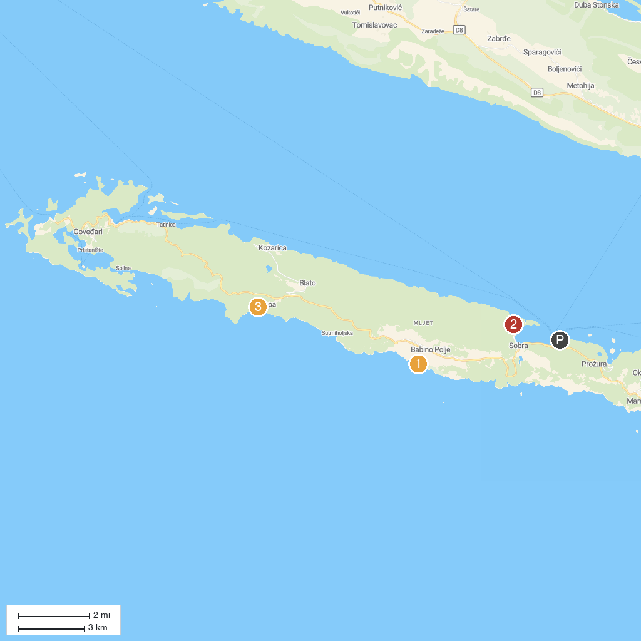
MAP KEY
1. Odysseus Cave | 3. Beach Ropa
2. Klačna luka
P. Cruise port / terminal
Map © MapTiler © OpenStreetMap contributors · cruiseports.org

