Miyazaki City, Miyazaki Prefecture, Japan
Miyazaki is Kyushu's sun-drenched coast — palm trees, prehistoric mythology, the world's only authorized Moai replicas, and Wagyu beef that regularly outranks Kobe.
⚓ Pier (Aburatsu or Miyazaki Port) · 🕒 Typical call: 8-10 hrs · 💴 Currency: Japanese Yen (JPY) · 🗣️ Language: Japanese (minimal English outside city)
✍️ MY DAY IN PORT (FILL IN)
Ship / Date
In port | arrive ______ · all aboard ______
Booked excursion
Notes / meeting point
GETTING ASHORE
- Docking: Pier at Aburatsu Port (~45 km south) for large ships; Miyazaki Port for smaller vessels
- Walk to center: Not walkable — taxi or train required from both ports
- Best For: Shinto shrines, mythology, Nichinan Coast scenery, Wagyu beef
- Don't Miss: Aoshima Island's Devil's Washboard and Udo Shrine's oceanside cave
GETTING AROUND
- 🚕 Taxi: ¥3,300–¥5,000+ per trip — Taxis wait at the pier. Fares to Obi Castle Town run ~¥3,300 and to Udo Jingu ~¥4,500; Miyazaki City center is further a
- 📱 Rideshare: ✅ Uber, Go, DiDi
TOP THINGS TO DO
- Aoshima Island & Devil's Washboard — A tiny subtropical island connected by footbridge, ringed by dramatic basalt washboard formations (Oni-no-Sentakuita) best seen…
- Udo Shrine — Cave Shrine on the Pacific Cliffs — One of Japan's most dramatic sacred sites: a vermilion shrine built inside a sea cave on the Nichinan Coast, dedicated to the…
- Sun Messe Nichinan — The Moai Park — The only place outside Easter Island with officially authorized Moai statue replicas — Japan sent a restoration team to Rapa Nui…
- Obi Castle Town — Little Kyoto of Kyushu — A beautifully preserved feudal castle town in Nichinan with samurai residences, moss-covered stone walls, and castle ruins.
- Heiwadai Park & Haniwa Garden — A hilltop park in Miyazaki City with a 37-meter Peace Tower built from stones donated across Asia, plus over 400 replica haniwa…
BEST WALKS
- Aoshima Island Loop: 1.5 km | 30 min | Easy | Free — Take a taxi from Aburatsu to Aoshima (~30 min).
- Miyazaki City Shrine Walk: 2 km | 45 min | Easy | Free — From Miyazaki Port shuttle drop, walk through cedar forest to Miyazaki Shrine (dedicated to…
cruiseports.org/miyazaki-city · Confirm terminal & all-aboard time with your ship

Miyazaki City, Miyazaki Prefecture, Japan — Port Map
Red = walkable sights · Amber = excursions farther out · P = cruise terminal
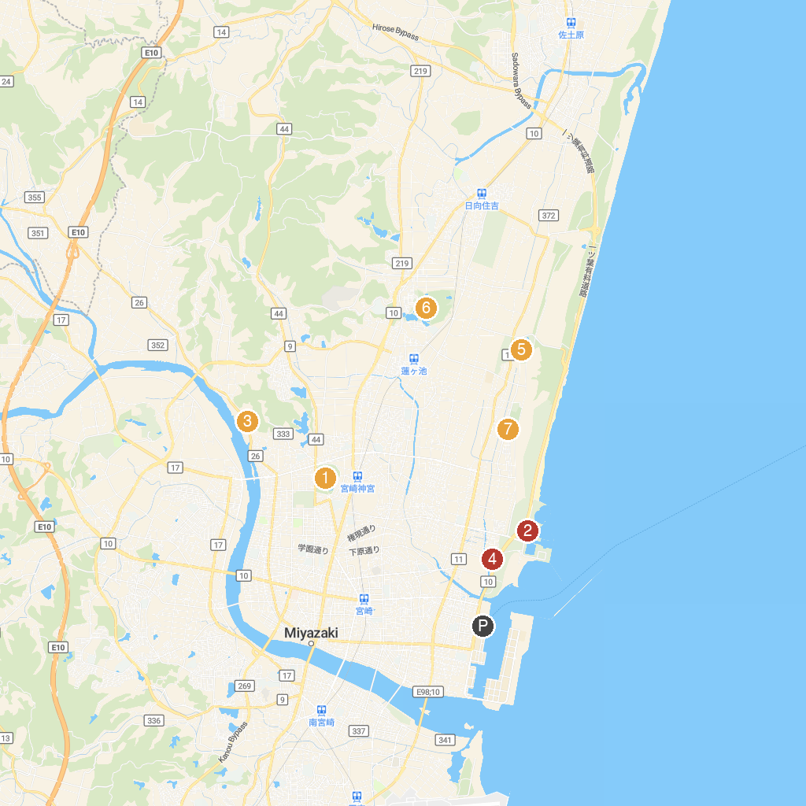
MAP KEY
1. Miyazaki Jingu | 5. Hitotsuba Inari Shrine
2. Miyazaki Seaside Park | 6. Shimin-no-mori (Country Forest)
3. Aoshima Shrine | 7. Hasugaikeshiseki Park
4. Oyodo River Study Center | 8. English Cottage
P. Cruise port / terminal
Map © MapTiler © OpenStreetMap contributors · cruiseports.org

