Miyakojima Island, Okinawa Prefecture, Japan
Flat coral-reef island in Japan's far southwest with some of Asia's whitest beaches, three landmark bridges to outer islands, and water so clear it glows neon turquoise — locals call it Miyako Blue.
⚓ Docked — Hirara Port · 🕒 Typical call: 8-10 hrs · 💴 Japanese Yen (JPY) · 🗣️ Japanese (minimal English outside terminal) · 🚗 Car rental recommended
✍️ MY DAY IN PORT (FILL IN)
Ship / Date
In port | arrive ______ · all aboard ______
Booked excursion
Notes / meeting point
GETTING ASHORE
- Docking: Pier at Hirara Port (Harimizu Wharf cruise berth) — no tender required
- Walk to center: ~2.5 km / 30 min to downtown Hirara; shuttle buses usually available
- Best for: World-class beaches, snorkeling, scenic island bridges
- Don't miss: Yonaha Maehama Beach and a drive across the 3.5 km Irabu Bridge
GETTING AROUND
- 🚕 Taxi: ~¥500 flag fall; ¥3,000–¥4,000 to Yonaha Maehama Beach — Taxis queue at Hirara Port. Cash (JPY) strongly preferred — Miyakojima is largely cash-based. Fares revised Aug 2023: ¥5
TOP THINGS TO DO
- Yonaha Maehama Beach Day — Seven kilometres of powdery white sand backed by Kurima Island views — regularly voted the best beach in Japan.
- Island Bridge Drive — Cross all three iconic bridges in a single loop: the 3.54 km Irabu Bridge (Japan's longest toll-free span), the scenic Kurima…
- Snorkeling at Aragusuku Beach — Shallow coral-rich waters teeming with clownfish and sea turtles just metres from the shore.
- Cape Higashi-Hennazaki — A narrow 2 km peninsula of grass and wind-bent trees jutting into the ocean — a designated Place of Scenic Beauty.
- Shigira Golden Hot Springs — Jungle-themed open-air onsen on the southern coast.
BEST WALKS
- Hirara Town Stroll: 2 km · 25-30 min · Easy — Walk from the cruise terminal along the port road into downtown Hirara for local noodle shops…
- Sunayama Beach: Short walk from car park · Moderate (steep sandy hill) — From the Sunayama car park, a short climb over a sandy ridge leads to a photogenic beach with a…
WEATHER · DAYLIGHT · MONEY
Month | High °F | Low °F | Rainy days
May | 80 | 75 | 19
Jul | 86 | 82 | 20
Sep | 84 | 80 | 21
Daylight: May 5:55AM–7:15PM · Jul 5:58AM–7:30PM · Sep 6:25AM–6:42PM
cruiseports.org/miyakojima-island · Confirm terminal & all-aboard time with your ship

Miyakojima Island, Okinawa Prefecture, Japan — Port Map
Red = walkable sights · Amber = excursions farther out · P = cruise terminal
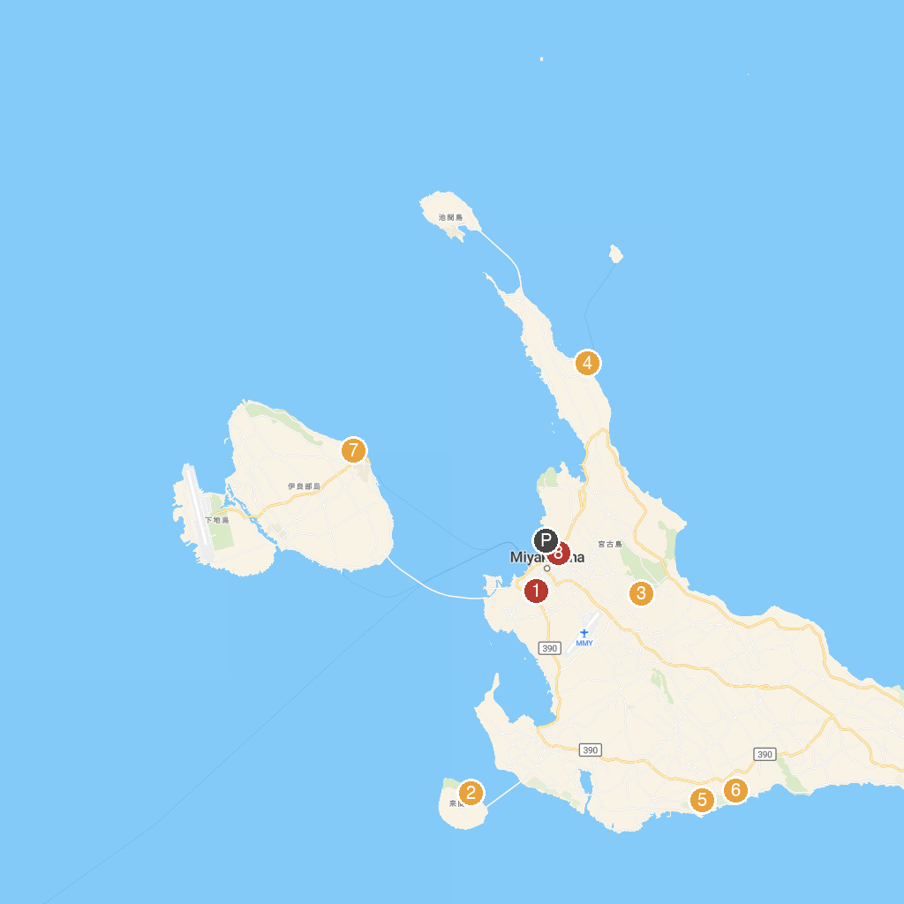
MAP KEY
1. Kamamamine Park | 5. The Shigira Ocean Sky Lift
2. Ryūgu Castle Observation Deck | 6. Amaga
3. Miyakojima City Museum | 7. サバウツガー
4. Shimajiri Fisherman's Wharf | 8. 大和井
P. Cruise port / terminal
Map © MapTiler © OpenStreetMap contributors · cruiseports.org

