Minneapolis-Saint Paul, Minnesota, USA
The northern terminus of Upper Mississippi River cruising, where Saint Paul's Gilded Age grandeur meets Minneapolis's world-class arts scene — all framed by the only major waterfall on America's great river.
⚓ Docked (Lambert's Landing, Saint Paul) · 🕒 Typical call: embark/debark or full day · 💵 US Dollar · 🗣️ English · 🌊 Mississippi River cruise
✍️ MY DAY IN PORT (FILL IN)
Ship / Date
In port | arrive ______ · all aboard ______
Booked excursion
Notes / meeting point
GETTING ASHORE
- Docking: Pier — Lambert's Landing, downtown Saint Paul (no tender)
- Walk to center: 5–10 min to Lowertown Saint Paul; Minneapolis 12 miles by light rail or rideshare
- Best For: History, arts, architecture, classic Midwestern food
- Don't Miss: Stone Arch Bridge views of St. Anthony Falls; Spoonbridge and Cherry sculpture garden
GETTING AROUND
- 🚕 Taxi: $31–$49 — Metered taxis available from MSP Airport and throughout the city. Downtown Minneapolis fares run $39–$49 (~12 miles); do
- 📱 Rideshare: ✅ Uber, Lyft
- 🚌 Hop-on hop-off: ✅
TOP THINGS TO DO
- Saint Paul Gangster History Tour — In the 1930s, Saint Paul's infamous 'O'Connor System' made the city a safe haven for John Dillinger, Baby Face Nelson, and Ma…
- Stone Arch Bridge & St. Anthony Falls — Walk the historic Stone Arch Bridge — built of native limestone and granite by railroad baron James J.
- Minneapolis Sculpture Garden & Mia — The free Minneapolis Sculpture Garden showcases the iconic Spoonbridge and Cherry sculpture and 40+ works from the Walker Art…
- Summit Avenue Victorian Mansions Walk — Stroll the longest stretch of preserved Victorian-era architecture in the United States.
- Lock & Dam No. 1 Transit — Watch your riverboat navigate through Lock and Dam No.
BEST WALKS
- Lambert's Landing to Lowertown Saint Paul: 0.3 miles · ~10 min · Easy (slight uphill) — From the dock, follow the riverfront path north and uphill into Lowertown — Saint Paul's arts and…
- Rice Park & Summit Avenue: 0.8 miles from dock · ~20 min walk · Moderate — Head uphill from Lowertown to Rice Park — Saint Paul's charming central square flanked by the Saint…
WEATHER · DAYLIGHT · MONEY
Month | High °F | Low °F | Rainy days
May | 68 | 49 | 12
Jul | 82 | 64 | 10
Sep | 73 | 57 | 9
Daylight: May 5:43AM–8:34PM · Jul 5:40AM–8:55PM · Sep 6:51AM–7:22PM
cruiseports.org/minneapolis-saint-paul · Confirm terminal & all-aboard time with your ship

Minneapolis-Saint Paul, Minnesota, USA — Port Map
Red = walkable sights · Amber = excursions farther out · P = cruise terminal
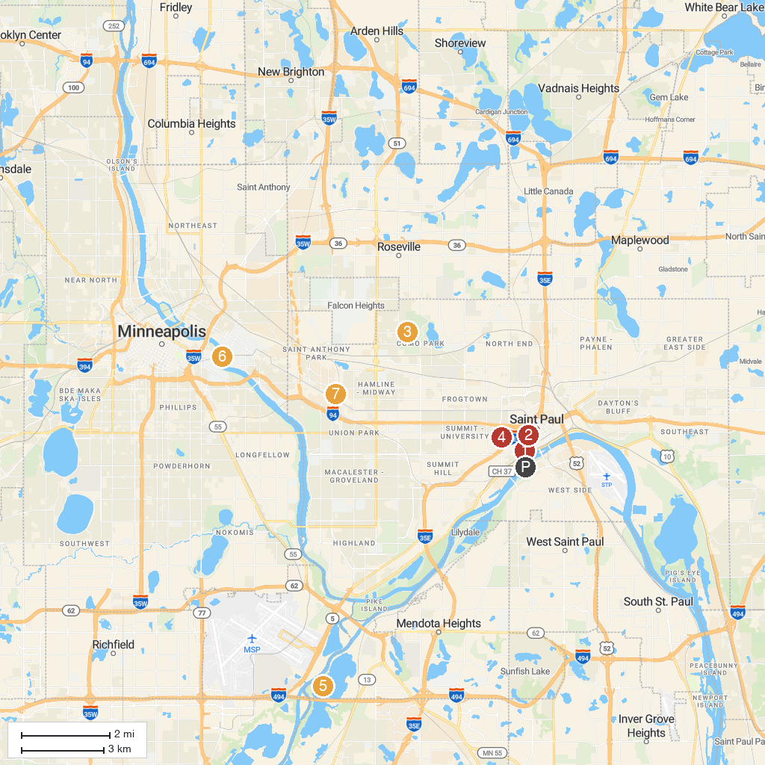
MAP KEY
1. Science Museum of Minnesota | 5. Cathedral of Saint Paul
2. Guthrie Theater | 6. Fort Snelling State Park
3. Minnesota Children's Museum | 7. Weisman Art Museum
4. Como Park Zoo & Conservatory | 8. Twin City Model Railroad Museum
P. Cruise port / terminal
Map © MapTiler © OpenStreetMap contributors · cruiseports.org

