Mindelo, Cape Verde
The Cultural Capital of Cape Verde
⚓ Port · 🎨 Arts & Music · 🇨🇻 Cape Verde · 🚶 Walkable City
✍️ MY DAY IN PORT (FILL IN)
Ship / Date
In port | arrive ______ · all aboard ______
Booked excursion
Notes / meeting point
GETTING ASHORE
- Currency: Cape Verdean Escudo (CVE)
- Language: Portuguese, Kriolu
- Time Zone: UTC-1
- Vibe: Cosmopolitan & Artistic
GETTING AROUND
- 🚕 Taxi: ~500 CVE (~€5) to city center — Taxis wait at the terminal exit. Fares are not metered — always agree on the price before you get in. Euros are widely a
- 📱 Rideshare: ❌ not available
TOP THINGS TO DO
- City Center & Music Walk — Stroll colorful colonial streets and visit the Municipal Market.
- Monte Verde Hike — Climb São Vicente's highest point for sweeping views over Mindelo Bay and the volcanic interior.
- Baía das Gatas Beach — Relax at the sheltered bay with natural rock pools, golden sand, and calm turquoise water.
- Centro Cultural do Mindelo — Discover Cape Verdean arts and heritage in this restored 19th-century customs house with exhibitions, performances, and a craft…
BEST WALKS
- Waterfront Promenade Walk: Easy — A gentle stroll along the bay with views of ships and the city skyline.
- Colonial Heart Exploration: Moderate — Wander the colorful colonial-era streets around the main square and Rua de Lisboa.
- Market Wander: Easy — Browse the vibrant Municipal Market for fresh produce, fish, and local goods.
WEATHER · DAYLIGHT · MONEY
Month | High °F | Low °F | Rainy days
May | 78 | 70 | 0
Jul | 81 | 73 | 1
Sep | 84 | 77 | 6
Daylight: May 6:08AM–7:03PM · Jul 6:15AM–7:16PM · Sep 6:28AM–6:41PM
cruiseports.org/mindelo · Confirm terminal & all-aboard time with your ship

Mindelo, Cape Verde — Port Map
Red = walkable sights · Amber = excursions farther out · P = cruise terminal
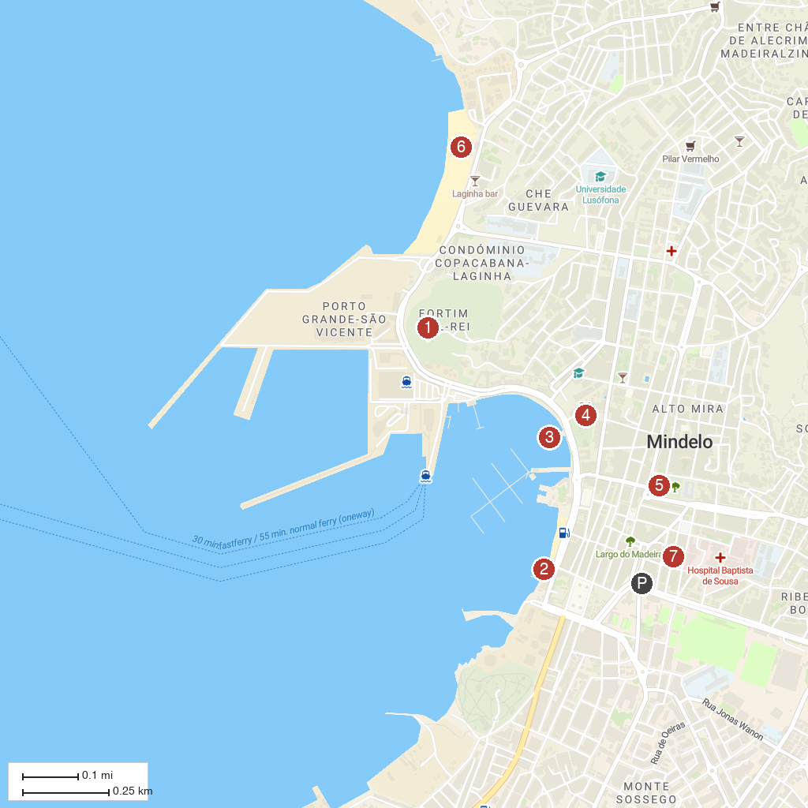
MAP KEY
1. Fortim do Rei | 5. People's Palace
2. Belem Tower Replica | Museum of the Sea | 6. Laginha Beach
3. Mansa Floating Hub | 7. Núcleo Museológico Cesária Évora
4. Zoom Zoom Mindelo
P. Cruise port / terminal
Map © MapTiler © OpenStreetMap contributors · cruiseports.org

