Manama, Bahrain
Where 5,000 years of Dilmun civilization meets a gleaming Gulf capital. Bahrain punches well above its size — ancient forts, UNESCO pearl heritage, and one of the Gulf's best museums, all reachable in a single shore day.
⚓ Docked (pier) · 🕒 Typical call: 8-10 hrs · 💵 Bahraini Dinar (BHD) / USD widely accepted · 🗣️ Arabic (English spoken everywhere)
✍️ MY DAY IN PORT (FILL IN)
Ship / Date
In port | arrive ______ · all aboard ______
Booked excursion
Notes / meeting point
GETTING ASHORE
- Docking: Pier — Khalifa Bin Salman Port, Hidd (15–20 min to city center)
- Walk to center: Not walkable; shuttle or taxi/Uber required
- Best For: History, culture, souq shopping, Arabic cuisine
- Don't Miss: Bahrain National Museum + Qal'at al-Bahrain (UNESCO fort)
GETTING AROUND
- 🚕 Taxi: BHD 4–10 (~USD 11–26) — Taxis queue at the port exit gate. Agree on a fare before departure or ensure the meter is running; fares to downtown Ma
- 📱 Rideshare: ✅ Uber, Careem, Bolt
TOP THINGS TO DO
- Qal'at al-Bahrain (Bahrain Fort) — A UNESCO World Heritage Site built atop 4,000 years of continuous settlement.
- UNESCO Pearling Path — Muharraq — Bahrain was once the pearl capital of the world.
- Bab Al Bahrain & Manama Souq — The historic gateway to Manama opens onto a labyrinth of gold jewellers, spice stalls, perfume merchants, and fabric shops.
- Bahrain National Museum — One of the finest museums in the Gulf — covering 6,000 years from Dilmun artifacts to traditional pearl diving equipment.
- Tree of Life (Shajarat al-Hayat) — A 400-year-old mesquite tree standing alone in Bahrain's barren desert with no obvious water source — a genuine mystery and…
BEST WALKS
- Manama Waterfront & Souq Loop: 2–3 km • 1–1.5 hrs • Easy — From Bab Al Bahrain, walk through the spice and gold souq lanes, then south along the corniche to…
- Muharraq Pearling Path: 2.5 km • 1.5 hrs • Easy — The UNESCO Pearling Path in Muharraq is a self-guided trail through restored pearl merchants'…
WEATHER · DAYLIGHT · MONEY
Month | High °F | Low °F | Rainy days
May | 93 | 80 | 0
Jul | 101 | 89 | 0
Sep | 99 | 85 | 0
Daylight: May 4:51AM–6:16PM · Jul 4:55AM–6:32PM · Sep 5:23AM–5:41PM
cruiseports.org/mina-salman-manama · Confirm terminal & all-aboard time with your ship

Manama, Bahrain — Port Map
Red = walkable sights · Amber = excursions farther out · P = cruise terminal
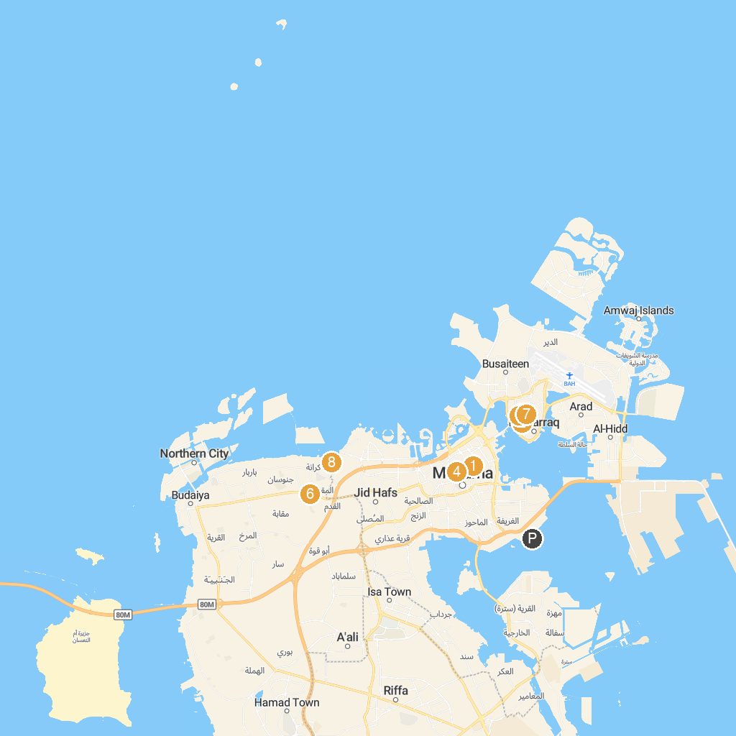
MAP KEY
1. Ibrahim Al Arrayed House | 5. Vertical Garden
2. Mohammed Bin Faris House for vocal Music | 6. The Great Escape Challenge
3. Abdullah Al Zayed House for Bahraini Press Heritage | 7. Beit Sheikh Isa Bin Ali Al Khalifa (House)
4. Khalaf House | 8. Bahrain Fort
P. Cruise port / terminal
Map © MapTiler © OpenStreetMap contributors · cruiseports.org

