Miltenberg, Bavaria, Germany
Miltenberg's cobbled Schnatterloch market square and half-timbered façades look lifted from a Brothers Grimm illustration — and somehow, they're all real and completely intact.
⚓ Docked (river pier) · 🕒 Typical call: 6–8 hrs · 💶 Euro (€) · 🗣️ German
✍️ MY DAY IN PORT (FILL IN)
Ship / Date
In port | arrive ______ · all aboard ______
Booked excursion
Notes / meeting point
GETTING ASHORE
- Docking: River pier on the Main — no tendering, steps from the old town
- Walk to center: 3–5 min to Schnatterloch market square
- Best For: Medieval architecture, beer & wine, leisurely strolls
- Don't Miss: Gasthaus Zum Riesen — Germany's oldest royal inn (documented 1411)
GETTING AROUND
- 🚕 Taxi: €5–€10 — Local taxis operate with regulated fares (€4.70 base + €2.30/km day rate). Useful for reaching the hilltop Miltenberg Ca
- 📱 Rideshare: ❌ not available
TOP THINGS TO DO
- Old Town & Schnatterloch Walking Tour — Explore the Schnatterloch market square with its 1583 Renaissance fountain, the Hauptstraße lined with 14th–17th century…
- Mildenburg Castle & Museum — Hike 15 minutes uphill from the market square to this 12th-century castle for panoramic views of the Main River loop.
- Faust Brewery Beer Garden — Miltenberg's family-owned Brauhaus Faust sits right on the river.
- Museum Stadt Miltenberg — Housed in a handsome Renaissance building on the Schnatterloch, this museum covers the town's Roman roots, medieval Jewish…
- Main River Cycle Route — Miltenberg sits on the Main-Radweg, one of Germany's most scenic flat bike paths.
BEST WALKS
- River Promenade to Schnatterloch & St. Jakobus: 1.5 km · 30 min · Easy · Flat, some cobbles — Start at the river dock and stroll the Mainpromenade before heading into the old town via the…
- Castle Hill Walk: 2 km round trip · 45 min · Moderate · Uphill trail — From the Schnatterloch, follow the wooded path up to Mildenburg Castle for sweeping views over the…
WEATHER · DAYLIGHT · MONEY
Month | High °F | Low °F | Rainy days
May | 66 | 49 | 12
Jul | 78 | 61 | 11
Sep | 70 | 54 | 9
Daylight: May 5:38AM–9:01PM · Jul 5:32AM–9:24PM · Sep 6:59AM–7:35PM
cruiseports.org/miltenberg · Confirm terminal & all-aboard time with your ship

Miltenberg, Bavaria, Germany — Port Map
Red = walkable sights · Amber = excursions farther out · P = cruise terminal
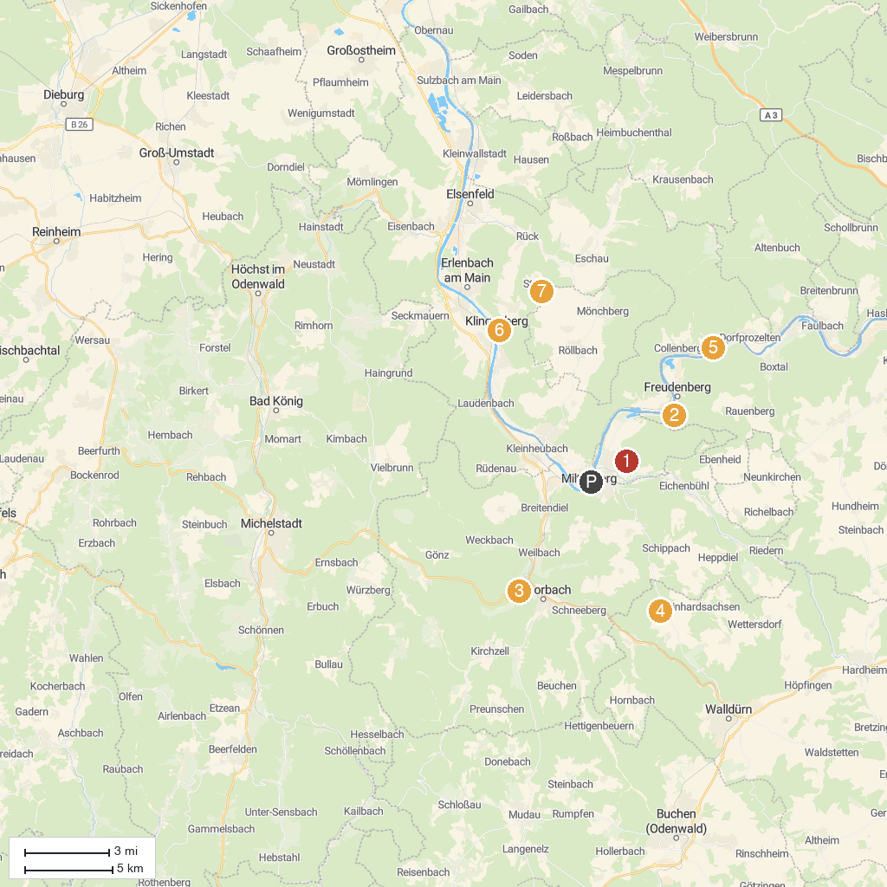
MAP KEY
1. Centgrafenkapelle | 5. Kollenburg
2. Burg Freudenburg | 6. Esskastanien-Lehrpfad Klingenberg
3. Amorsbrunn | 7. ALPAKAPROJEKT
4. Odenwald Freilandmuseum e.V. | 8. Shipping and Shipbuilding Museum
P. Cruise port / terminal
Map © MapTiler © OpenStreetMap contributors · cruiseports.org

