Milos Island, Cyclades, Greece
Milos is the volcanic oddity of the Cyclades — white lunar rock formations tumbling into cobalt sea, hidden sea caves accessible only by boat, and a hilltop capital where the Venus de Milo was unearthed. It rewards curious cruisers who venture beyond the port.
⚓ Tender (most ships) / Docked (small vessels) · 🕒 Typical call: 6–8 hrs · 💶 Euro (€) · 🗣️ Greek
✍️ MY DAY IN PORT (FILL IN)
Ship / Date
In port | arrive ______ · all aboard ______
Booked excursion
Notes / meeting point
GETTING ASHORE
- Docking: Tender to Adamas pier; small ships may dock at 65 m quay
- Walk to Center: Tender drops in central Adamas — town is immediate
- Best For: Boat tours, lunar beaches, volcanic scenery, history
- Don't Miss: Sarakiniko Beach and a sea-cave boat tour to Kleftiko
GETTING AROUND
- 🚕 Taxi: €4–12 — Taxis from Adamas port: ~€4–6 within town, ~€10–12 to Plaka (5 min). Limited fleet — book ahead via WhatsApp in peak sea
TOP THINGS TO DO
- Sarakiniko Beach — The Lunar Landscape — Milos's signature sight: brilliant white volcanic rock sculpted into otherworldly ridges and pools overlooking deep-blue sea.
- Full-Day Boat Tour — Kleftiko & Sea Caves — The essential Milos experience: sail to Kleftiko's dramatic white rock arches and crystal-clear sea caves on the southwest coast…
- Plaka, Roman Theater & Venus de Milo Site — Ride the bus to Plaka's whitewashed hilltop capital and Kastro viewpoint, then descend to ancient Melos — the Roman theater with…
- Early Christian Catacombs of Milos — One of Greece's most important early Christian sites: an underground network of burial chambers carved into soft rock near…
- Adamas on Foot — Milos Mining Museum — Explore the compact port village on foot: the waterfront promenade, colourful fishing boats, and the Milos Mining Museum…
BEST WALKS
- Adamas Waterfront Stroll: 1 km · Flat · 20 min — Walk the full length of the Adamas waterfront from the tender pier past harbour tavernas, the Milos…
- Adamas to Plaka Hilltop: 5 km one-way · Moderate · Or take the bus — Follow the road northwest up to Plaka — the whitewashed hilltop capital — then continue to the…
WEATHER · DAYLIGHT · MONEY
Month | High °F | Low °F | Rainy days
May | 72 | 64 | 2
Jul | 84 | 76 | 1
Sep | 79 | 72 | 2
Daylight: May 6:15AM–8:22PM · Jul 6:15AM–8:40PM · Sep 7:04AM–7:29PM
cruiseports.org/milos-island · Confirm terminal & all-aboard time with your ship

Milos Island, Cyclades, Greece — Port Map
Red = walkable sights · Amber = excursions farther out · P = cruise terminal
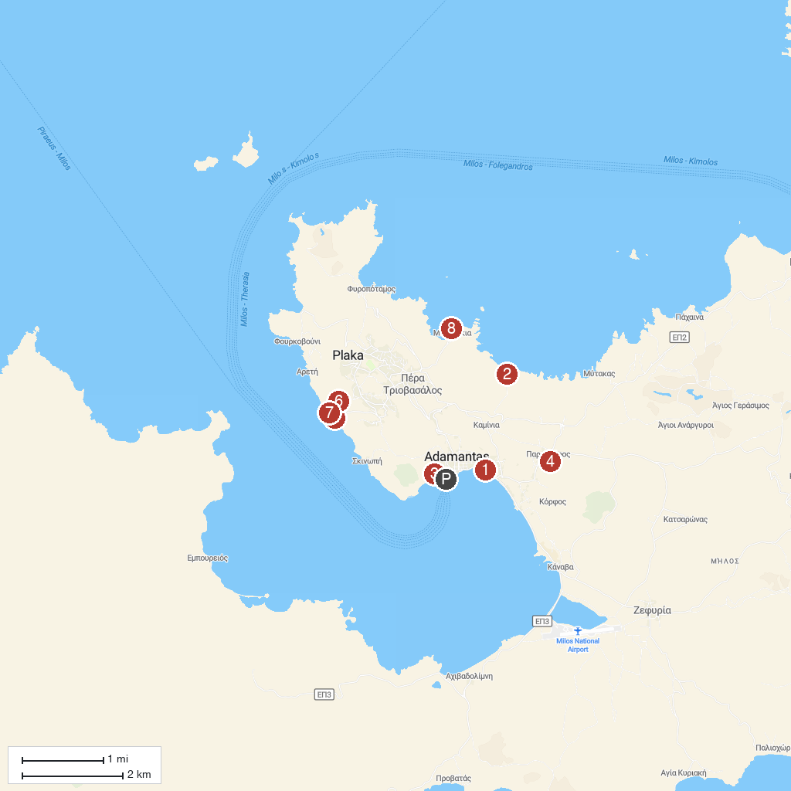
MAP KEY
1. Milos Mining Museum/Μεταλλευτικό Μουσείο Μήλου | 5. Klima Beach
2. Sarakiniko | 6. Ancient Theater of Milos
3. Lagada Beach | 7. Σύρματα στο Κλήμα Μήλου
4. Donkey Farm Milos | 8. Mandrakia beach
P. Cruise port / terminal
Map © MapTiler © OpenStreetMap contributors · cruiseports.org

