Milford Haven, Pembrokeshire, Wales
One of the world's deepest natural harbours, Milford Haven is your gateway to Britain's only coastal National Park — wild clifftops, medieval walled towns, and a quirky American-Quaker founding story.
⚓ Tender port · 🕒 Typical call: 7-9 hrs · 💷 GBP (cards widely accepted) · 🗣️ English & Welsh
✍️ MY DAY IN PORT (FILL IN)
Ship / Date
In port | arrive ______ · all aboard ______
Booked excursion
Notes / meeting point
GETTING ASHORE
- Docking: Tender to Mackerel Stage pontoon, Milford Waterfront
- Walk to centre: Steps away from marina; 10-15 min uphill to town centre
- Best For: Medieval castles, coastal walks, wildlife, Tenby day trip
- Don't Miss: Pembroke Castle or a day trip to Tenby's walled harbour
GETTING AROUND
- 🚕 Taxi: Quote on request — Local firms include Milford Haven Sea Port Taxis and ATX Taxis (01646 288741). The town centre is very close to the port
TOP THINGS TO DO
- Pembroke Castle — Birthplace of King Henry VII and one of Wales' greatest medieval fortresses, with a massive circular Norman keep and the vast…
- Tenby Walled Town & Harbour — Pastel-painted Georgian houses inside 13th-century walls, a working harbour, golden beaches, and boat trips to Caldey Island…
- St Davids Cathedral & Bishop's Palace — The UK's smallest city hides a stunning 12th-century cathedral and the atmospheric ruins of the Bishop's Palace.
- Skomer Island Puffins — Britain's most accessible puffin colony — boat trips from Martin's Haven (near Marloes) put you within metres of Atlantic…
- Pembrokeshire Coast Path — Join the 186-mile national trail straight from the marina.
BEST WALKS
- Milford Waterfront & Marina Stroll: 30-45 min · Flat · Free — From the Mackerel Stage pontoon, walk the length of the waterfront past boutique shops, Foam café…
- The Rath Park & Harbour Views: 45-60 min · Moderate (uphill) · Free — Head uphill from the marina to The Rath, a grassy elevated park with war memorials and panoramic…
WEATHER · DAYLIGHT · MONEY
Month | High °F | Low °F | Rainy days
May | 58 | 49 | 13
Jul | 65 | 58 | 14
Sep | 63 | 56 | 14
Daylight: May 5:27AM–9:06PM · Jul 5:20AM–9:31PM · Sep 6:55AM–7:34PM
cruiseports.org/milford-haven · Confirm terminal & all-aboard time with your ship

Milford Haven, Pembrokeshire, Wales — Port Map
Red = walkable sights · Amber = excursions farther out · P = cruise terminal
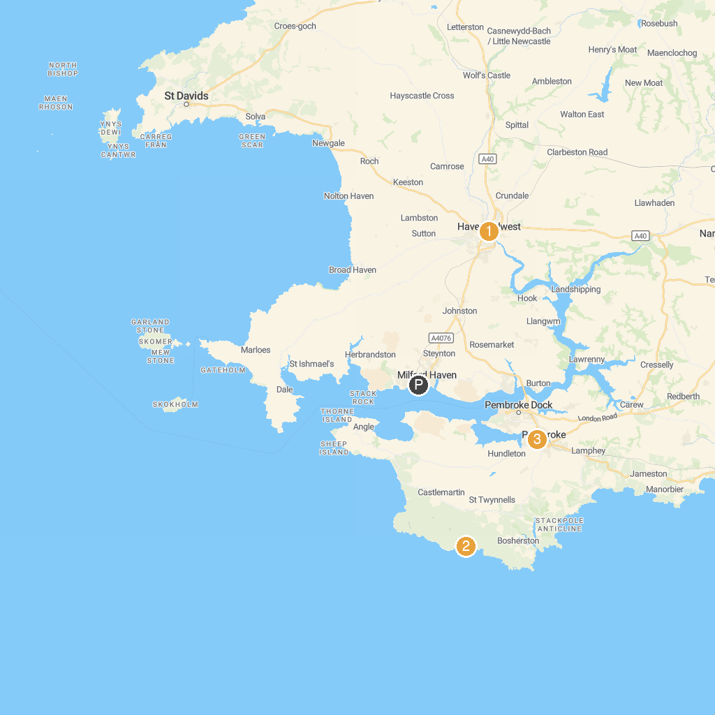
MAP KEY
1. St Govans Head | 5. Carew Tidal Mill
2. Haverfordwest Town Museum | 6. Pembroke Castle
3. The Cauldron | 7. Carew Castle
4. National Trust - Stackpole
P. Cruise port / terminal
Map © MapTiler © OpenStreetMap contributors · cruiseports.org

