Milazzo, Sicily, Italy
A narrow peninsula jutting into the Tyrrhenian Sea, Milazzo punches well above its size — a colossal hilltop castle, pristine volcanic-tinged waters, and a hydrofoil ride to UNESCO Aeolian Islands just 45 minutes away.
⚓ Pier (docked) · 🕒 Typical call: 7-9 hrs · 💶 Currency: Euro (€) · 🗣️ Language: Italian · 🏝️ Aeolian Islands gateway
✍️ MY DAY IN PORT (FILL IN)
Ship / Date
In port | arrive ______ · all aboard ______
Booked excursion
Notes / meeting point
GETTING ASHORE
- Docking: Pier — ships dock at Banchina XX Luglio or Luigi Rizzo, steps from the seafront promenade
- Walk to center: 5 min flat to Piazza Caio Duilio; 20 min (steep final stretch) to the Castle
- Best For: History buffs, beach lovers, and cruisers wanting a DIY Aeolian Islands day trip
- Don't Miss: Castello di Milazzo — one of Europe's largest fortified citadels, with Aeolian Islands panoramas
GETTING AROUND
- 🚕 Taxi: €13–€16 — Taxis wait at the port and can take you to Milazzo city center or train station in about 5–10 minutes. Fixed-rate privat
- 📱 Rideshare: ✅ Uber Black
TOP THINGS TO DO
- Castello di Milazzo & Borgo Antico — One of Europe's largest fortified citadels spans the hilltop above town — built by Normans, Aragonese, and Spanish over centuries.
- DIY Vulcano Island Day Trip — Take a Liberty Lines hydrofoil to Vulcano (45 min), the closest Aeolian Island.
- Piscina di Venere & Capo Milazzo — At the tip of the Milazzo peninsula, a natural volcanic-rock pool shelters a jade-green swimming cove.
- Spiaggia di Ponente Beach — Milazzo's main beach stretches along the peninsula's western flank with views of the Aeolian Islands.
- Sicilian Street Food & Market Walk — Milazzo's town center rewards a food-focused stroll.
BEST WALKS
- Lungomare to Borgo Antico & Castle: 3 km · ~1.5 hrs · Moderate (uphill finish) — Follow the palm-lined Lungomare Garibaldi from the pier into the town center, then wind uphill…
- Pier to Ponente Beach: 1.5 km · ~20 min · Easy (flat) — A short, entirely flat walk from the harbor across the narrow neck of the peninsula to Milazzo's…
WEATHER · DAYLIGHT · MONEY
Month | High °F | Low °F | Rainy days
May | 72 | 60 | 9
Jul | 86 | 74 | 4
Sep | 80 | 70 | 11
Daylight: May 5:48AM–8:02PM · Jul 5:48AM–8:21PM · Sep 6:41AM–7:06PM
cruiseports.org/milazzo · Confirm terminal & all-aboard time with your ship

Milazzo, Sicily, Italy — Port Map
Red = walkable sights · Amber = excursions farther out · P = cruise terminal
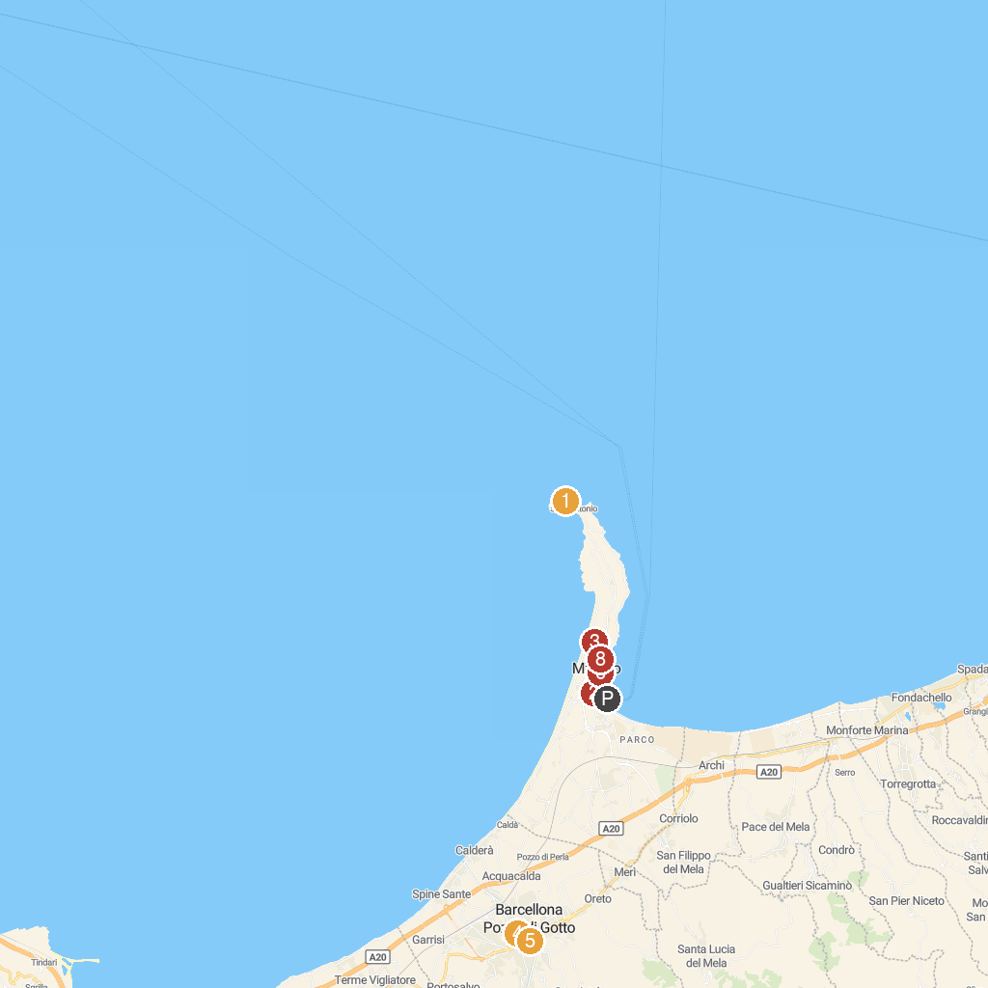
MAP KEY
1. Lighthouse of Cape Milazzo | 5. Oratorio Salesiani
2. NAVISAL srl | 6. Chiesa di S. Giacomo
3. Castello di Milazzo | 7. Porto di Milazzo
4. Parco Urbano Giuseppe La Rosa | 8. Palazzo D'Amico
P. Cruise port / terminal
Map © MapTiler © OpenStreetMap contributors · cruiseports.org

