Miami, Florida, USA
The Cruise Capital of the World. Miami delivers sun-soaked beaches, electric nightlife, Latin culture, and one of the planet's most spectacular skylines — all within reach of the world's busiest cruise port.
⚓ Docked — multiple terminals · 🕒 Typical call: homeport (overnight) · 💵 USD · 🗣️ English / Spanish · 🌡️ Hot & humid May–Oct
✍️ MY DAY IN PORT (FILL IN)
Ship / Date
In port | arrive ______ · all aboard ______
Booked excursion
Notes / meeting point
GETTING ASHORE
- Docking: Docked at PortMiami (Dodge Island) — 8+ modern terminals
- Walk to center: Port is on an island — Bayside Marketplace ~1.5 mi but no safe pedestrian path; take Uber/taxi
- Best For: Beach days, Everglades wildlife, Latin culture, skyline boat tours
- Don't Miss: An airboat through the Everglades — book in advance, morning slots fill fast
GETTING AROUND
- 🚕 Taxi: $15–20 — Metered taxis queue at all PortMiami terminals. Downtown Miami is a short 5–10 min ride; fares are roughly $15–20 (Miami
- 📱 Rideshare: ✅ Uber, Lyft
- 🚌 Hop-on hop-off: ✅ Big Bus Miami
TOP THINGS TO DO
- Everglades Airboat Adventure — Glide across the sawgrass at 40 mph on a flat-bottomed airboat, spotting alligators, herons, and turtles in America's largest…
- South Beach Art Deco & Ocean Drive — Walk Ocean Drive's pastel 1930s hotels, swim the famous white-sand beach, and people-watch from a Lincoln Road café.
- Little Havana Food & Culture Walk — Sip a cortadito at a ventanita on Calle Ocho, watch dominoes at Maximo Gomez Park, browse hand-rolled cigars, and eat lunch at…
- Wynwood Walls & Street Art District — The world's most famous open-air street art museum: a full city block of giant murals by globally renowned artists.
- Key Biscayne Beach Day — Escape tourist crowds at Crandon Park Beach on Key Biscayne — turquoise water, calm surf, palm-shaded picnic areas, and far fewer…
BEST WALKS
- Bayside to Brickell via Metromover: 3 km · ~1 hr · Easy · Free transit — Uber from port to Bayside Marketplace, then hop the free Metromover south to Brickell City Centre…
- Ocean Drive to Lincoln Road, South Beach: 2.5 km · ~1 hr · Easy · South Beach — Start at the Art Deco Welcome Center on Ocean Drive at 10th Street, walk north past the iconic…
WEATHER · DAYLIGHT · MONEY
Month | High °F | Low °F | Rainy days
May | 83 | 74 | 16
Jul | 87 | 78 | 22
Sep | 86 | 77 | 24
Daylight: May 6:35AM–7:59PM · Jul 6:39AM–8:14PM · Sep 7:06AM–7:24PM
cruiseports.org/miami · Confirm terminal & all-aboard time with your ship

Miami, Florida, USA — Port Map
Red = walkable sights · Amber = excursions farther out · P = cruise terminal
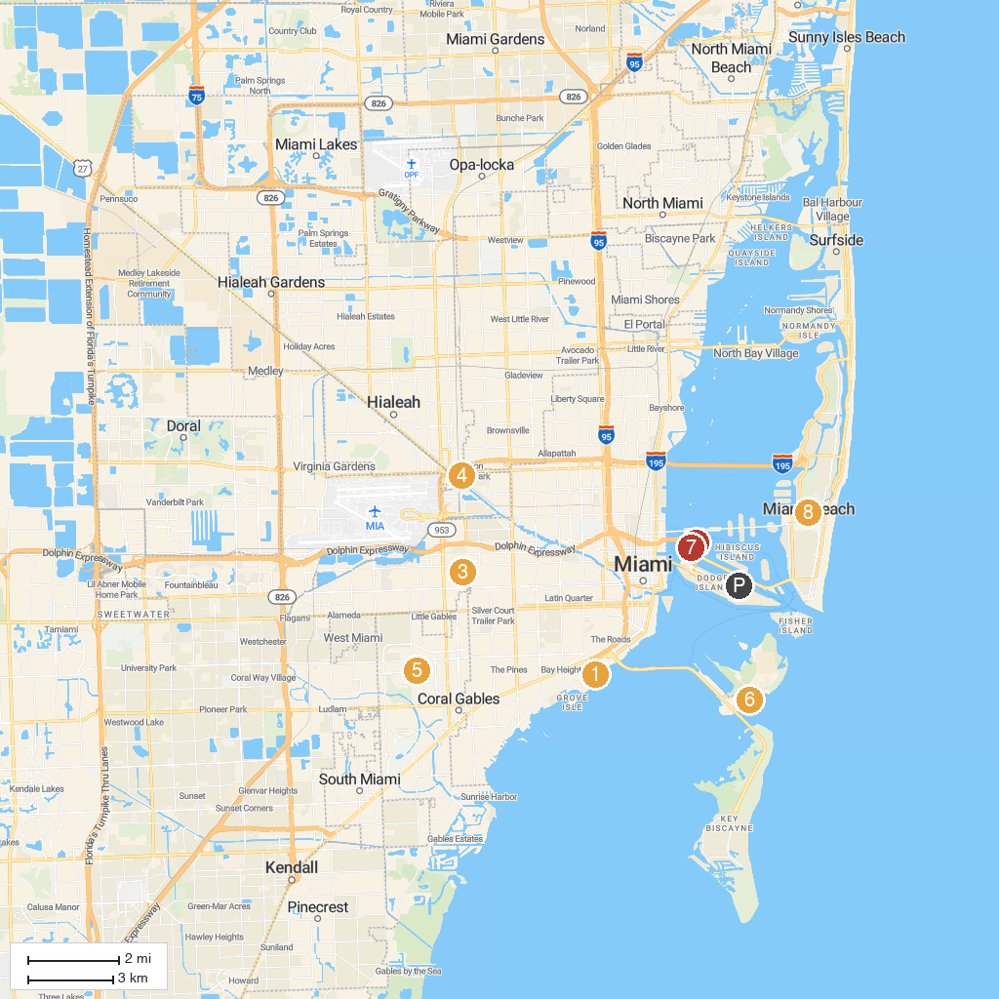
MAP KEY
1. Vizcaya Museum & Gardens | 5. Venetian Pool
2. Jungle Island | 6. Historic Virginia Key Beach Park
3. Magic City Casino | 7. Miami Children's Museum
4. Casino Miami | 8. Miami Beach Botanical Garden
P. Cruise port / terminal
Map © MapTiler © OpenStreetMap contributors · cruiseports.org

