Metz, Grand Est, France
Glowing with golden Jaumont limestone and the most stained glass of any building on Earth, Metz is France's quietly dazzling river gem — where Gothic grandeur meets bold modern art and a very good quiche.
⚓ River dock (gangway to quay) · 🕒 Typical call: 7-9 hrs · 💶 Euro (€) · 🗣️ French
✍️ MY DAY IN PORT (FILL IN)
Ship / Date
In port | arrive ______ · all aboard ______
Booked excursion
Notes / meeting point
GETTING ASHORE
- Docking: River pier — gangway directly onto the Moselle quayside
- Walk to centre: 5-10 min flat walk to Temple Neuf; 12 min to Cathedral
- Best For: Stained glass, Gothic architecture, Lorraine food, modern art
- Don't Miss: Cathedral Saint-Étienne's Marc Chagall windows & the covered market
GETTING AROUND
- 🚕 Taxi: €5–€10 — Taxis are available near the port. Base fare is ~€3.08 with per-km rates of €0.92–€2.60. Most city-center rides will be
- 📱 Rideshare: ✅ Uber, Bolt
TOP THINGS TO DO
- Cathédrale Saint-Étienne — God's Lantern — The 13th-century Gothic cathedral holds the world's largest expanse of stained glass — 6,496 sq m spanning eight centuries of…
- Centre Pompidou-Metz — The Paris Pompidou's sister institution, housed in a breathtaking building with a wavy white roof inspired by a Chinese straw hat.
- Imperial Quarter & Metz Train Station — Kaiser Wilhelm II built this entire neighbourhood in heavy neo-Romanesque style during the German annexation (1871-1918) to…
- Musée de la Cour d'Or — A sprawling museum built directly over excavated Roman baths, with Gallo-Roman mosaics, medieval architectural fragments, and…
- Marché Couvert & Lorraine Food Trail — The covered market next to the Cathedral is stacked with Lorraine specialities: authentic quiche Lorraine (no cheese!), Mirabelle…
BEST WALKS
- Riverside to Cathedral Loop: 3.5 km · ~1 hr · Flat — From the dock, stroll north to Temple Neuf on its river island, cross into the old town, climb to…
- Imperial Quarter Walk: 2 km · ~45 min · Flat — Head southwest from the Cathedral through the strikingly different Imperial Quarter — heavy German…
WEATHER · DAYLIGHT · MONEY
Month | High °F | Low °F | Rainy days
May | 65 | 48 | 11
Jul | 77 | 59 | 9
Sep | 70 | 53 | 8
Daylight: May 5:52AM–9:11PM · Jul 5:47AM–9:34PM · Sep 7:12AM–7:47PM
cruiseports.org/metz · Confirm terminal & all-aboard time with your ship

Metz, Grand Est, France — Port Map
Red = walkable sights · Amber = excursions farther out · P = cruise terminal
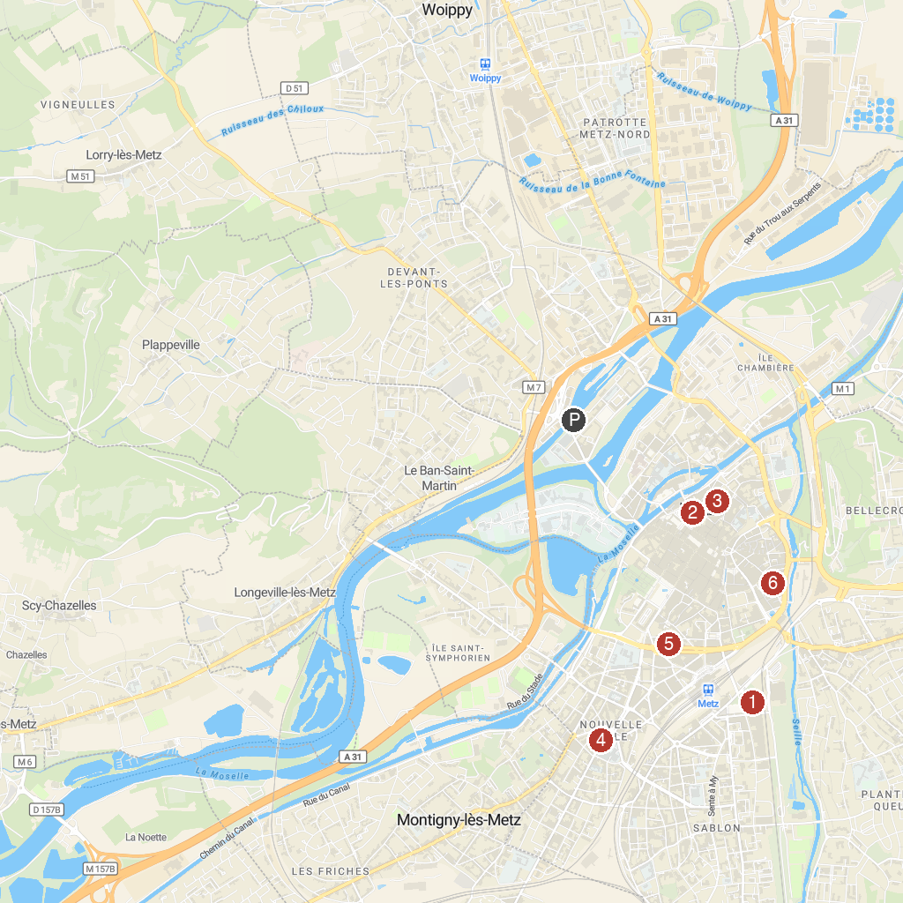
MAP KEY
1. Centre Pompidou-Metz | 5. Église Sainte-Thérèse-de-l'Enfant-Jésus
2. Cathédrale Saint-Etienne de Metz | 6. Tour Camoufle
3. Museum of La Cour d'Or | 7. Église Saint-Maximin de Metz
4. Zoo d'Amnéville
P. Cruise port / terminal
Map © MapTiler © OpenStreetMap contributors · cruiseports.org

