Mettlach, Saarland, Germany
Mettlach sits in a deep forested valley where the Saar River carves its famous hairpin bend. Two draws dominate every shore day: a sweeping view over the Saarschleife loop and the baroque Villeroy & Boch abbey that put this small town on the world map.
⚓ Docked (riverside pier) · 🕒 Typical call: 6–8 hrs · 💶 Euro (€) · 🗣️ German (French widely understood)
✍️ MY DAY IN PORT (FILL IN)
Ship / Date
In port | arrive ______ · all aboard ______
Booked excursion
Notes / meeting point
GETTING ASHORE
- Docking: Docked at Saaruferstraße riverside pier — no tendering
- Walk to center: 2–5 min flat walk from pier
- Best For: Saar Loop views, ceramics shopping, Franco-German cuisine
- Don't Miss: Cloef viewpoint & Baumwipfelpfad treetop walk above the Saar Loop
GETTING AROUND
- 🚕 Taxi: €8–11 — Local taxis are available at the dock area for short hops around town. Saarland base fare is €4.80 plus €3.10/km — short
TOP THINGS TO DO
- Saarschleife Cloef Viewpoint — Germany's most dramatic river bend, where the Saar loops nearly 360 degrees through a forested gorge.
- Villeroy & Boch Discovery Center — The world-famous ceramics brand has been headquartered in this stunning baroque Benedictine abbey since 1809.
- Baumwipfelpfad Treetop Walk — A 1,250-meter wooden walkway rises through the Saar forest canopy to a 42-meter observation tower at the Cloef — the best…
- Old Abbey Park & Alte Turm — The park behind the Villeroy & Boch abbey contains the Alte Turm, a stone tower built around 990 AD — the oldest surviving sacred…
- Burg Montclair Castle Ruins — Medieval castle ruins perched on the forested ridge inside the Saar Loop.
BEST WALKS
- Pier to Villeroy & Boch Abbey Loop: 1–1.5 km · 20–30 min · Flat · Free — A short, rewarding walk through the town center to the baroque abbey complex, the abbey park, and…
- St. Lutwinus Church Walk: 0.5 km · 10 min · Flat · Free — From the pier, stroll into the town center to the neo-Romanesque St.
WEATHER · DAYLIGHT · MONEY
Month | High °F | Low °F | Rainy days
May | 65 | 49 | 12
Jul | 76 | 59 | 11
Sep | 69 | 53 | 10
Daylight: May 5:49AM–9:11PM · Jul 5:43AM–9:34PM · Sep 7:10AM–7:46PM
cruiseports.org/mettlach · Confirm terminal & all-aboard time with your ship

Mettlach, Saarland, Germany — Port Map
Red = walkable sights · Amber = excursions farther out · P = cruise terminal
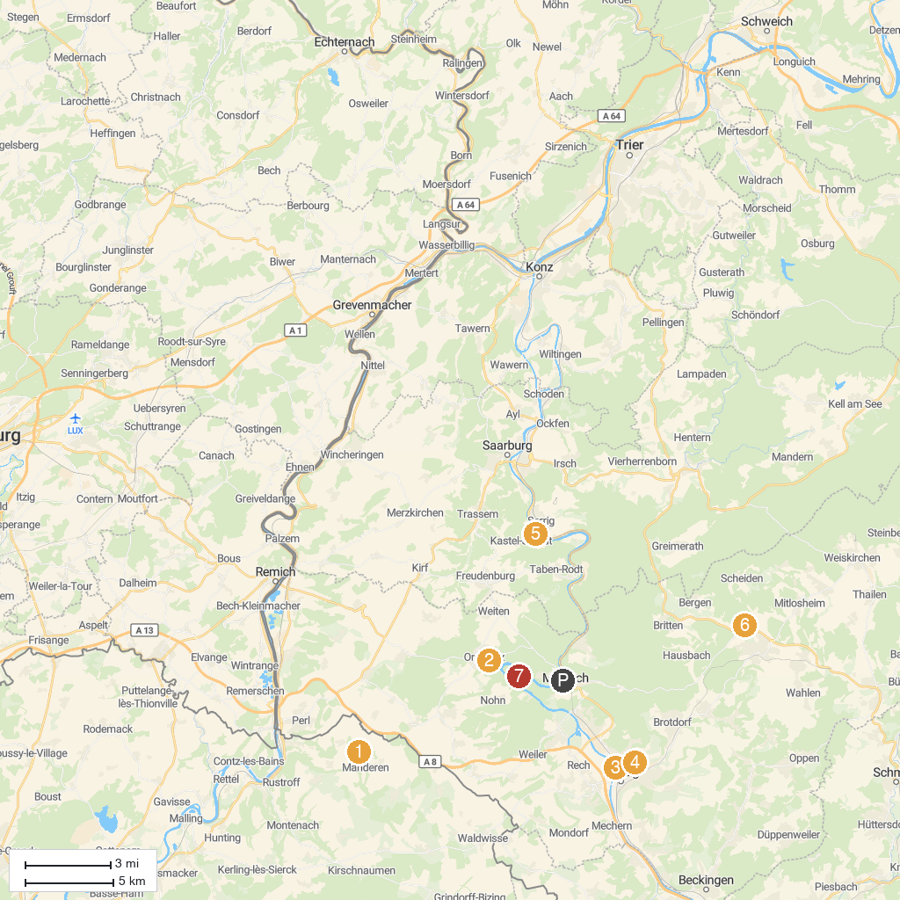
MAP KEY
1. Malbrouck Castle | 5. Klause bei Kastel
2. Treetop Walk Saarschleife | 6. SeeGarten Losheim
3. Merziger Tierpark | 7. Saarburg
4. Garten der Sinne | 8. Burg Montclair
P. Cruise port / terminal
Map © MapTiler © OpenStreetMap contributors · cruiseports.org

