Methoni, Peloponnese, Greece
A Venetian fortress at the edge of the ancient world. Methoni's sea-girt castle, octagonal Bourtzi tower, and uncrowded beaches make it the Peloponnese's best-kept cruise secret.
⚓ Tender (no cruise pier) · 🕒 Typical call: 6-8 hrs · 💶 Currency: Euro · 🗣️ Language: Greek (English widely spoken) · 🏰 History-rich destination
✍️ MY DAY IN PORT (FILL IN)
Ship / Date
In port | arrive ______ · all aboard ______
Booked excursion
Notes / meeting point
GETTING ASHORE
- Docking: Tender — ships anchor offshore; small boats ferry passengers to the village harbour
- Walk to Castle: ~5 min from the harbour landing to the castle entrance
- Best For: Medieval history, unspoiled beaches, authentic Greek village life
- Don't Miss: Methoni Castle and the Bourtzi octagonal tower on its sea islet
GETTING AROUND
- 🚕 Taxi: €8–€15 — Taxis run from the port to the town center in about 5 minutes. Only 3–4 taxis operate in town, so pre-arranging is advis
TOP THINGS TO DO
- Methoni Castle & Bourtzi Tower — Explore one of Europe's best-preserved Venetian coastal fortresses.
- Voidokilia Beach Day Trip — Often called Greece's most beautiful beach, Voidokilia is a perfect semicircle of golden sand enclosing a turquoise lagoon where…
- Pylos & Niokastro Fortress — The charming town of Pylos sits 10 km north of Methoni around a sweeping natural harbour.
- Methoni Beach & Seafood Lunch — Methoni's own 2-km sandy beach is just a short walk from the village, with calm clear water backed by pine trees.
- Koroni Village & Castle — Methoni's twin Venetian fortress town, Koroni sits about 28 km to the north-east on the next peninsula.
BEST WALKS
- Harbour to Castle Loop: 1.5 km | 30–60 min | Easy (flat, then uneven cobble inside castle) — From the fishing quay walk south along the waterfront to the castle entrance, cross the 14-arch…
- Village Square & Beach Stroll: 2 km one-way | 25 min | Very easy (flat) — Wander through the village square past traditional tile-roofed houses and tavernas, then continue…
WEATHER · DAYLIGHT · MONEY
Month | High °F | Low °F | Rainy days
May | 73 | 62 | 6
Jul | 87 | 74 | 1
Sep | 81 | 71 | 5
Daylight: May 6:25AM–8:33PM · Jul 6:26AM–8:51PM · Sep 7:15AM–7:40PM
cruiseports.org/methoni · Confirm terminal & all-aboard time with your ship

Methoni, Peloponnese, Greece — Port Map
Red = walkable sights · Amber = excursions farther out · P = cruise terminal
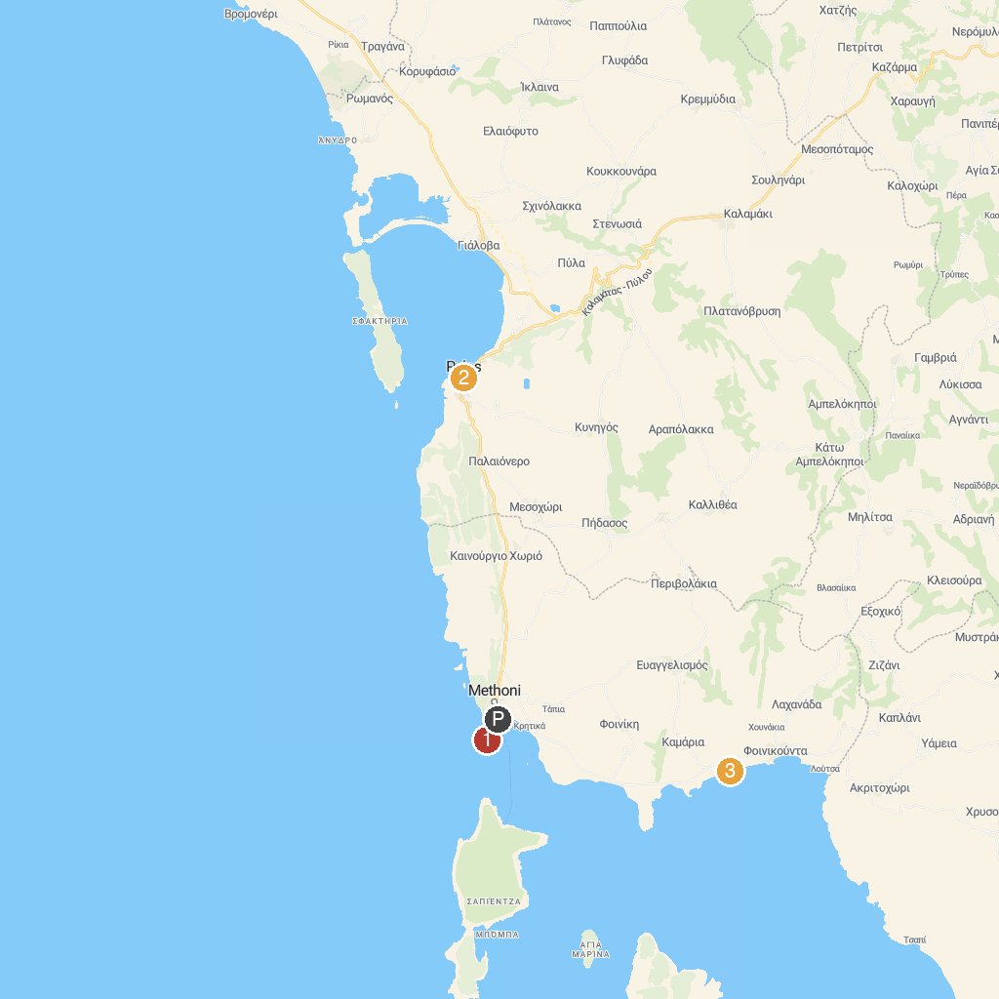
MAP KEY
1. Bourtzi of Methoni Castle | 3. Παραλία Μαυροβούνι
2. Pylos Central Square
P. Cruise port / terminal
Map © MapTiler © OpenStreetMap contributors · cruiseports.org

