Merzig, Saarland, Germany
A border-town gem on the Saar, where wolf howls drift from forest hillsides and crisp apple cider flows alongside Romanesque spires — a low-key river stop that surprises.
⚓ Docked (riverside pier) · 🕒 Typical call: 6–8 hrs · 💶 Euro (€) · 🗣️ German (French widely spoken near border)
✍️ MY DAY IN PORT (FILL IN)
Ship / Date
In port | arrive ______ · all aboard ______
Booked excursion
Notes / meeting point
GETTING ASHORE
- Docking: Ships berth directly at the Saarufer riverside pier — no tender required.
- Walk to center: Flat 10–15 min walk (~800 m) along the river path to the old town.
- Best For: Wolf sanctuary, Viez apple cider tasting, Saarschleife loop excursion.
- Don't Miss: Wolfspark Werner Freund and a glass of local Viez at a riverside Biergarten.
GETTING AROUND
- 🚕 Taxi: €5–€15 — Taxis are available near the port area. Short rides to the city center or nearby attractions run roughly €5–€15 using th
TOP THINGS TO DO
- Wolfspark Werner Freund — The world-famous wolf sanctuary founded by researcher Werner Freund houses packs of Arctic, European, and Canadian wolves.
- Saarschleife — Germany's Most Famous River Bend — The Saarschleife (Great Saar Loop) near Orscholz is a spectacular horseshoe bend carved by the Saar River, best seen from the…
- St. Peter's Church — Saarland's Largest Romanesque Church — Consecrated in 1205, this late-Romanesque basilica in the old town is the largest preserved Romanesque church in the Saarland…
- Viez Tasting & Old Town Stroll — Merzig calls itself the 'Viez Metropolis' — Viez is a tart, dry Saarland apple cider served in traditional stoneware mugs.
- Stadtpark & Saline Graduation Tower — A peaceful city park a short walk from the pier features a traditional Saline (graduation tower) where salty water trickles…
BEST WALKS
- Saarufer to Old Town: 800 m · 15 min · Flat · Easy — Follow the paved riverside path north from the pier past the Yachthafen marina and Brauhaus…
- Stadtpark & Saline Loop: 1.2 km · 20 min · Flat · Easy — From the old town, head west into the Stadtpark to find the Saline graduation tower — a quiet…
WEATHER · DAYLIGHT · MONEY
Month | High °F | Low °F | Rainy days
May | 62 | 46 | 12
Jul | 73 | 56 | 11
Sep | 66 | 51 | 9
Daylight: May 5:50AM–9:14PM · Jul 5:44AM–9:38PM · Sep 7:12AM–7:48PM
cruiseports.org/merzig · Confirm terminal & all-aboard time with your ship

Merzig, Saarland, Germany — Port Map
Red = walkable sights · Amber = excursions farther out · P = cruise terminal
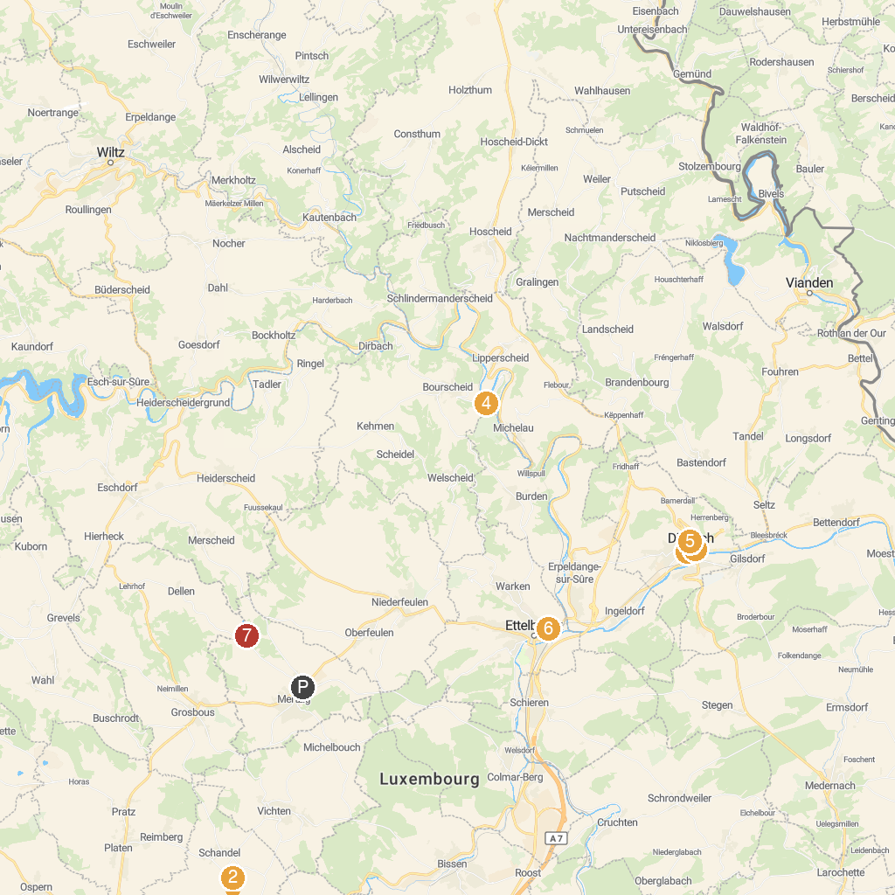
MAP KEY
1. Belvédère « Houfëls » | 5. Château de Bourscheid
2. Musée Automobile - Conservatoire National de Véhicules Historiques | 6. National Museum of Military History (MNHM) Asbl
3. Useldange Castle | 7. General Patton Museum
4. Musée d'Histoire(s) Diekirch | 8. Point de départ promenade Château de Turelbaach
P. Cruise port / terminal
Map © MapTiler © OpenStreetMap contributors · cruiseports.org

