Menton, French Riviera, France
Warmer, quieter, and more colourful than its famous neighbours, Menton blends French elegance with Italian soul — and practically has Monaco in its backyard.
⚓ Tender port · 🕒 Typical call: 6–8 hrs · 💶 Currency: Euro (€) · 🗣️ French / Italian spoken
✍️ MY DAY IN PORT (FILL IN)
Ship / Date
In port | arrive ______ · all aboard ______
Booked excursion
Notes / meeting point
GETTING ASHORE
- Docking: Tender to Quai Napoléon III, Vieux Port
- Walk to centre: 5 min (flat) to Old Town base; 15–20 min to hilltop
- Best For: Colourful Old Town, lemon culture, day trips to Monaco & Italy
- Don't Miss: Cemetery panorama, Jean Cocteau Bastion, Plage des Sablettes
GETTING AROUND
- 🚕 Taxi: €8 base + €2.54/km (day rate) — Metered taxis serve Menton with Alpes-Maritimes regulated fares. Day rate: €8 base (incl. 1.6 km) + €2.54/km; night/Sund
- 📱 Rideshare: ✅ Uber
TOP THINGS TO DO
- Menton Old Town & Hilltop Cemetery — Wind through terracotta alleys to the Baroque Basilique Saint-Michel Archange, then climb to the Cimetière du Vieux Château for…
- Jean Cocteau Museum & Bastion — The 17th-century harbour fort decorated personally by artist-filmmaker Jean Cocteau holds a museum dedicated to his work.
- Val Rahmeh Botanical Garden — A subtropical paradise sheltered by the Alps — giant water lilies, avocado trees, and rare specimens from around the world.
- Monaco Day Trip by Train — Board the regional train at Gare de Menton (20–25 min walk or taxi from port) and reach Monaco in 10 minutes.
- Ventimiglia Market & Italian Lunch — Jump the border to Ventimiglia, Italy (~15 min by train) for a Friday market, fresh pasta, and limoncello — a genuine…
BEST WALKS
- Old Town & Hilltop Loop: 2–3 hrs | Moderate | Cobblestones & stairs — From the Vieux Port, head to the Jean Cocteau Bastion, then enter the Old Town alleys, visit the…
- Promenade du Soleil Stroll: 1 hr | Easy | Flat seafront — A flat, scenic paved promenade stretching along the waterfront from the old port westward.
WEATHER · DAYLIGHT · MONEY
Month | High °F | Low °F | Rainy days
May | 70 | 58 | 9
Jul | 83 | 71 | 4
Sep | 77 | 65 | 7
Daylight: May 6:04AM–8:48PM · Jul 6:02AM–9:09PM · Sep 7:09AM–7:39PM
cruiseports.org/menton · Confirm terminal & all-aboard time with your ship

Menton, French Riviera, France — Port Map
Red = walkable sights · Amber = excursions farther out · P = cruise terminal
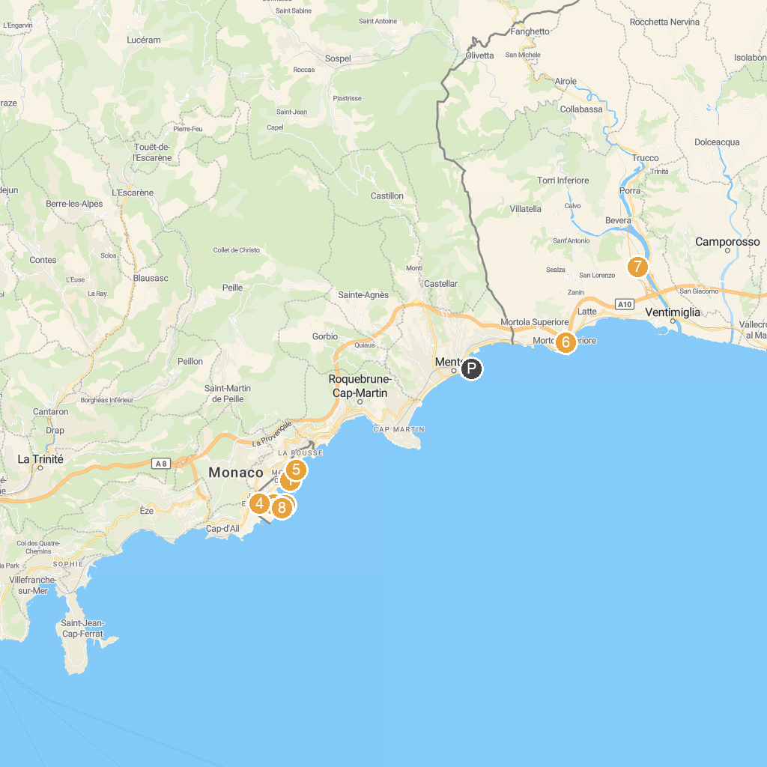
MAP KEY
1. Casino de Monte-Carlo | 5. Princess Grace Japanese Garden
2. Prince's Palace of Monaco | 6. Giardini Botanici Hanbury
3. Musée océanographique de Monaco | 7. Cactusmania By Manera di Manera Annarita
4. Exotic Garden of Monaco | 8. Jardins Saint-Martin
P. Cruise port / terminal
Map © MapTiler © OpenStreetMap contributors · cruiseports.org

