Memphis, Tennessee, USA
The Birthplace of Rock 'n' Roll and Home of the Blues greets river cruisers at a modern floating dock right at the foot of Beale Street — where legendary music, soul-deep barbecue, and powerful history converge on the Mississippi.
⚓ Docked (Beale Street Landing pier) · 🕒 Typical call: 8-10 hrs · 💵 US Dollar (USD) · 🗣️ English · 🎸 Music & culture destination
✍️ MY DAY IN PORT (FILL IN)
Ship / Date
In port | arrive ______ · all aboard ______
Booked excursion
Notes / meeting point
GETTING ASHORE
- Docking: Direct pier — Beale Street Landing floating dock (251 Riverside Dr); no tendering
- Walk to center: Beale Street 5 min (0.3 mi); National Civil Rights Museum 15-20 min (0.8 mi)
- Best For: Blues music, Southern BBQ, civil rights history, Graceland, Sun Studio
- Don't Miss: Peabody Duck March (11 AM or 5 PM) — arrive 30 min early for a good spot
GETTING AROUND
- 🚕 Taxi: $5–$10 — The riverfront terminal is right at the edge of downtown. A cab to Beale Street or any central attraction is a short, in
- 📱 Rideshare: ✅ Uber, Lyft
- 🚌 Hop-on hop-off: ✅ Memphis Hop
TOP THINGS TO DO
- Graceland — Home of Elvis Presley — Tour the King's mansion, custom-decorated jungle den and TV room, his twin-engine jet, and the vast automobile museum.
- National Civil Rights Museum at the Lorraine Motel — One of America's most powerful museums, built around the preserved Lorraine Motel where Dr.
- Sun Studio — Birthplace of Rock 'n' Roll — Step inside the tiny studio where Elvis, Johnny Cash, Jerry Lee Lewis, and Howlin' Wolf made their first recordings.
- Beale Street Historic District — Three blocks of flashing neon, blues clubs, and the Brass Note Walk of Fame — America's most iconic music street.
- Memphis Barbecue Crawl — Memphis dry-rub ribs are a food world unto themselves.
BEST WALKS
- Riverfront to Beale Street: 0.5 mi · 10-15 min · Easy — Walk up the landing ramp to Tom Lee Park, stroll along the newly revitalized riverfront greenway…
- Museum Mile — Beale Street to Civil Rights Museum: 0.8 mi · 15-20 min · Easy flat walk — From Beale Street head south on Main Street past the Memphis Rock 'n' Soul Museum (Beale & 3rd)…
- Downtown Loop: Peabody Duck March: 1.2 mi round trip · 20 min · Easy — Walk north on Main Street to the Peabody Hotel (149 Union Ave).
WEATHER · DAYLIGHT · MONEY
Month | High °F | Low °F | Rainy days
May | 80 | 62 | 12
Jul | 90 | 74 | 12
Sep | 85 | 67 | 6
Daylight: May 5:56AM–7:57PM · Jul 5:57AM–8:14PM · Sep 6:43AM–7:06PM
cruiseports.org/memphis-tn · Confirm terminal & all-aboard time with your ship

Memphis, Tennessee, USA — Port Map
Red = walkable sights · Amber = excursions farther out · P = cruise terminal
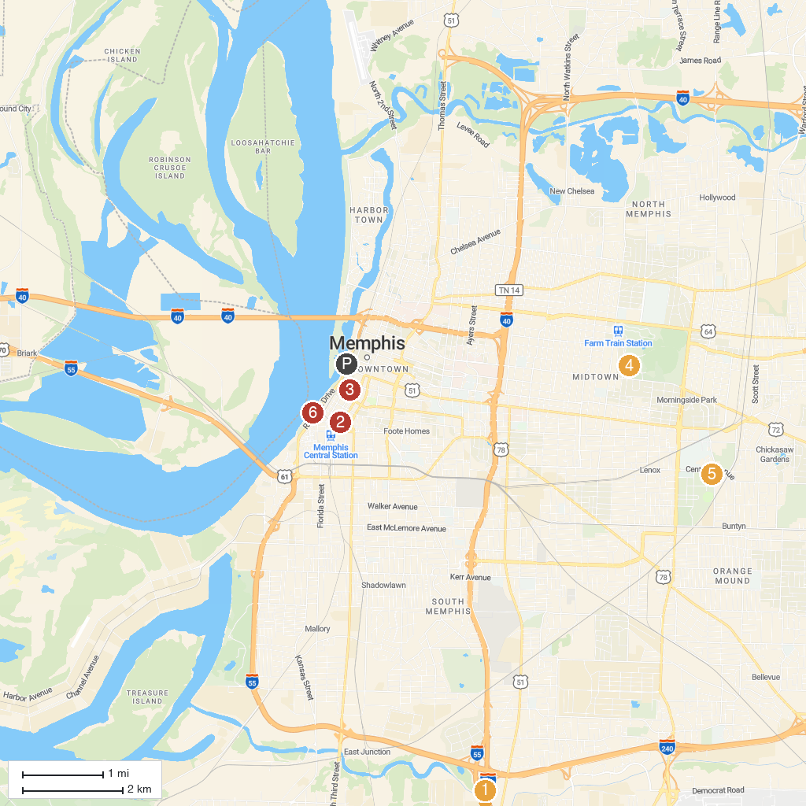
MAP KEY
1. Graceland | 5. Memphis Botanic Garden
2. National Civil Rights Museum | 6. Dixon Gallery & Gardens
3. Orpheum Theatre | 7. Children's Museum of Memphis
4. Memphis Brooks Museum of Art | 8. Tom Lee Park
P. Cruise port / terminal
Map © MapTiler © OpenStreetMap contributors · cruiseports.org

