Melun, Île-de-France, France
Once a royal Capetian capital on an island in the Seine, Melun punches well above its size — it sits minutes from the château that inspired Versailles, and it makes the finest Brie in France.
⚓ Docked (riverside quay) · 🕒 Typical call: 8–10 hrs · 💶 Currency: Euro (€) · 🗣️ Language: French · 🚂 Paris: 28 min by train
✍️ MY DAY IN PORT (FILL IN)
Ship / Date
In port | arrive ______ · all aboard ______
Booked excursion
Notes / meeting point
GETTING ASHORE
- Docking: Direct quay along the Seine — no tender
- Walk to center: 5–10 min across the bridge to Place Saint-Jean
- Best For: Château day-trips, French history, cheese & pastry
- Don't Miss: Château de Vaux-le-Vicomte (the château that created Versailles)
GETTING AROUND
- 🚕 Taxi: €8–€15 — Local taxis serve the port area. Short city-center trips run approximately €8–€11; a ride to Fontainebleau (~18 km) will
- 📱 Rideshare: ✅ Uber
TOP THINGS TO DO
- Château de Vaux-le-Vicomte — The baroque masterpiece that made Louis XIV so jealous he imprisoned its owner and hired the same trio of architect, decorator…
- Château de Fontainebleau — A royal palace inhabited by French monarchs from the 12th to 19th centuries and a favourite of Napoleon.
- Forest of Fontainebleau — 25,000 hectares of former royal hunting ground packed with sandstone boulders, marked hiking trails, and world-famous bouldering…
- Musée de la Gendarmerie Nationale — A surprisingly gripping modern museum tracing the history of France's military police from the Middle Ages to today — 2,000…
- Île Saint-Étienne & Collégiale Notre-Dame — The Roman-era island heart of Melun.
BEST WALKS
- Île Saint-Étienne Historic Loop: 1.5 km · 30 min · Flat — Cross from the quay onto the island, walk to Collégiale Notre-Dame de Melun, continue along the…
- Town Center & Saint-Aspais Walk: 2 km · 40 min · Flat — From the quay, cross to Place Saint-Jean for cafés and market stalls, then stroll to the Gothic…
WEATHER · DAYLIGHT · MONEY
Month | High °F | Low °F | Rainy days
May | 66 | 49 | 13
Jul | 78 | 60 | 8
Sep | 71 | 55 | 8
Daylight: May 6:08AM–9:23PM · Jul 6:03AM–9:46PM · Sep 7:26AM–8:01PM
cruiseports.org/melun · Confirm terminal & all-aboard time with your ship

Melun, Île-de-France, France — Port Map
Red = walkable sights · Amber = excursions farther out · P = cruise terminal
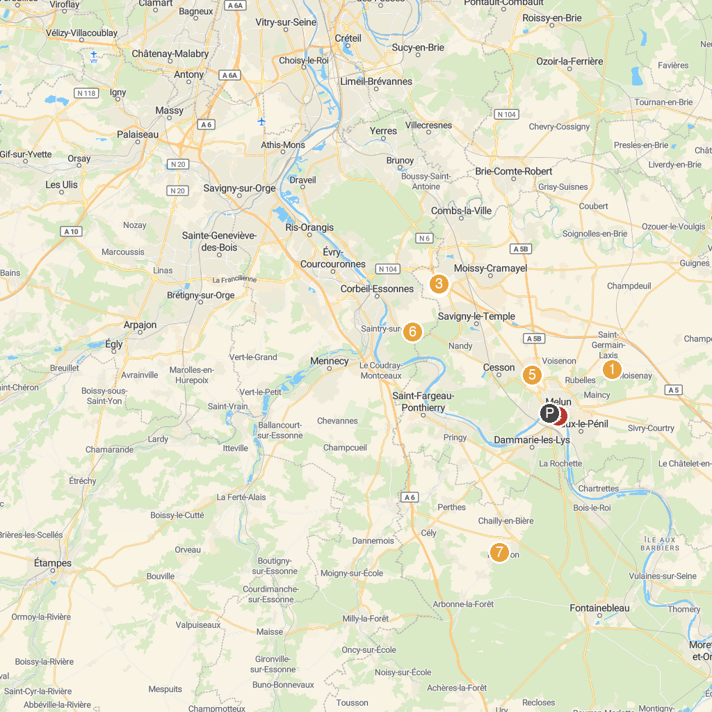
MAP KEY
1. Tour Denecourt Fontainebleau | 5. Collegiate Church of Notre-Dame
2. Château de Vaux-le-Vicomte | 6. Lasergame Vert-Saint-Denis Evolution
3. Gulli Parc Carré Sénart | 7. Winnoland
4. Koezio Sénart | 8. Musée départemental des peintres de Barbizon
P. Cruise port / terminal
Map © MapTiler © OpenStreetMap contributors · cruiseports.org

