Mělník, Czech Republic
Perched on a vineyard hill above the confluence of the Elbe and Vltava rivers, Mělník is a Bohemian wine town crowned by a Lobkowicz château — a relaxed, scenic stop just 35 km downstream from Prague.
🚢 River port (ship ties up dockside) · 🕒 Typical call: half to full day · 💵 Czech Koruna (CZK) — cards widely accepted · 🗣️ Czech / English common in tourist sites · 🍷 Bohemian wine region
✍️ MY DAY IN PORT (FILL IN)
Ship / Date
In port | arrive ______ · all aboard ______
Booked excursion
Notes / meeting point
GETTING ASHORE
- Getting There: Ship docks on the Elbe at Mělník; the old town sits on the hill above the landing
- Walk to Center: ~10-15 min uphill from the riverside landing to the château and town square
- Best For: Wine tasting, Baroque château, river views, easy day trips to Prague
- Don't Miss: Mělník Château terrace over the river confluence & a tasting of Ludmila wine
GETTING AROUND
- 🚕 Taxi: 80–130 CZK (~–6 USD) — Local taxis charge roughly 24 CZK/km plus a 30 CZK start fee. The port to the town center is only 2–4 km, making any tax
- 📱 Rideshare: ✅ Bolt
TOP THINGS TO DO
- Mělník Château (Lobkowicz) — The Baroque château crowning the town has been the seat of the Lobkowicz family, returned to them in 1992 after nationalisation.
- Château Wine Cellars & Tasting — Beneath the château run historic cellars that store the estate's Bohemian wines.
- Church of Sts. Peter and Paul & Confluence View — Beside the château stands the Gothic Church of Sts.
- Day Trip to Prague — Just ~35 km upstream, Prague is an easy coach excursion from Mělník.
BEST WALKS
- Château Hill & Old Town Walk: ~1.5 km · 30-45 min · uphill cobblestones — From the riverside landing, climb the vineyard slope to the château and the Church of Sts.
- Vineyard Slopes Stroll: ~1 km · 20-30 min · gentle slope — Wander the terraced vineyards below the château — including the St.
WEATHER · DAYLIGHT · MONEY
Month | High °F | Low °F | Rainy days
May | 67 | 48 | 10
Jul | 79 | 60 | 11
Sep | 70 | 53 | 8
Daylight: May 5:16AM–8:41PM · Jul 5:07AM–9:09PM · Sep 6:36AM–7:19PM
cruiseports.org/melnik · Confirm terminal & all-aboard time with your ship

Mělník, Czech Republic — Port Map
Red = walkable sights · Amber = excursions farther out · P = cruise terminal
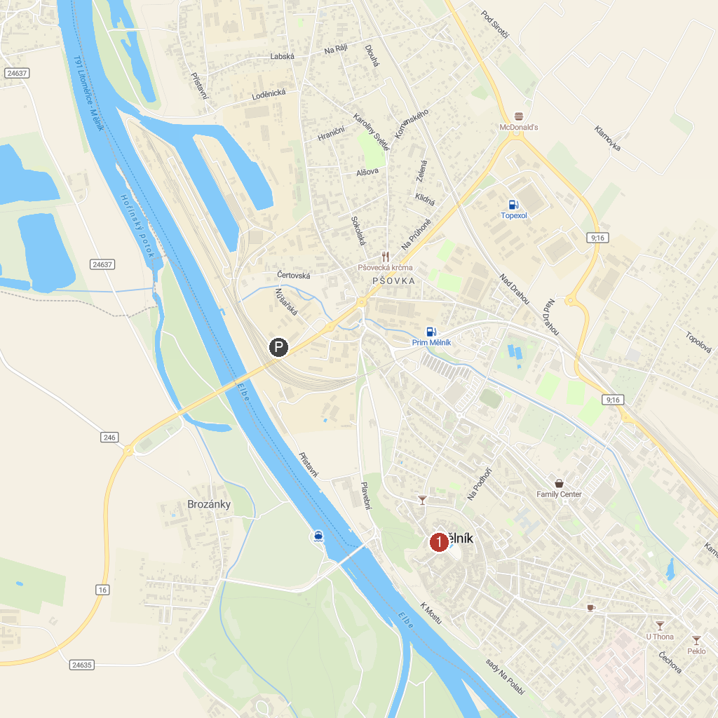
MAP KEY
1. Mělnické podzemí | 5. The Rotunda of St. George and St. Adalbert on Mount Rip
2. Pavilon Přátelství | 6. Kostel sv. Klimenta
3. Dančí obora | 7. Pokličky
4. Laudon's pavilion | 8. Kokořín Castle
P. Cruise port / terminal
Map © MapTiler © OpenStreetMap contributors · cruiseports.org

