Melilla, Melilla, Spain
A Spanish city on African soil — Melilla blends Andalusian tapas culture with Moroccan souks, Gaudí-inspired buildings, and a sea fortress unlike anything else in the Med.
⚓ Pier (docked) · 🕒 Typical call: 6-8 hrs · 💶 Euro (€) · 🗣️ Spanish · 🏛️ Modernist architecture
✍️ MY DAY IN PORT (FILL IN)
Ship / Date
In port | arrive ______ · all aboard ______
Booked excursion
Notes / meeting point
GETTING ASHORE
- Docking: Pier at Puerto de Melilla — no tender required
- Walk to center: ~10-15 min (800 m) to Plaza de España
- Best For: Architecture, history, multicultural food, beaches
- Don't Miss: Melilla la Vieja fortress and the Modernist Golden Triangle
GETTING AROUND
- 🚕 Taxi: €5–€9 — Metered taxis wait at the port and are inexpensive for the short ride to the city center; fares are per vehicle (up to 4
TOP THINGS TO DO
- Melilla la Vieja — the Sea Fortress — This massive multi-tiered citadel juts into the sea and dates largely from the 16th–17th centuries (Spain took Melilla in 1497).
- Modernist Golden Triangle — Melilla has the second-largest concentration of Art Nouveau architecture in Spain after Barcelona.
- Route of the Four Temples — In one 15-minute radius, visit a Catholic church, a mosque, a synagogue, and a Hindu temple — Melilla's four communities have…
- City Beaches — Playa de los Cárabos and Playa de San Lorenzo stretch south from the port along a wide boardwalk.
- Tapas & Moroccan Fusion Lunch — Melilla follows the southern Spanish tradition: order a drink, get a free tapa.
BEST WALKS
- Pier to Fortress Walk: 1.5 km · ~20 min · Easy — From the cruise pier, walk along the waterfront to the base of Melilla la Vieja.
- Modernist Architecture Stroll: 1.5 km loop · ~45 min · Easy — From Plaza de España, loop through the Triángulo de Oro — the Golden Triangle of Art Nouveau…
WEATHER · DAYLIGHT · MONEY
Month | High °F | Low °F | Rainy days
May | 73 | 62 | 5
Jul | 84 | 72 | 0
Sep | 80 | 70 | 5
Daylight: May 7:07AM–9:08PM · Jul 7:08AM–9:26PM · Sep 7:54AM–8:18PM
cruiseports.org/melilla · Confirm terminal & all-aboard time with your ship

Melilla, Melilla, Spain — Port Map
Red = walkable sights · Amber = excursions farther out · P = cruise terminal
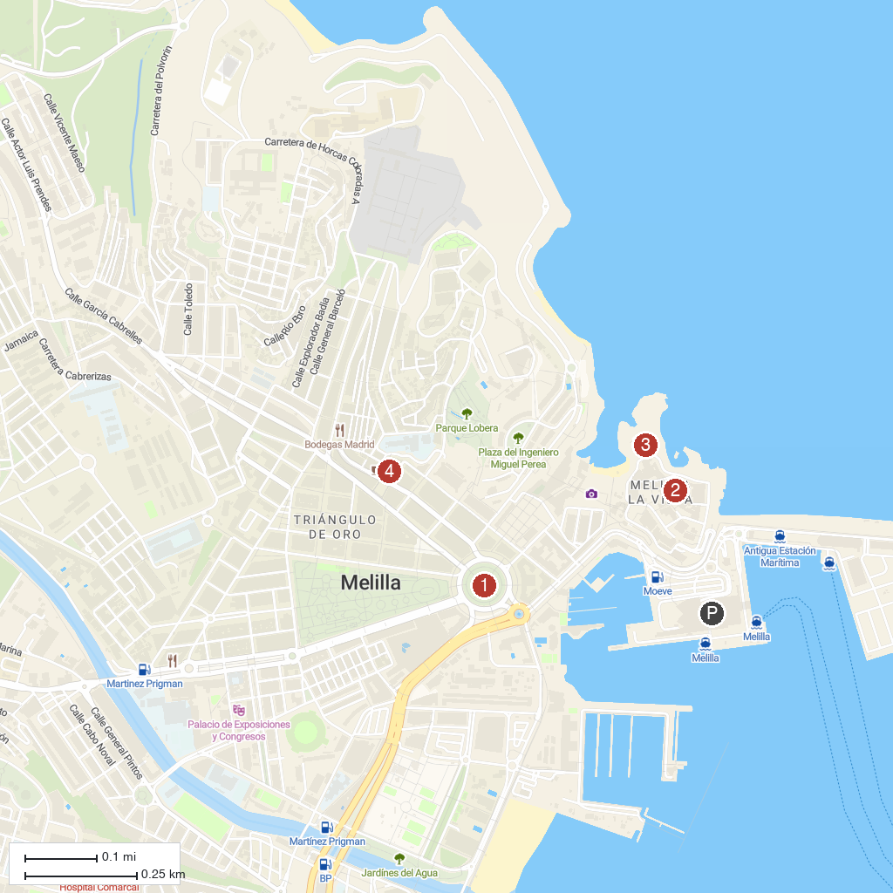
MAP KEY
1. Plaza de España | 3. Museo Militar
2. Melilla la Vieja | 4. Iglesia del Sagrado Corazon de Jesus
P. Cruise port / terminal
Map © MapTiler © OpenStreetMap contributors · cruiseports.org

