Melbourne, Victoria, Australia
Australia's cultural capital rewards cruise visitors with brilliant food, vibrant street art, and easy tram access to world-class museums — all from a purpose-built terminal just minutes from the CBD.
⚓ Docked — Station Pier · 🕒 Typical call: 8–10 hrs · 💵 Australian Dollar (AUD) · 🗣️ English
✍️ MY DAY IN PORT (FILL IN)
Ship / Date
In port | arrive ______ · all aboard ______
Booked excursion
Notes / meeting point
GETTING ASHORE
- Docking: Station Pier, Port Melbourne — ships dock directly, no tender
- Walk to centre: ~4.5 km / 2.8 mi; Route 109 tram in ~20 min
- Best For: City culture, street art, wildlife, regional wine & coastal scenery
- Don't Miss: Hosier Lane street art, Queen Victoria Market, Federation Square
GETTING AROUND
- 🚕 Taxi: A$16–25 — Taxis available directly outside Station Pier. Journey to city center takes 7–15 min depending on traffic.
- 📱 Rideshare: ✅ Uber
- 🚌 Hop-on hop-off: ✅
TOP THINGS TO DO
- Melbourne City Highlights & Laneways — Explore Federation Square, Melbourne's famous street-art laneways (Hosier Lane, Croft Alley), the historic Queen Victoria Market…
- Wildlife Encounter — Moonlit Sanctuary or Werribee Zoo — See kangaroos, wallabies, koalas, and Tasmanian devils up close.
- Great Ocean Road & Twelve Apostles — One of the world's great coastal drives.
- Yarra Valley Wine & Gourmet Food — Victoria's oldest wine region is around an hour from the city.
- Sovereign Hill Gold Rush, Ballarat — An open-air living museum in Ballarat (~90 min west) recreating the 1850s Victorian gold rush — pan for gold, watch a gold pour…
BEST WALKS
- Bay Trail: Station Pier to St Kilda: ~6 km one-way | ~70 min | Flat, paved path — Follow the sealed Bay Trail south-east from the pier along Port Phillip Bay, passing Lagoon Pier…
- CBD Laneways Walking Loop: 3 km loop | ~90 min with stops | Flat city streets — Take the #109 tram to the Free Tram Zone, then walk: Federation Square → Flinders Street Station →…
WEATHER · DAYLIGHT · MONEY
Month | High °F | Low °F | Rainy days
May | 61 | 48 | 11
Jul | 56 | 44 | 12
Sep | 62 | 46 | 12
Daylight: May 7:13AM–5:19PM · Jul 7:32AM–5:19PM · Sep 6:21AM–6:10PM
cruiseports.org/melbourne · Confirm terminal & all-aboard time with your ship

Melbourne, Victoria, Australia — Port Map
Red = walkable sights · Amber = excursions farther out · P = cruise terminal
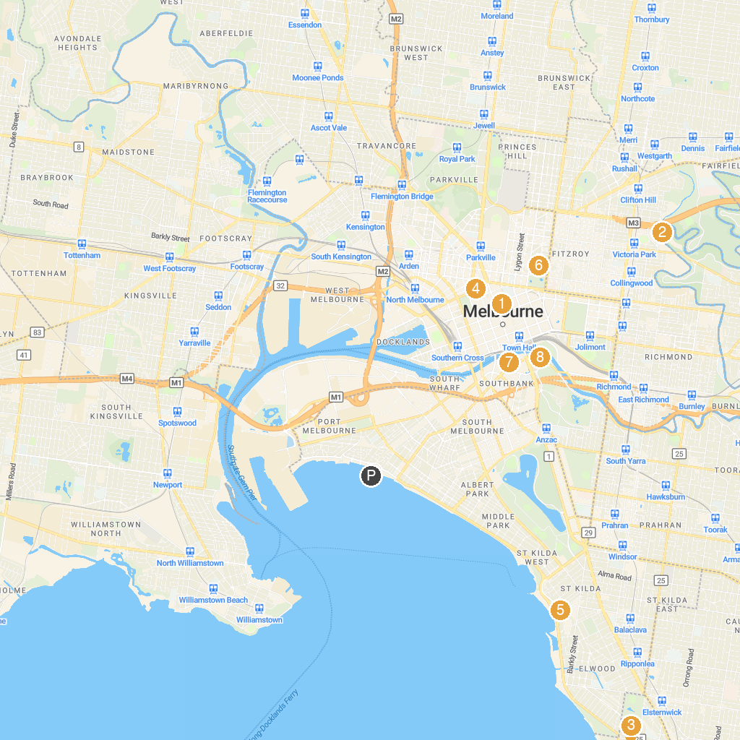
MAP KEY
1. Shot Tower Museum | 5. Luna Park Melbourne
2. Dights Falls | 6. Melbourne Museum
3. Elsternwick Park | 7. Melbourne Skydeck
4. Queen Victoria Market | 8. Alexandra Gardens
P. Cruise port / terminal
Map © MapTiler © OpenStreetMap contributors · cruiseports.org

