Meissen, Saxony, Germany
Where European porcelain was born and a Gothic castle still lords over the Elbe. Meissen rewards even a half-day stop with history, cobblestones, and Saxony's finest wine.
⚓ Pier (docked) · 🕒 Typical call: 6-8 hrs · 💶 Currency: Euro (€) · 🗣️ Language: German
✍️ MY DAY IN PORT (FILL IN)
Ship / Date
In port | arrive ______ · all aboard ______
Booked excursion
Notes / meeting point
GETTING ASHORE
- Docking: Pier on Elbe left bank (Uferstraße); no tender required
- Walk to centre: ~500 m (5–7 min) to Marktplatz; 15–20 min uphill to castle
- Best For: History, porcelain, Saxon wine, scenic river views
- Don't Miss: Albrechtsburg Castle + Dom, and the Porcelain Manufactory workshop tour
GETTING AROUND
- 🚕 Taxi: ~€4.50–€7 (base + short distance) — Local taxis serve Meissen with a ~€4.50 base fare plus €2.50/km (day rate). Given the port's proximity to the old town,
- 📱 Rideshare: ❌ not available
- 🚌 Hop-on hop-off: ✅
TOP THINGS TO DO
- Albrechtsburg Castle & Cathedral — Germany's first residential palace (late 15th century) stands shoulder-to-shoulder with the Gothic Meissen Cathedral on Castle…
- Meissen Porcelain Manufactory Tour — The birthplace of European porcelain (founded 1710).
- Marktplatz & Frauenkirche Porcelain Carillon — The medieval market square is ringed by colourful Renaissance townhouses and the late-Gothic Town Hall.
- Saxon Wine & Meissner Fummel — Meissen sits at the heart of Saxony's wine route.
BEST WALKS
- Riverside to Castle Hill Loop: 3–4 km · 1.5–2 hrs · Moderate (steep uphill) — From the pier, walk the Elbe promenade north to the Marktplatz.
- Manufactory Walk: ~2 km one-way · 20 min flat — Follow Uferstraße south from the pier along the Elbe to the Staatliche Porzellan-Manufaktur Meissen.
WEATHER · DAYLIGHT · MONEY
Month | High °F | Low °F | Rainy days
May | 65 | 48 | 9
Jul | 77 | 60 | 11
Sep | 69 | 53 | 9
Daylight: May 5:15AM–8:50PM · Jul 5:08AM–9:14PM · Sep 6:41AM–7:19PM
cruiseports.org/meissen · Confirm terminal & all-aboard time with your ship

Meissen, Saxony, Germany — Port Map
Red = walkable sights · Amber = excursions farther out · P = cruise terminal
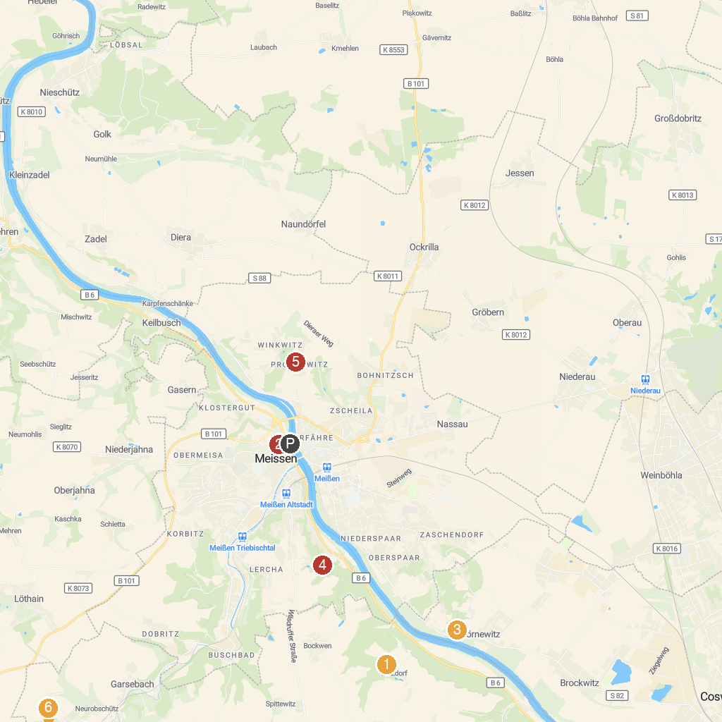
MAP KEY
1. Lügenmuseum | 5. Boselgarten
2. Moritzburg Castle | 6. Schloss Siebeneichen
3. Batzdorf Castle | 7. Schloss Proschwitz
4. Albrechtsburg Castle | 8. Altes Kalkbergwerk Miltitz
P. Cruise port / terminal
Map © MapTiler © OpenStreetMap contributors · cruiseports.org

