Meaux, Île-de-France, France
The 'City of Bishops' on the Marne delivers a medieval cathedral, world-famous cheese, Roman ramparts, and the largest Great War museum in Europe — all within a short walk of the quay.
⚓ Docked — river quay (no tender) · 🕒 Typical call: 6–8 hrs · 💶 Currency: Euro (€) · 🗣️ Language: French · 🧀 Famous for Brie de Meaux AOC
✍️ MY DAY IN PORT (FILL IN)
Ship / Date
In port | arrive ______ · all aboard ______
Booked excursion
Notes / meeting point
GETTING ASHORE
- Docking: Direct alongside at Quai Jacques Prévert / Quai Sadi Carnot on the Marne — no tender
- Walk to centre: 5–10 min flat walk to Cathedral & Jardin Bossuet
- Best For: History lovers, foodies, day-trippers to Paris (~35 min by train)
- Don't Miss: Brie de Meaux tasting + Musée de la Grande Guerre (WWI museum)
GETTING AROUND
- 🚕 Taxi: ~€8 minimum — Taxis are available near the port. The dock is so central that most rides to town attractions will register only the min
- 📱 Rideshare: ✅ Uber
TOP THINGS TO DO
- Musée de la Grande Guerre — The largest WWI museum in Europe sits just outside Meaux, on the ground where the First Battle of the Marne was fought in 1914.
- Cathédrale Saint-Étienne & Episcopal Quarter — A masterpiece of Gothic architecture built from the 12th to 16th centuries, the cathedral contains the tomb of bishop-orator…
- Brie de Meaux Tasting & Maison du Brie — Meaux is the birthplace of the 'King of Cheeses'.
- Musée Bossuet (Episcopal Palace) — Occupying the 12th-century Bishop's Palace beside the cathedral, this museum displays 17th- and 18th-century paintings…
- Day Trip to Paris by Train — Meaux's train station is 10 minutes from the dock.
BEST WALKS
- Episcopal Quarter Loop: 1.5 km · 25–30 min · Flat · Historic — From the Marne quay, walk up to Place Henri IV, then to Cathédrale Saint-Étienne, through Jardin…
- Marne Riverside & Parc du Pâtis: 2–3 km · 40 min · Flat · Nature — Head downstream (south) along the Marne towpath to reach Parc Naturel du Pâtis — a 150-hectare park…
WEATHER · DAYLIGHT · MONEY
Month | High °F | Low °F | Rainy days
May | 65 | 49 | 12
Jul | 77 | 60 | 9
Sep | 71 | 55 | 8
Daylight: May 6:06AM–9:24PM · Jul 6:01AM–9:47PM · Sep 7:25AM–8:00PM
cruiseports.org/meaux · Confirm terminal & all-aboard time with your ship

Meaux, Île-de-France, France — Port Map
Red = walkable sights · Amber = excursions farther out · P = cruise terminal
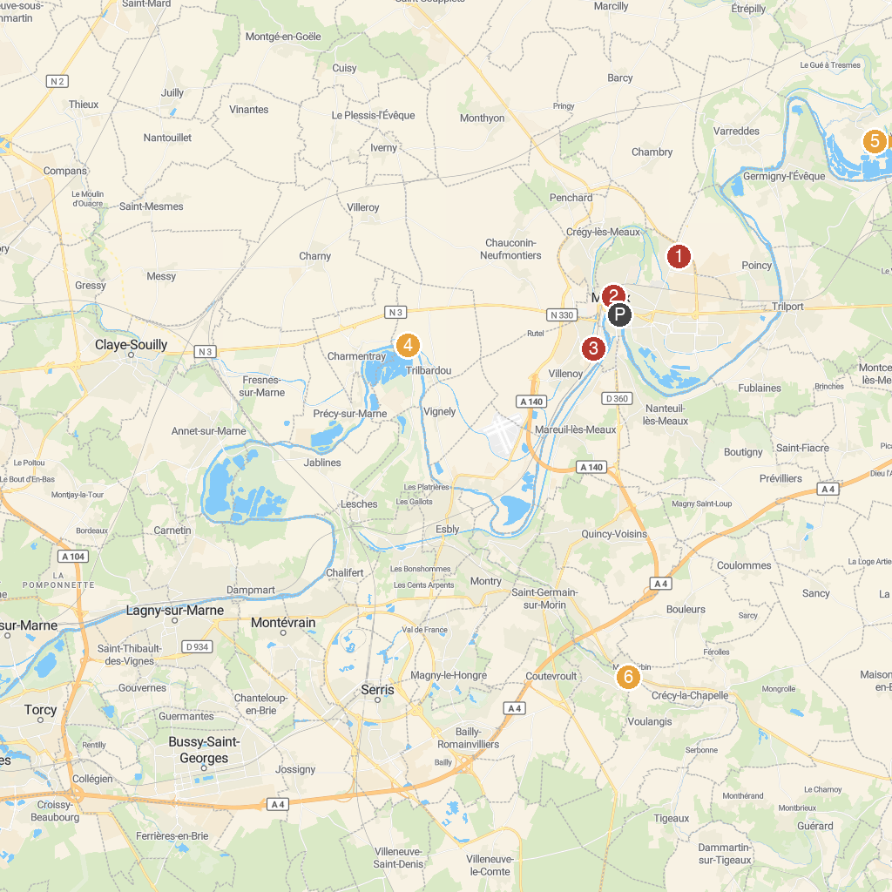
MAP KEY
1. SEA LIFE Val d'Europe | 5. Trilbardou Lift Plant
2. Museum of the Great War in Meaux | 6. Pumping station at Villers-lès-Rigault
3. Bossuet Garden of Meaux | 7. Moulin Jaune
4. Gulli Parc Meaux | 8. Disneyland Railroad - Discoveryland Station
P. Cruise port / terminal
Map © MapTiler © OpenStreetMap contributors · cruiseports.org

