Mazatlán, Sinaloa, Mexico
Mexico's Pearl of the Pacific delivers the full package: a beautifully restored colonial old town, sweeping malecón walks, island beaches a short boat ride away, and one of the world's highest natural lighthouses looming over it all.
⚓ Pier (docked) · 🕒 Typical call: 7-9 hrs · 💵 Mexican Peso (USD accepted but peso better) · 🗣️ Spanish (some English in tourist zones)
✍️ MY DAY IN PORT (FILL IN)
Ship / Date
In port | arrive ______ · all aboard ______
Booked excursion
Notes / meeting point
GETTING ASHORE
- Docking: Commercial pier — ships dock directly, no tender required
- Walk to center: ~20 min on foot following Blue Line, or 10-min taxi
- Best For: Colonial history, beach days, pulmonia rides, seafood
- Don't Miss: Plazuela Machado, El Faro hike, Stone Island boat trip
GETTING AROUND
- 🚕 Taxi: $8–$12 USD — Fixed-rate taxis wait at the cruise terminal. Agree on the fare before departing — drivers do not use meters. Cash (USD
- 📱 Rideshare: ✅ Uber, Bolt, DiDi
TOP THINGS TO DO
- Old Mazatlán & Plazuela Machado — Stroll cobblestone streets past restored 19th-century facades to Plazuela Machado — the lively heart of the historic district…
- El Faro Lighthouse Hike — Hike 1.4 miles up Cerro del Crestón to one of the highest natural lighthouses in the world.
- Stone Island (Isla de la Piedra) — A short panga (boat) ride from the port lands you on a long, uncrowded beach.
- Deer Island (Isla de Venados) — Part of an ecological reserve, Deer Island has clear water for snorkeling and unspoiled beaches.
- Cliff Divers & Malecón — Watch local divers plunge into the Pacific from the rocky shoreline — a Mazatlán tradition.
BEST WALKS
- Blue Line: Port to Plazuela Machado: 1.5 km · 20 min · Flat — Follow the blue tile line embedded in the pavement from the cruise terminal gate through the city…
- Historic Center Loop: 2 km · 45-60 min · Easy (cobblestones) — From Plazuela Machado, walk to the Angela Peralta Theater (just off the plaza), then north to the…
WEATHER · DAYLIGHT · MONEY
Month | High °F | Low °F | Rainy days
May | 85 | 69 | 0
Jul | 88 | 78 | 12
Sep | 87 | 77 | 19
Daylight: May 5:24AM–6:39PM · Jul 5:29AM–6:54PM · Sep 5:52AM–6:08PM
cruiseports.org/mazatlan · Confirm terminal & all-aboard time with your ship

Mazatlán, Sinaloa, Mexico — Port Map
Red = walkable sights · Amber = excursions farther out · P = cruise terminal
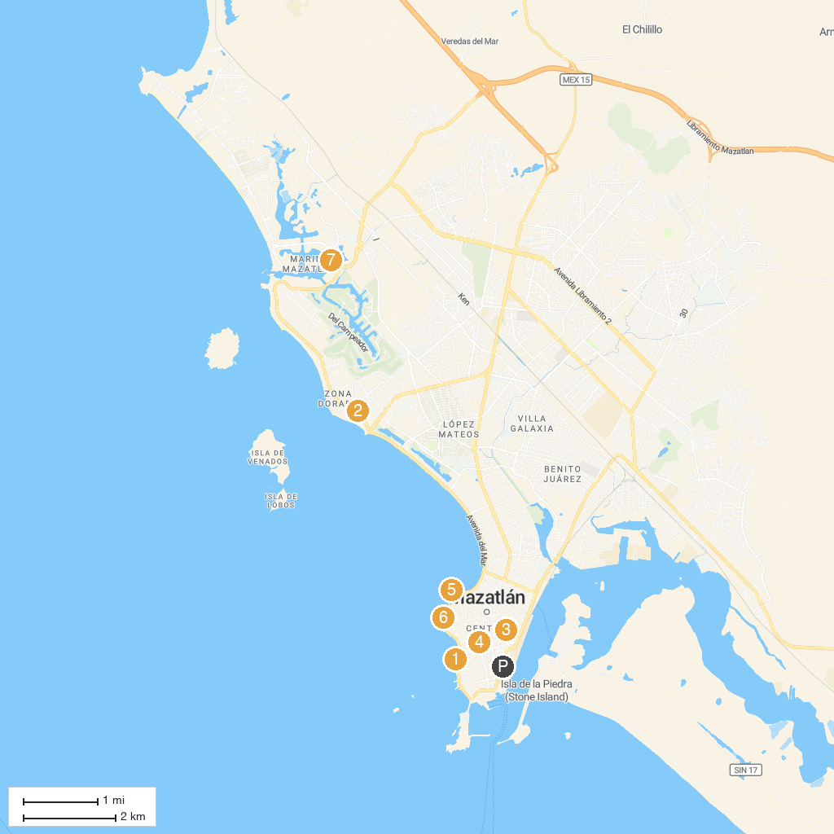
MAP KEY
1. Monumento a Pedro Infante | 5. Casa del Marino
2. Casino MonteCarlo | 6. Malecón de Mazatlán
3. Museo El Rincón de Pedro Infante | 7. Bibi Fleet Sportfishing - Pesca Deportiva
4. Nidart | 8. Mazagua Water Park
P. Cruise port / terminal
Map © MapTiler © OpenStreetMap contributors · cruiseports.org

