Matsuyama, Ehime, Japan
Capital of Ehime Prefecture and Shikoku's largest city, Matsuyama pairs one of Japan's last original feudal castles with the ancient hot springs that inspired Studio Ghibli's Spirited Away — a rare port where history soaks right into the pavement.
⚓ Pier (Matsuyama Gaiko) · 🕒 Typical call: 8-10 hrs · 💴 Japanese Yen (JPY) — carry cash · 🗣️ Japanese (some English at tourist sites) · 🚃 Vintage streetcar network in city
✍️ MY DAY IN PORT (FILL IN)
Ship / Date
In port | arrive ______ · all aboard ______
Booked excursion
Notes / meeting point
GETTING ASHORE
- Docking: Pier — Matsuyama Outer Port (Gaiko), ~8 km west of city center
- Walk to center: Not walkable; shuttle bus or taxi to Okaido (~15–20 min, ¥3,000–4,000)
- Best For: Culture, history, hot springs, Japanese street food, castle views
- Don't Miss: Dogo Onsen Honkan (fully reopened July 2024) and Matsuyama Castle ropeway
GETTING AROUND
- 🚕 Taxi: ¥2,490–¥3,220 — Taxis are readily available at the port and take 20–25 minutes to the city center. Fares range from ¥2,490 to JR Matsuya
- 📱 Rideshare: ✅ Uber
TOP THINGS TO DO
- Matsuyama Castle & Ropeway — One of only 12 original castles surviving in Japan (built 1854), Matsuyama Castle crowns Mount Katsuyama with panoramic views of…
- Dogo Onsen Honkan — Japan's oldest hot spring bathhouse (1894), Dogo Onsen is said to have inspired the bathhouse in Spirited Away.
- Ishite-ji Temple & Pilgrimage Cave — Temple #51 on the famous Shikoku 88-Temple Pilgrimage, Ishite-ji features a National Treasure Niomon gate and a 200-meter cave…
- Taimeshi & Jakoten Food Walk — Ehime's signature dishes: taimeshi (sea bream rice, Matsuyama style cooked in a clay pot, or Uwajima style with raw sea bream…
- Botchan Train & Karakuri Clock — Ride the charming diesel replica of a retro steam tram (the 'Botchan Ressha') between Matsuyama City Station and Dogo Onsen.
BEST WALKS
- Castle to Dogo Onsen by Tram: 2–3 hrs | Easy | Tram + walking — From Matsuyama City Station, walk to the castle ropeway base, ride up, explore the castle, then…
- Dogo Onsen to Ishite-ji Temple: 30 min walk | Easy | Free — From Dogo Onsen Station, walk east along the pilgrimage route to Ishite-ji Temple (about 15 min on…
WEATHER · DAYLIGHT · MONEY
Month | High °F | Low °F | Rainy days
May | 72 | 59 | 10
Jul | 84 | 75 | 16
Sep | 82 | 71 | 13
Daylight: May 5:08AM–7:02PM · Jul 5:09AM–7:20PM · Sep 5:52AM–6:15PM
cruiseports.org/matsuyama · Confirm terminal & all-aboard time with your ship

Matsuyama, Ehime, Japan — Port Map
Red = walkable sights · Amber = excursions farther out · P = cruise terminal
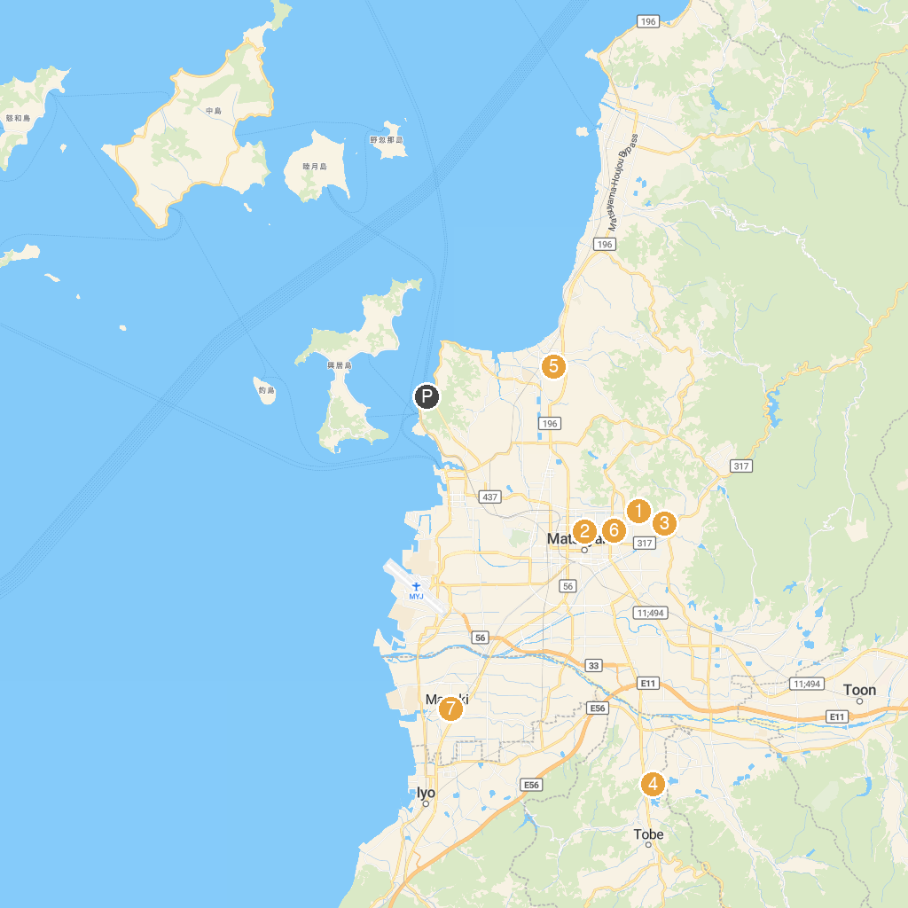
MAP KEY
1. Dogo Onsen Main Building | 5. Miurart Village Art Museum
2. Matsuyama Castle | 6. Ehime pref. Life and Culture Center
3. Ishite Temple | 7. Masaki Park
4. Tobe Zoological Park
P. Cruise port / terminal
Map © MapTiler © OpenStreetMap contributors · cruiseports.org

