Matarani, Arequipa, Peru
An industrial cargo port on Peru's arid Pacific coast, Matarani punches above its weight as the gateway to Arequipa — the 'White City' of volcanic sillar stone — and the world-famous Colca Canyon condor flights.
⚓ Docked (TISUR pier) · 🕒 Typical call: 8-10 hrs · 💵 Peruvian Sol (PEN) · 🗣️ Spanish · 🏔️ Altitude: Arequipa at 7,660 ft
✍️ MY DAY IN PORT (FILL IN)
Ship / Date
In port | arrive ______ · all aboard ______
Booked excursion
Notes / meeting point
GETTING ASHORE
- Docking: Pier — TISUR industrial wharf; shuttle bus to port gate required
- Walk to center: Not walkable — mandatory shuttle to Mollendo (25 min) or taxi to Arequipa (2–2.5 hrs)
- Best For: Arequipa's colonial architecture, Santa Catalina Monastery, Colca Canyon condors
- Don't Miss: Chupe de camarones (river prawn chowder) — the signature dish of Arequipa
GETTING AROUND
- 🚕 Taxi: $7–$10 USD — Quick 10-minute ride to Mollendo city center (~13 km). Always negotiate the fare upfront; taxis here do not use meters.
TOP THINGS TO DO
- Arequipa & Santa Catalina Monastery — The 'White City' is built almost entirely from white sillar volcanic stone.
- Juanita the Ice Maiden — Museo Santuarios Andinos — View the remarkably preserved 15th-century mummy of a young Inca girl sacrificed on Mount Ampato.
- Mejía Lagoons — Coastal Bird Sanctuary — A rare wetland oasis in the coastal desert, just 45 minutes south of the port.
- Mollendo Beach & Castillo de Forga — The closest option to the port — a coastal resort town 25 minutes away.
- Colca Canyon — Condor Viewpoint — One of the world's deepest canyons and the best place on Earth to watch Andean condors soar on thermals at Cruz del Condor…
BEST WALKS
- Mollendo Clifftop & Beach Walk: ~1.5 km · Easy · 30–45 min — From Mollendo's Plaza de Armas, walk downhill to the beachfront promenade and along the cliffs…
- Arequipa: Plaza de Armas to Santa Catalina: ~0.8 km · Easy · 10-min walk — Start at Arequipa's dazzling Plaza de Armas — flanked by the Basilica Cathedral and the Jesuit…
WEATHER · DAYLIGHT · MONEY
Month | High °F | Low °F | Rainy days
May | 73 | 62 | 0
Jul | 73 | 61 | 0
Sep | 73 | 62 | 0
Daylight: May 6:11AM–5:33PM · Jul 6:23AM–5:40PM · Sep 5:51AM–5:51PM
cruiseports.org/matarani · Confirm terminal & all-aboard time with your ship

Matarani, Arequipa, Peru — Port Map
Red = walkable sights · Amber = excursions farther out · P = cruise terminal
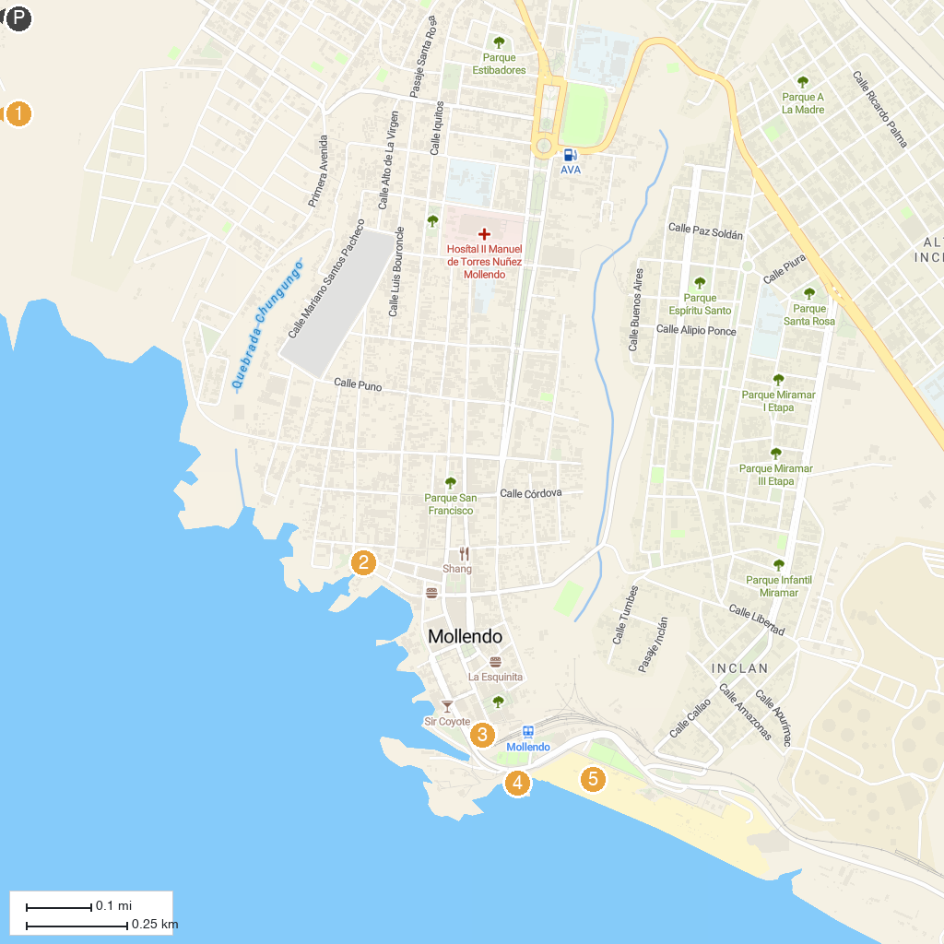
MAP KEY
1. Playa “Catarindo” | 4. Aquatic Park Mollendo
2. Aguadita | 5. Primera Playa
3. Malecón Ratti
P. Cruise port / terminal
Map © MapTiler © OpenStreetMap contributors · cruiseports.org

