Martigues, Provence, France
Painted fishermen's houses mirrored in still canals, baroque church facades, and a sun-drenched harbor — Martigues earns its nickname as the Venice of Provence. It's a compact, walkable town where river-cruise passengers step straight into an authentic Provençal rhythm.
⚓ Pier (river/small cruise vessels) · 🕒 Typical call: 6–8 hrs · 💵 Euro (€) · 🗣️ French
✍️ MY DAY IN PORT (FILL IN)
Ship / Date
In port | arrive ______ · all aboard ______
Booked excursion
Notes / meeting point
GETTING ASHORE
- Docking: Pier near Louis Sammut Avenue, behind Town Hall (river & small cruise ships)
- Walk to Center: Pier is steps from the historic l'Ile district — 2–5 min on foot
- Best For: Canal strolls, Provençal markets, Côte Bleue beaches
- Don't Miss: Miroir aux Oiseaux quayside & Église de la Madeleine baroque facade
GETTING AROUND
- 🚕 Taxi: €8–15 — Local taxis operate on Bouches-du-Rhône department tariffs (base ~€8, ~€2.20/km). Short in-town trips fall near the mini
- 📱 Rideshare: ✅ Uber
- 🚌 Hop-on hop-off: ✅
TOP THINGS TO DO
- Canal Quarter Walking Tour — Wander all three historic districts — l'Ile, Jonquières, and Ferrières.
- Côte Bleue Boat Trip — Cruise the dramatic limestone cliffs and hidden calanques of the Côte Bleue, stopping at the fishing villages of Carro, La…
- Fort de Bouc Guided Tour — Explore the medieval fortification that has served as a state prison, lighthouse, and military post — perched at the channel…
- Kayaking the Canals — Paddle the waterways of Martigues at eye level with the painted facades — tours depart from the town center and suit beginners.
- Provençal Market & Wine Tasting — Browse the Wednesday, Saturday, or Sunday market for local produce, then visit the Saint-Julien-les-Martigues cooperative winery…
BEST WALKS
- Miroir aux Oiseaux & l'Ile Circuit: 1.5 km · 30–45 min · Flat — The essential Martigues stroll.
- Three Districts Loop: 3 km · 1 hr · Flat — Link all three historic quarters: start in l'Ile, cross to Ferrières to see the colorful harbor…
WEATHER · DAYLIGHT · MONEY
Month | High °F | Low °F | Rainy days
May | 72 | 58 | 7
Jul | 86 | 70 | 2
Sep | 78 | 64 | 6
Daylight: May 6:15AM–8:57PM · Jul 6:13AM–9:17PM · Sep 7:19AM–7:49PM
cruiseports.org/martigues · Confirm terminal & all-aboard time with your ship

Martigues, Provence, France — Port Map
Red = walkable sights · Amber = excursions farther out · P = cruise terminal
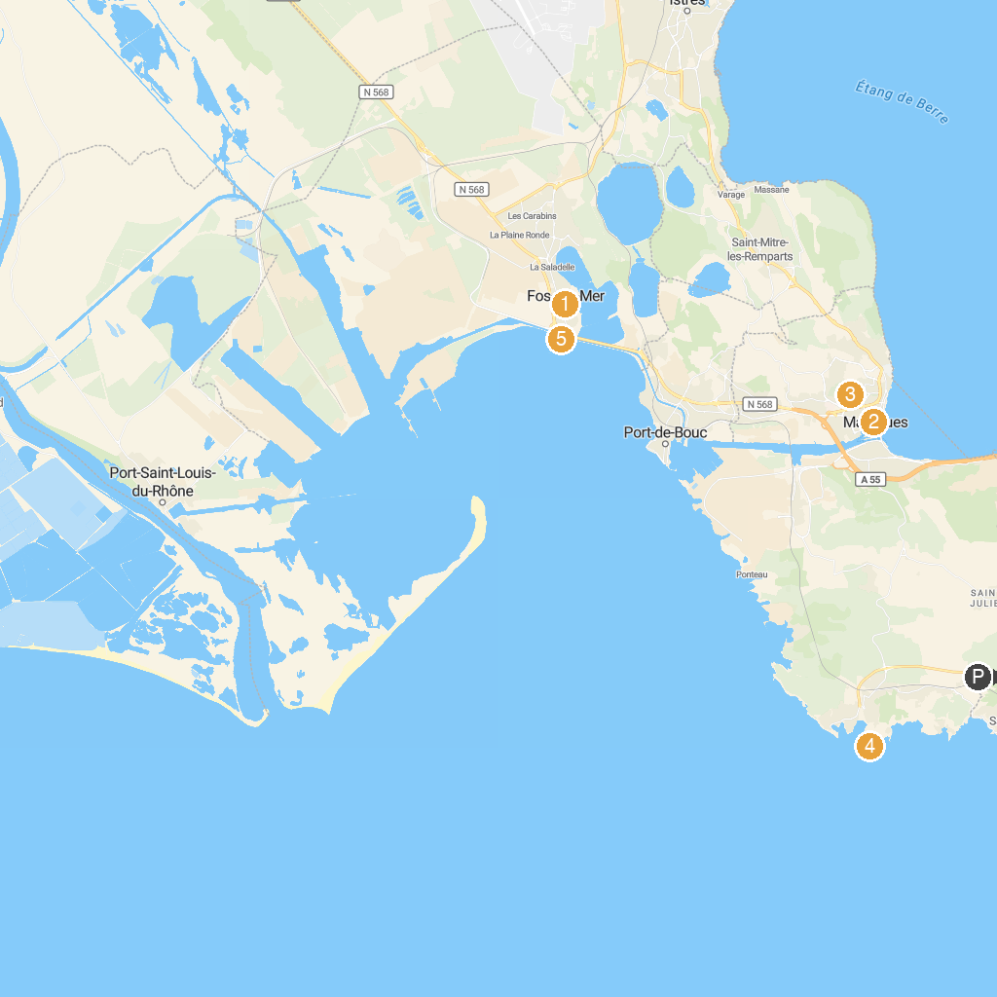
MAP KEY
1. Château de l'Hauture | 5. Maison de la Mer et du Sport
2. musée Ziem | 6. Parc Ferrage
3. Chapelle catholique Notre-Dame de Miséricorde, dite Notre-Dame des Marins | 7. La Romaniquette
4. Lighthouse Cap Crown | 8. Parc Maurin
P. Cruise port / terminal
Map © MapTiler © OpenStreetMap contributors · cruiseports.org

