Martha's Vineyard, Massachusetts, USA
A car-free island getaway draped in Victorian charm — where gingerbread cottages, fresh lobster, and the oldest carousel in America await just a tender ride away.
⚓ Tender (no pier) · 🕒 Typical call: 6-8 hrs · 💵 USD · 🗣️ English · 🦞 Seasonal (May–Oct)
✍️ MY DAY IN PORT (FILL IN)
Ship / Date
In port | arrive ______ · all aboard ______
Booked excursion
Notes / meeting point
GETTING ASHORE
- Docking: Tender to Oak Bluffs or Vineyard Haven
- Walk to center: 2-5 min from tender pier (Oak Bluffs)
- Best For: History, beaches, fresh seafood, architecture
- Don't Miss: Gingerbread Cottages & Flying Horses Carousel
GETTING AROUND
- 🚕 Taxi: $14–$60 — Multiple local cab companies (Stagecoach, MV Taxi, Lighthouse Taxi). Fares vary by distance — within a town ~$14, Vineya
- 📱 Rideshare: ✅ Uber, Lyft
TOP THINGS TO DO
- Aquinnah Cliffs (Gay Head) — Dramatic multicolored clay cliffs on the island's western tip — sacred Wampanoag land with sweeping ocean views.
- Edgartown Historic District — Stately white-shingled 19th-century whaling captains' homes, manicured gardens, and the Edgartown Harbor Lighthouse — a flat…
- Gingerbread Cottages Walk — Over 300 whimsical Victorian Methodist cottages in the Camp Meeting Association (Trinity Park) neighborhood — one of America's…
- Inkwell Beach — Calm, swimmable beach about a 5-minute walk south of the Oak Bluffs tender pier along Seaview Avenue, with deep historical…
- Seafood Lunch in Oak Bluffs — Fresh lobster rolls, clam chowder, and raw bar right on the harbor at spots like Coop de Ville and Nancy's — where President…
BEST WALKS
- Oak Bluffs Harbor & Gingerbread Cottages Loop: 1.5 miles · 45 min · Easy — From the tender pier, walk the harbor front past restaurants and the Flying Horses Carousel, then…
- Edgartown Village & Harbor Light: 1 mile loop · 45 min · Easy — From the Edgartown bus stop, walk the white-shingled main street to the waterfront, then follow the…
WEATHER · DAYLIGHT · MONEY
Month | High °F | Low °F | Rainy days
May | 60 | 51 | 12
Jul | 77 | 68 | 9
Sep | 71 | 64 | 10
Daylight: May 5:23AM–7:54PM · Jul 5:22AM–8:13PM · Sep 6:23AM–6:50PM
cruiseports.org/marthas-vineyard-island · Confirm terminal & all-aboard time with your ship

Martha's Vineyard, Massachusetts, USA — Port Map
Red = walkable sights · Amber = excursions farther out · P = cruise terminal
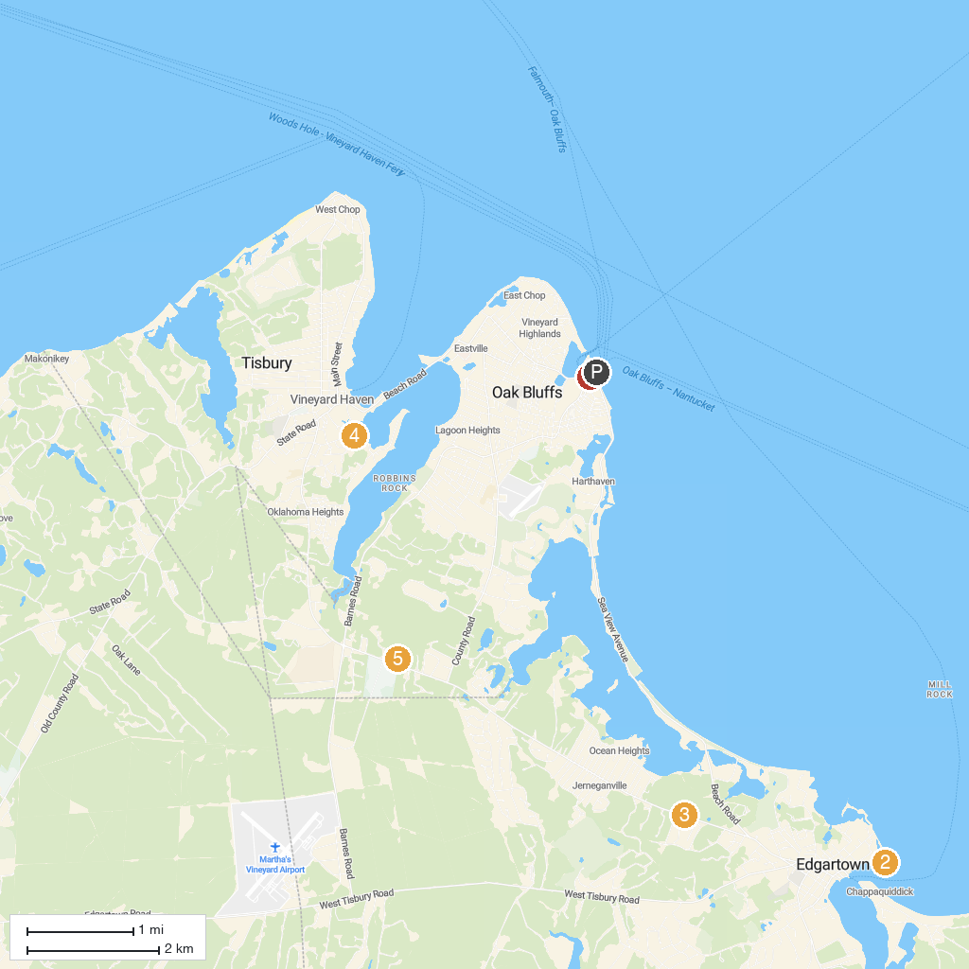
MAP KEY
1. Flying Horses Carousel a Vineyard Preservation Trust Property | 5. Martha's Vineyard Museum
2. Lighthouse Beach | 6. Woods Hole Science Aquarium
3. Caroline Tuthill Preserve | 7. YMCA of Martha's Vineyard Ice Arena
4. South Cape Beach State Park
P. Cruise port / terminal
Map © MapTiler © OpenStreetMap contributors · cruiseports.org

