Marstrand, Bohuslän, Sweden
A car-free island fortress town on Sweden's granite west coast — sailing culture, 17th-century ramparts, and hand-peeled shrimp straight from the harbour.
⚓ Tender (most ships anchor offshore) · 🕒 Typical call: 6–8 hrs · 💳 Cashless — card only (SEK) · 🗣️ Swedish (English universally spoken) · ⛵ Sweden's sailing capital
✍️ MY DAY IN PORT (FILL IN)
Ship / Date
In port | arrive ______ · all aboard ______
Booked excursion
Notes / meeting point
GETTING ASHORE
- Docking: Tender to Marstrandsön guest harbour (Gästhamn); small expedition ships may dock quayside
- Walk to centre: 0 min — tender lands you on the harbour promenade
- Best For: History buffs, seafood lovers, hikers, sailors
- Don't Miss: Carlsten Fortress tower views + a räkmacka (shrimp sandwich) on the quay
GETTING AROUND
- 🚕 Taxi: Varies — confirm fare before boarding — Local taxis operate on Koön and can reach the ferry terminal or the mainland. Fares are unregulated in Sweden; always ag
TOP THINGS TO DO
- Carlsten Fortress Guided Tour — Built in 1658 by King Carl X Gustav, Carlsten Fortress looms over the island from its granite peak.
- Coastal Ring Trail — A 5 km loop around Marstrandsön follows wooden boardwalks and granite ledges past sea coves, pine groves, and the famous Nålsögat…
- Harbour Promenade & Old Town — Stroll Hamngatan along the harbour to admire mega-yachts, 19th-century villas with ornate Swedish gingerbread trim…
- West Coast Seafood Lunch — The Bohuslän coast is famous for hand-peeled shrimp, pickled herring, and scampi pulled from cold, clean Atlantic waters.
- Sailing & Kayak on the Archipelago — Marstrand is Sweden's undisputed sailing capital — home to the GKSS Match Cup Sweden regatta each July.
BEST WALKS
- Harbour to Carlsten Fortress: 0.5 km · 10–15 min · Steep uphill · Cobblestones — From the Gästhamn tender dock, follow the signs uphill through the old town lanes to the fortress…
- Coastal Ring Trail: 5 km loop · 1–1.5 hrs · Moderate · Granite & boardwalk — Follow the marked coastal path from the harbour around the full perimeter of Marstrandsön.
WEATHER · DAYLIGHT · MONEY
Month | High °F | Low °F | Rainy days
May | 57 | 47 | 12
Jul | 67 | 59 | 14
Sep | 61 | 54 | 13
Daylight: May 4:50AM–9:31PM · Jul 4:35AM–10:02PM · Sep 6:44AM–7:32PM
cruiseports.org/marstrand · Confirm terminal & all-aboard time with your ship

Marstrand, Bohuslän, Sweden — Port Map
Red = walkable sights · Amber = excursions farther out · P = cruise terminal
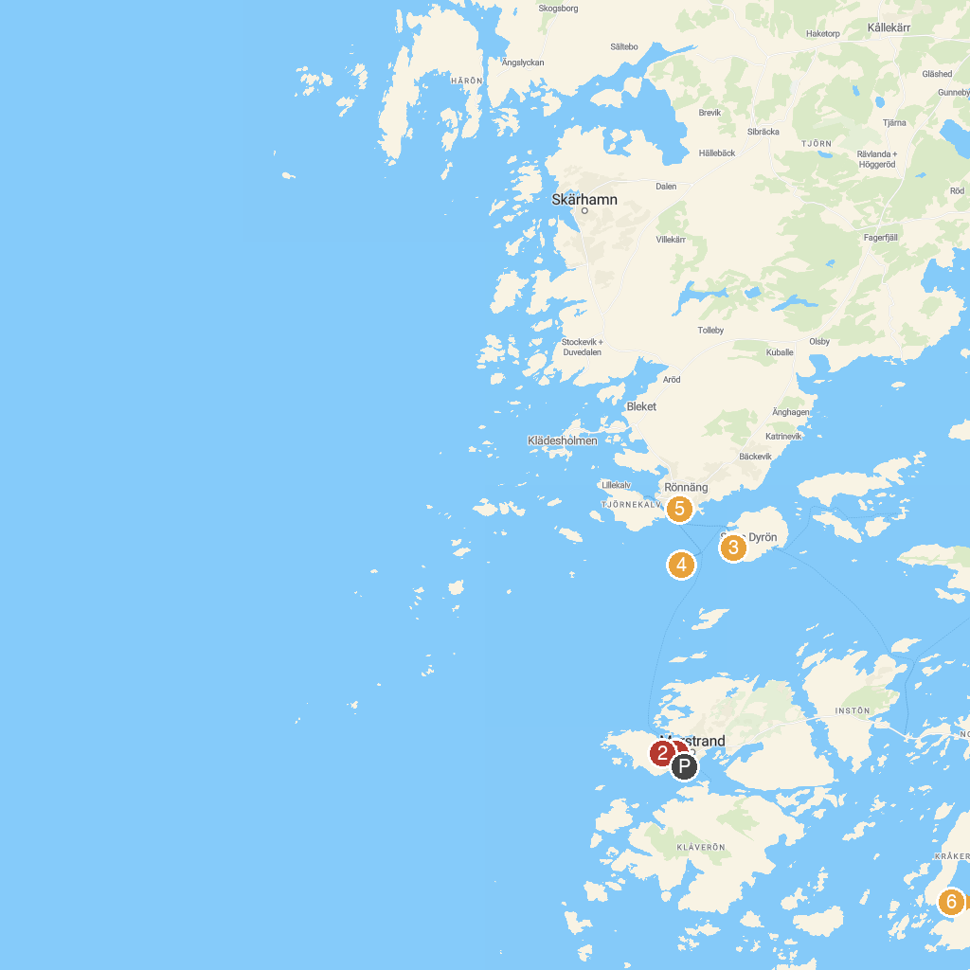
MAP KEY
1. Marstrands Church | 5. Tjörnehuvud
2. Carlstens Fästning | 6. Kärna Bokskog
3. Dynes Ravin | 7. Rörö
4. Åstol
P. Cruise port / terminal
Map © MapTiler © OpenStreetMap contributors · cruiseports.org

