Marseille, Provence, France
France's oldest city and its most visceral — a gritty, gorgeous port where bouillabaisse was invented, the Calanques begin, and 26 centuries of history press close.
⚓ Docked (MPCT cruise terminal) · 🕒 Typical call: 8–10 hrs · 💶 Euro (EUR) · 🗣️ French · Some English in tourist zones
✍️ MY DAY IN PORT (FILL IN)
Ship / Date
In port | arrive ______ · all aboard ______
Booked excursion
Notes / meeting point
GETTING ASHORE
- Docking: MPCT — Môle Léon Gourret
- To Vieux-Port: ~8 km — shuttle or taxi (not walkable)
- Best For: Calanques · Old port · Food
- Don't Miss: Basilique Notre-Dame de la Garde
GETTING AROUND
- 🚕 Taxi: €15–€25 — Official taxis are available at the port exit. Fare to the Old Port (Vieux-Port) is typically €15–€25; expect up to €35
- 📱 Rideshare: ✅ Uber, Bolt
- 🚌 Hop-on hop-off: ✅ Colorbüs Marseille
TOP THINGS TO DO
- Calanques National Park Boat Tour — The creamy white limestone fjords east of Marseille are one of France's great natural spectacles.
- Basilique Notre-Dame de la Garde — Marseille's gilded hilltop basilica — 'La Bonne Mère' — is the city's spiritual anchor and its best viewpoint.
- Aix-en-Provence Half-Day — Thirty minutes by train or bus, Aix is a world apart — fountained boulevards, Cézanne's studio, excellent markets, and…
- MuCEM & the Historic Harbour — The Museum of European and Mediterranean Civilisations (MuCEM) is a landmark building right at the port entrance, connected by…
- Bouillabaisse & Vieux-Port Lunch — The Vieux-Port's quayside restaurants serve the real thing — bouillabaisse (book ahead), grilled sea urchin, and tielle pastries.
BEST WALKS
- Vieux-Port to Notre-Dame de la Garde: 3.5 km · 1.5–2 hrs · Moderate (steep finish) — Start at Quai des Belges at the foot of the Old Port, walk through the Panier quarter (Marseille's…
- Vieux-Port & MuCEM Waterfront Stroll: 2 km · 45 min · Easy — A flat, scenic walk along the north shore of the Vieux-Port from Quai des Belges to Fort Saint-Jean…
WEATHER · DAYLIGHT · MONEY
Month | High °F | Low °F | Rainy days
May | 69 | 56 | 7
Jul | 83 | 69 | 1
Sep | 76 | 63 | 5
Daylight: May 6:14AM–8:55PM · Jul 6:12AM–9:16PM · Sep 7:18AM–7:48PM
cruiseports.org/marseille · Confirm terminal & all-aboard time with your ship

Marseille, Provence, France — Port Map
Red = walkable sights · Amber = excursions farther out · P = cruise terminal
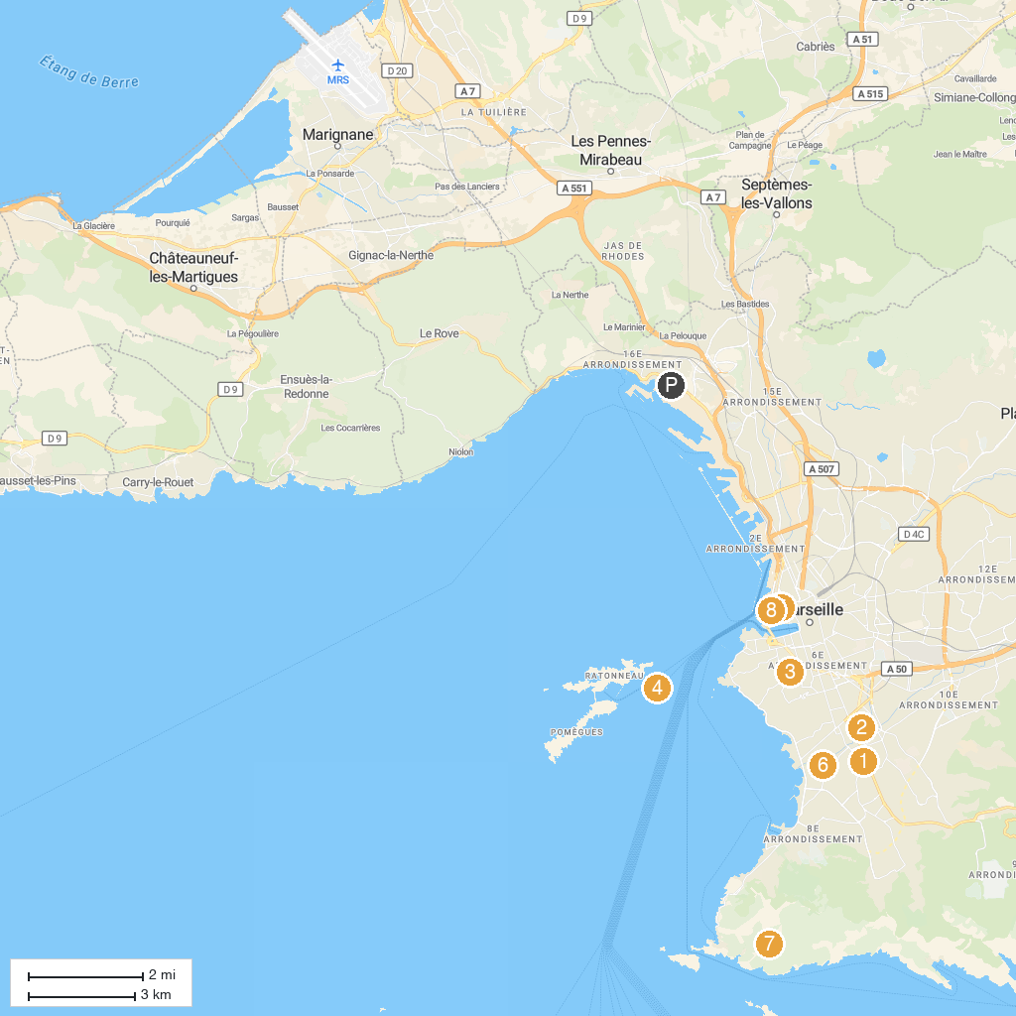
MAP KEY
1. Unité d'Habitation | 5. Old Charity Center
2. Orange Vélodrome | 6. Parc Borély
3. Notre-Dame de la Garde | 7. Pas de la Demi Lune
4. Château d'If | 8. Cathédrale La Major
P. Cruise port / terminal
Map © MapTiler © OpenStreetMap contributors · cruiseports.org

