Marseilles-lès-Aubigny, Cher, France
A sleepy Berrichon village on the Canal latéral à la Loire, Marseilles-lès-Aubigny is where river cruisers step off into quiet French countryside — vineyards, stone churches, and the pace of rural France at its most genuine.
⚓ River dock (quayside) · 🕒 Typical call: 4-6 hrs · 💶 Euro (€) · 🗣️ French
✍️ MY DAY IN PORT (FILL IN)
Ship / Date
In port | arrive ______ · all aboard ______
Booked excursion
Notes / meeting point
GETTING ASHORE
- Docking: River quay alongside the Canal latéral à la Loire
- Walk to centre: 2-5 min on foot to village centre
- Best For: Slow travel, cycling, rural French villages, wine region exploration
- Don't Miss: The canal towpath and the surrounding Sancerre wine country
GETTING AROUND
- 🚕 Taxi: €40–€70 each way to Sancerre — Local taxis (e.g. Taxi Fred, Robert Foulon) are the only independent option for reaching Sancerre (~30 km) or La Charité
TOP THINGS TO DO
- Sancerre Wine & Village Tour — Head to the hilltop town of Sancerre, one of France's most celebrated wine appellations.
- Canal du Berry Towpath Cycling — Rent a bike and follow the flat, traffic-free towpath along the Canal latéral à la Loire.
- La Charité-sur-Loire Day Trip — The Cluniac priory town of La Charité-sur-Loire — a UNESCO World Heritage site on the Santiago de Compostela pilgrimage route…
- Village Stroll & Local Market — When market day falls on your call, the small village square fills with local producers selling cheese, charcuterie, and seasonal…
BEST WALKS
- Canal du Berry Towpath Walk: 1-3 km · Flat · 30-90 min — Follow the gravel towpath in either direction from the quay.
- Village Centre Loop: 1 km · Easy · 20-30 min — A short loop from the quay takes in the village church, the small central square, and a classic…
WEATHER · DAYLIGHT · MONEY
Month | High °F | Low °F | Rainy days
May | 66 | 50 | 12
Jul | 78 | 61 | 9
Sep | 72 | 55 | 9
Daylight: May 6:12AM–9:16PM · Jul 6:08AM–9:39PM · Sep 7:25AM–7:59PM
cruiseports.org/marseille-les-aubigny · Confirm terminal & all-aboard time with your ship

Marseilles-lès-Aubigny, Cher, France — Port Map
Red = walkable sights · Amber = excursions farther out · P = cruise terminal
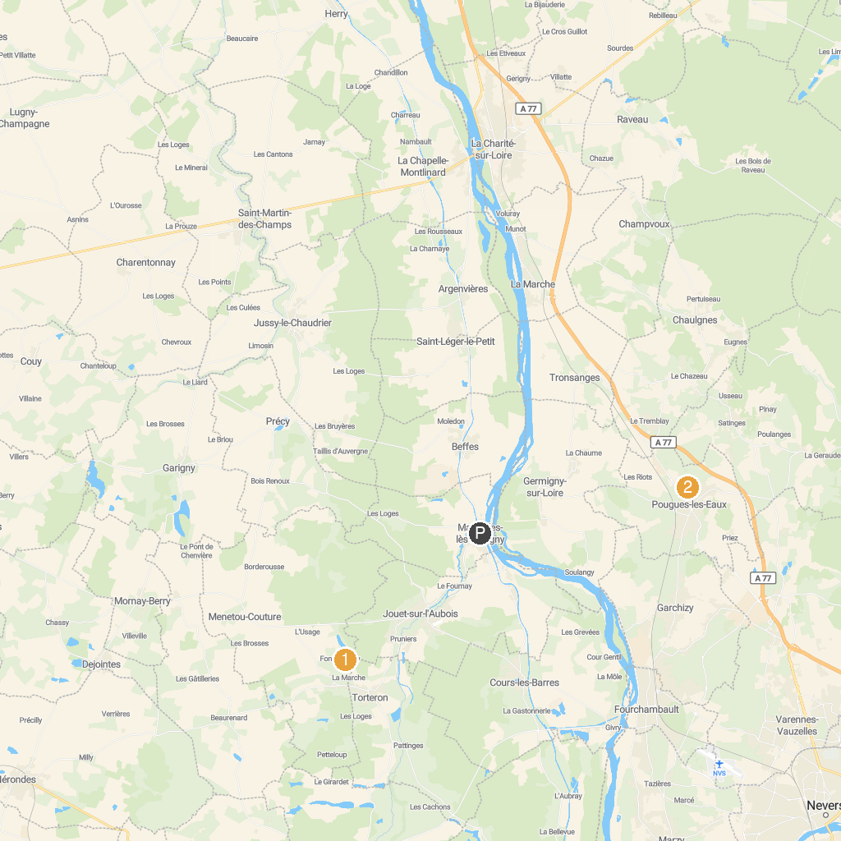
MAP KEY
1. Abbey Fontmorigny | 4. Nevers Cathedral
2. Church of Notre Dame in La Charité-sur-Loire | 5. Contemporary Art Center
3. Parc Roger Salengro | 6. Palais ducal de Nevers
P. Cruise port / terminal
Map © MapTiler © OpenStreetMap contributors · cruiseports.org

