Marsala, Sicily, Italy
Where Garibaldi launched Italian unification and English merchants invented a legendary wine — Marsala rewards curious cruisers with salt-white lagoons, Phoenician ghosts, and Sicily's finest cannoli.
⚓ Small pier / tender for larger ships · 🕒 Typical call: 6-8 hrs · 💶 Euro (€) · 🗣️ Italian
✍️ MY DAY IN PORT (FILL IN)
Ship / Date
In port | arrive ______ · all aboard ______
Booked excursion
Notes / meeting point
GETTING ASHORE
- Docking: Small pier alongside for compact ships; larger vessels may tender or arrive via shore excursion from Trapani
- Walk to center: ~10-15 min (800 m) flat walk to Porta Garibaldi and the historic center
- Best For: Wine lovers, history buffs, Phoenician archaeology, salt pan scenery
- Don't Miss: The Marsala Punic Ship at Baglio Anselmi Museum and the Stagnone salt pans with windmills
GETTING AROUND
- 🚕 Taxi: ~€10 — Urban taxi fare to the city center is roughly €10. Night surcharges apply. Taxis can be found at the port or booked via
TOP THINGS TO DO
- Punic Ship & Archaeological Museum — The Baglio Anselmi Museum houses the only intact Carthaginian warship ever recovered — sunk during the First Punic War in 241 BC.
- Marsala Wine Cellar Tasting — Tour the vaulted tuff-stone cellars of Cantine Florio (est.
- Stagnone Salt Pans & Windmills — The Saline di Marsala nature reserve stretches north of the city — shallow pink-tinged lagoons, centuries-old windmills, and…
- Mozia (Mothia) Phoenician Island — A tiny island in the Stagnone Lagoon preserves the ruins of one of the ancient Mediterranean's great Phoenician cities.
- Marsala Food & Wine Walking Tour — Explore the historic center on foot, stopping for couscous alla Trapanese (the region's signature dish), busiate pasta with pesto…
BEST WALKS
- Port to Piazza della Repubblica: 1.5 km · 20 min · Easy · Flat — The essential Marsala stroll: walk from the pier along the waterfront, pass through Porta…
- Baglio Anselmi Archaeological Museum: 800 m from pier · 10-15 min · Easy — Head directly to the museum housed in a former wine factory on the waterfront — home to the ancient…
WEATHER · DAYLIGHT · MONEY
Month | High °F | Low °F | Rainy days
May | 73 | 59 | 7
Jul | 88 | 72 | 1
Sep | 82 | 70 | 6
Daylight: May 6:00AM–8:13PM · Jul 6:00AM–8:31PM · Sep 6:52AM–7:17PM
cruiseports.org/marsala · Confirm terminal & all-aboard time with your ship

Marsala, Sicily, Italy — Port Map
Red = walkable sights · Amber = excursions farther out · P = cruise terminal
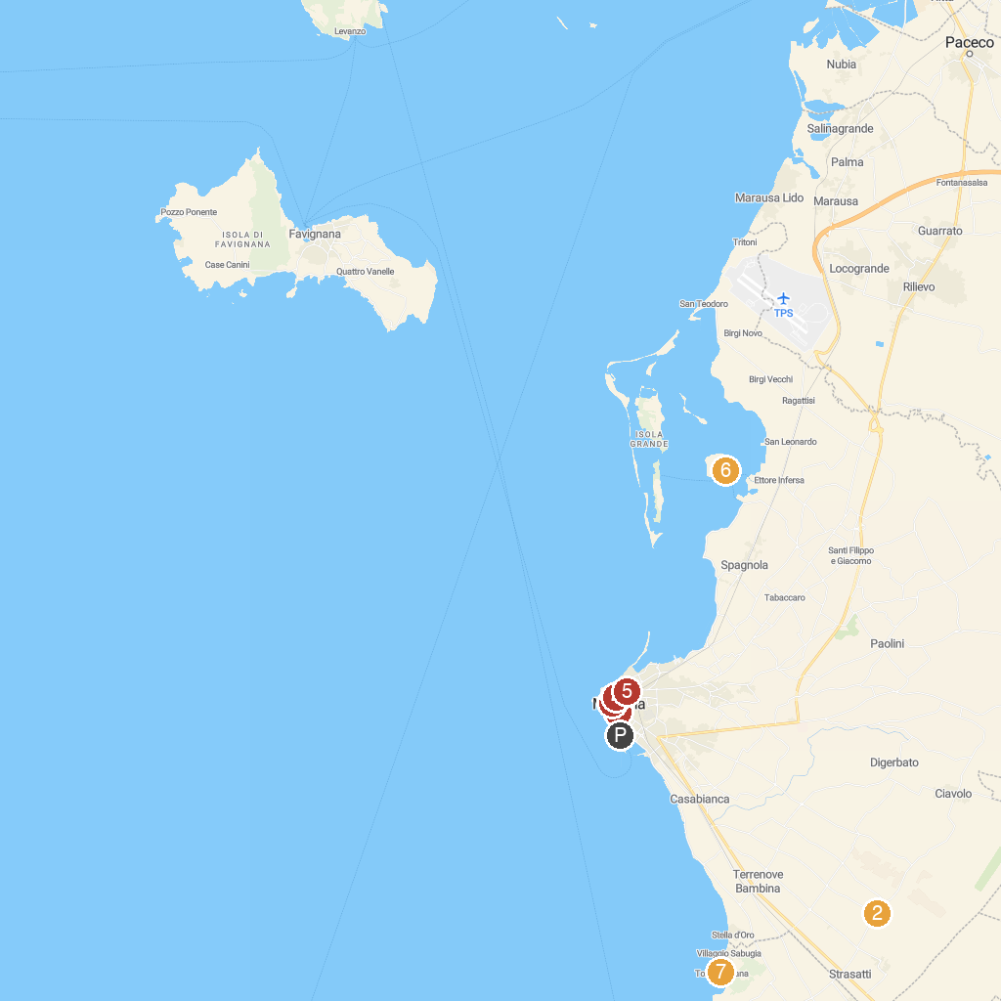
MAP KEY
1. Museum of Flemish-Era Tapestries | 5. Hypogeum Crispia Salvia
2. St Padre Delle Perriere Church | 6. Mozia imbarcadero Storico G.Whitaker
3. Porta Nuova | 7. Torre Sibiliana
4. Villa Cavallotti
P. Cruise port / terminal
Map © MapTiler © OpenStreetMap contributors · cruiseports.org

