Port Ghalib, Red Sea, Egypt
Where the Sahara meets the Red Sea — Port Ghalib is Egypt's most relaxed cruise port, with world-class reefs, rare dugongs, and a breezy marina promenade just steps from the pier.
⚓ Pier (deepwater berth) · 🕒 Typical call: 7-9 hrs · 💵 EGP / USD accepted · 🗣️ Arabic (English at marina) · 🤿 World-class diving
✍️ MY DAY IN PORT (FILL IN)
Ship / Date
In port | arrive ______ · all aboard ______
Booked excursion
Notes / meeting point
GETTING ASHORE
- Docking: Direct pier at Port Ghalib Marina — no tender
- Walk to marina: Steps from gangway to corniche & shops
- Best For: Diving, snorkeling with turtles & dugongs, desert safari
- Don't Miss: Marsa Mubarak dugong & turtle bay, Abu Dabbab snorkeling
GETTING AROUND
- 🚕 Taxi: €8–15 one-way — Local taxis are available for short trips within Port Ghalib and to nearby Marsa Alam town (about 65 km north). Negotiat
TOP THINGS TO DO
- Dugong & Turtle Snorkel — Marsa Mubarak — A short boat ride from the marina brings you to Marsa Mubarak (Dugong Bay), one of the few places on earth with reliable dugong…
- Abu Dabbab Bay — Shore Snorkeling with Turtles — A sandy-bottomed public bay ~30 minutes south by taxi.
- Desert Quad Bike & Bedouin Camp Safari — Ride quad bikes over the Eastern Desert dunes, dismount for a camel ride, then settle into a Bedouin camp for mint tea and…
- El Quseir Ottoman Fort & Old Town — Head about an hour north (≈75 km) to El Quseir, a preserved 16th-century Ottoman port with a restored fort, old coral-block…
- Scuba Diving — Elphinstone Reef — One of the world's legendary drift dives: sheer walls dropping hundreds of metres, resident anthias clouds, and encounters with…
BEST WALKS
- Port Ghalib Marina Corniche Stroll: 1.5 km · Flat · 20-30 min · Free — Walk the full marina waterfront from the cruise pier southward past boutiques, open-air cafes, and…
WEATHER · DAYLIGHT · MONEY
Month | High °F | Low °F | Rainy days
May | 90 | 76 | 0
Jul | 96 | 83 | 0
Sep | 94 | 82 | 0
Daylight: May 5:56AM–7:19PM · Jul 6:00AM–7:34PM · Sep 6:27AM–6:45PM
cruiseports.org/marsa-alam-ghalib · Confirm terminal & all-aboard time with your ship

Port Ghalib, Red Sea, Egypt — Port Map
Red = walkable sights · Amber = excursions farther out · P = cruise terminal
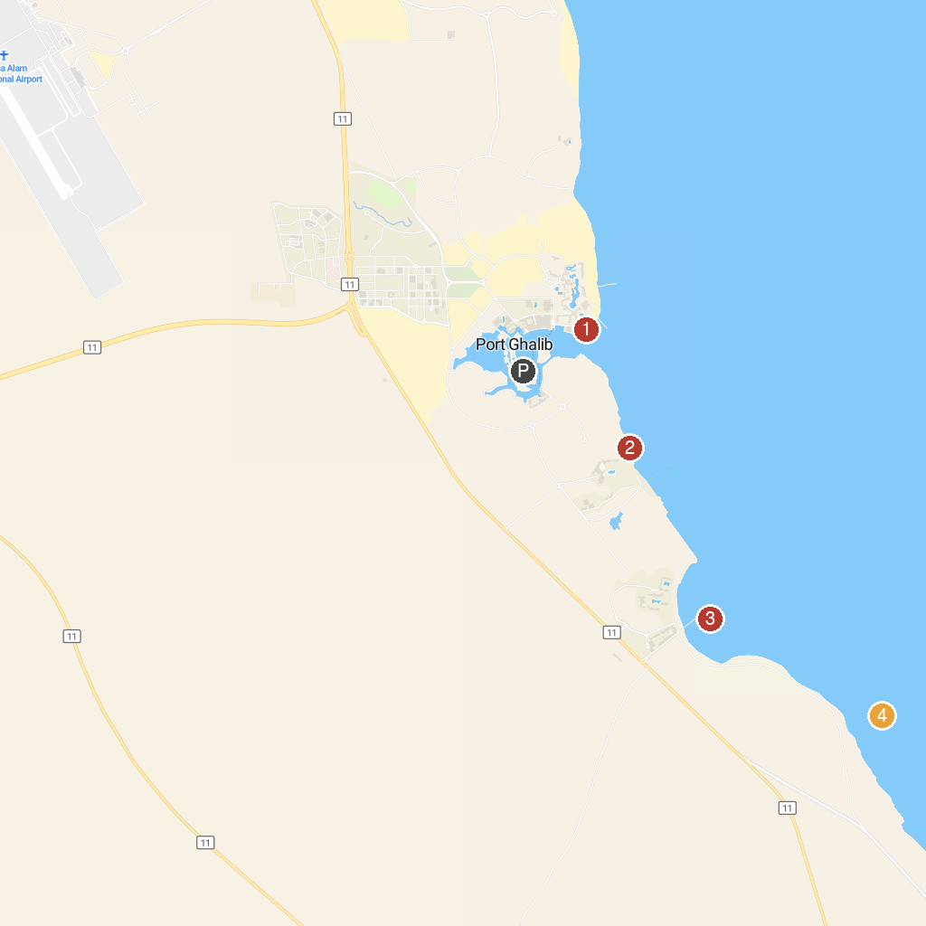
MAP KEY
1. Spiaggia di Ghalib | 3. Marsa Mubarak
2. Small Fayrouz turtle beach | 4. Shaab Salman - Dive site
P. Cruise port / terminal
Map © MapTiler © OpenStreetMap contributors · cruiseports.org

