Marquette, Michigan, USA
The rugged capital of Michigan's Upper Peninsula delivers epic lakefront scenery, iconic 1930s ore docks, a forested park preserved on Frederick Law Olmsted's advice, and a fiercely local culture that will win you over before you finish your first pasty.
⚓ Pier (Lower Harbor) · 🕒 Typical call: 7-9 hrs · 💵 USD · 🗣️ English · 🌊 Great Lakes
✍️ MY DAY IN PORT (FILL IN)
Ship / Date
In port | arrive ______ · all aboard ______
Booked excursion
Notes / meeting point
GETTING ASHORE
- Docking: Pier — ships dock at Lower Harbor, steps from downtown
- Walk to center: 5–10 min flat walk to Front Street shops & restaurants
- Best For: Nature walks, history, craft beer, local food
- Don't Miss: Black Rocks at Presque Isle Park & a traditional pasty
GETTING AROUND
- 🚕 Taxi: $14–$20 — Checker Cab serves the Marquette area. Downtown is compact and close to the port, so fares are modest.
- 📱 Rideshare: ✅ Uber, Lyft
TOP THINGS TO DO
- Presque Isle Park & Black Rocks — This 323-acre forested peninsula — which landscape architect Frederick Law Olmsted famously advised the city to leave untouched…
- Marquette Maritime Museum & Lighthouse Tour — Explore Lake Superior's storied shipwreck history, then take a guided tour inside the 1866 Marquette Harbor Lighthouse — a rare…
- Downtown Marquette Food & Culture Walk — Wander the sandstone-clad downtown for a traditional pasty, a pint at Ore Dock Brewing, handmade candy at Donckers soda fountain…
- Marquette Regional History Center — A modern museum covering Ojibwe culture, the iron-mining boom, and distinctive Yooper folklore.
- McCarty's Cove Beach — Marquette's most accessible beach is a 15-minute walk east of the dock.
BEST WALKS
- Harbor to Downtown Loop: 1.5 miles · 30–45 min · Easy, flat — Follow the Iron Ore Heritage Trail south from the pier, passing the iconic 1931 Lower Harbor Ore…
- Downtown Sandstone Architecture Walk: 0.75 miles · 20–30 min · Easy — Stroll through downtown Marquette's historic core, admiring buildings crafted from local…
WEATHER · DAYLIGHT · MONEY
Month | High °F | Low °F | Rainy days
May | 58 | 42 | 10
Jul | 74 | 60 | 9
Sep | 68 | 55 | 10
Daylight: May 6:15AM–9:17PM · Jul 6:12AM–9:38PM · Sep 7:28AM–8:00PM
cruiseports.org/marquette-mi · Confirm terminal & all-aboard time with your ship

Marquette, Michigan, USA — Port Map
Red = walkable sights · Amber = excursions farther out · P = cruise terminal
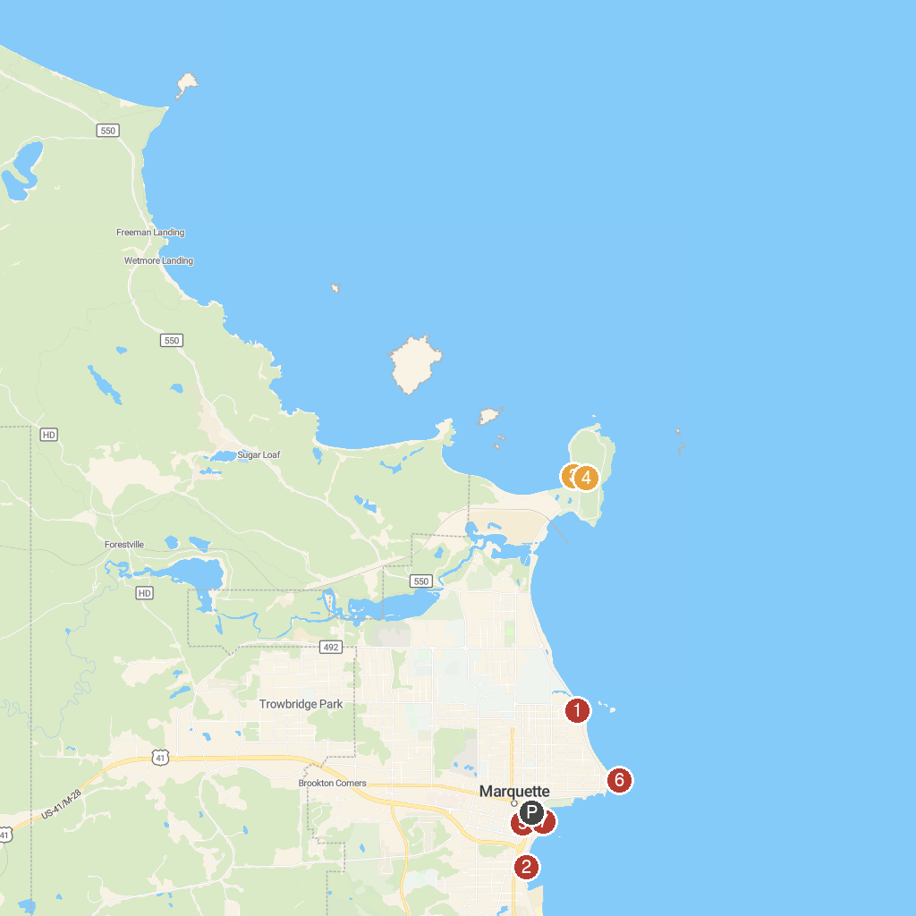
MAP KEY
1. Picnic Rocks Park | 5. Upper Peninsula Children's Museum
2. Founders Landing | 6. Marquette Harbor Lighthouse
3. Presque Isle Pavilion | 7. Lower Harbor Ore Dock
4. Presque Isle Park
P. Cruise port / terminal
Map © MapTiler © OpenStreetMap contributors · cruiseports.org

