Marina di Ragusa, Sicily, Italy
A modern yacht marina on Sicily's sun-baked southern coast, Marina di Ragusa puts you steps from award-winning golden beaches and within easy reach of the Val di Noto's dazzling Baroque hilltowns.
⚓ Small ship / tender port · 🕒 Typical call: 6–8 hrs · 💶 Currency: Euro (€) · 🗣️ Language: Italian
✍️ MY DAY IN PORT (FILL IN)
Ship / Date
In port | arrive ______ · all aboard ______
Booked excursion
Notes / meeting point
GETTING ASHORE
- Docking: Boutique ships dock at marina quay; larger vessels anchor and tender ashore
- Walk to centre: 5 min to beach; 10 min to Piazza Duca degli Abruzzi
- Best For: Beaches, Baroque architecture, Montalbano fans, seafood
- Don't Miss: UNESCO Ragusa Ibla (30 min) and Scaccia Ragusana flatbread
GETTING AROUND
- 🚕 Taxi: €220–260 — Pre-booked private transfers to Ragusa city are quoted at €220–260 per vehicle by local transfer companies. Street taxis
- 📱 Rideshare: ✅ Uber
TOP THINGS TO DO
- Ragusa Ibla — UNESCO Baroque Hilltop Town — Rebuilt in theatrical Baroque style after the 1693 earthquake, Ragusa Ibla rewards every minute.
- Inspector Montalbano Tour — Punta Secca — The famous Italian crime drama was filmed along this coastline.
- Donnafugata Castle — A romantic neo-Gothic castle surrounded by parkland and a famous stone maze, 25 minutes from the port.
- Modica Chocolate & Baroque Towns — Modica's ancient cold-pressed chocolate — made using a pre-Colombian Aztec recipe — is unique in Italy.
- Coastal Sailing & Snorkelling — Half- and full-day sailing trips depart from the marina, exploring undisturbed bays, sea cliffs, and clear waters along Sicily's…
BEST WALKS
- Marina to Piazza Duca degli Abruzzi: 800 m · 10 min · Flat — Walk east from the marina along the Lungomare Andrea Doria promenade, passing the beach and cycling…
- Irminio River Nature Reserve: 3 km · 30 min · Easy — Follow the promenade east all the way to the Riserva Naturale del Fiume Irminio, where the river…
WEATHER · DAYLIGHT · MONEY
Month | High °F | Low °F | Rainy days
May | 72 | 60 | 5
Jul | 85 | 73 | 0
Sep | 81 | 71 | 6
Daylight: May 5:54AM–8:02PM · Jul 5:54AM–8:20PM · Sep 6:44AM–7:08PM
cruiseports.org/marina-di-ragusa · Confirm terminal & all-aboard time with your ship

Marina di Ragusa, Sicily, Italy — Port Map
Red = walkable sights · Amber = excursions farther out · P = cruise terminal
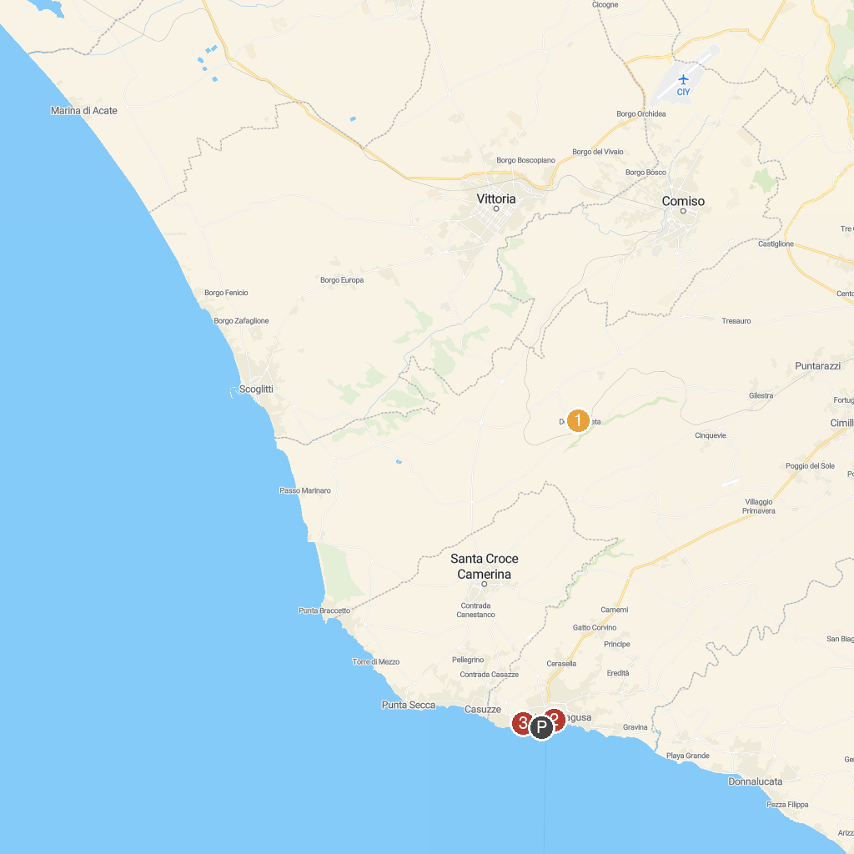
MAP KEY
1. Castello di Donnafugata | 4. Torre Cabrera
2. Palazzo Spadaro | 5. Monumento alla Scarpa
3. Centro storico di Scicli
P. Cruise port / terminal
Map © MapTiler © OpenStreetMap contributors · cruiseports.org

