Marín, Galicia, Spain
A real working naval port tucked into the Rías Baixas, Marín punches above its size — ancient petroglyphs, pristine Blue Flag beaches, and a fully pedestrianized medieval city just 10 minutes away by taxi.
⚓ Pier (docked) · 🕒 Typical call: 8-10 hrs · 💶 Currency: Euro (€) · 🗣️ Galician & Spanish
✍️ MY DAY IN PORT (FILL IN)
Ship / Date
In port | arrive ______ · all aboard ______
Booked excursion
Notes / meeting point
GETTING ASHORE
- Docking: Pier — Muelle Adolfo Reboredo; shuttle to port gate
- Walk to center: 2–5 min from port gate (shuttle drops here)
- Best For: Galician culture, seafood, day trip to Pontevedra city
- Don't Miss: Pulpo á feira + Albariño wine in Pontevedra's old town
GETTING AROUND
- 🚕 Taxi: €14–€17 — Taxis wait at the port and can take you to Pontevedra city center (7–8 km) in about 10 minutes. Meter fare; base charge
TOP THINGS TO DO
- Pontevedra Medieval Old Town — Pontevedra is internationally celebrated for banning cars from its entire historic center.
- Mogor Petroglyphs (Petroglifos de Mogor) — One of Galicia's most significant prehistoric rock-art sites, the Mogor Labyrinth is carved into coastal outcrops overlooking the…
- Coastal Walk to Portocelo & Mogor Beaches — The Senda Azul coastal path links Marín town to its Blue Flag beaches — sheltered Portocelo (1.5 km) and crescent-shaped Mogor…
- Combarro — Stone Granaries on the Water — Fifteen kilometers up the ría, Combarro is a perfectly preserved fishing village famous for its hórreos — stone grain stores…
- Galician Seafood & Tapas in Pontevedra — Galicia is Spain's seafood capital.
BEST WALKS
- Senda Azul to Portocelo Beach: 1.5 km · 20 min · Easy — From the port gate, follow the signed coastal footpath (Senda Azul) south along the ría to…
- Town Center to Mogor Petroglyphs: 2.2 km · 30 min · Easy–moderate — Continue past Portocelo along the coastal path to the Mogor Petroglyphs — Bronze Age carvings with…
WEATHER · DAYLIGHT · MONEY
Month | High °F | Low °F | Rainy days
May | 68 | 54 | 9
Jul | 78 | 62 | 4
Sep | 74 | 60 | 6
Daylight: May 7:14AM–9:49PM · Jul 7:11AM–10:10PM · Sep 8:14AM–8:45PM
cruiseports.org/marin-pontevedra-city · Confirm terminal & all-aboard time with your ship

Marín, Galicia, Spain — Port Map
Red = walkable sights · Amber = excursions farther out · P = cruise terminal
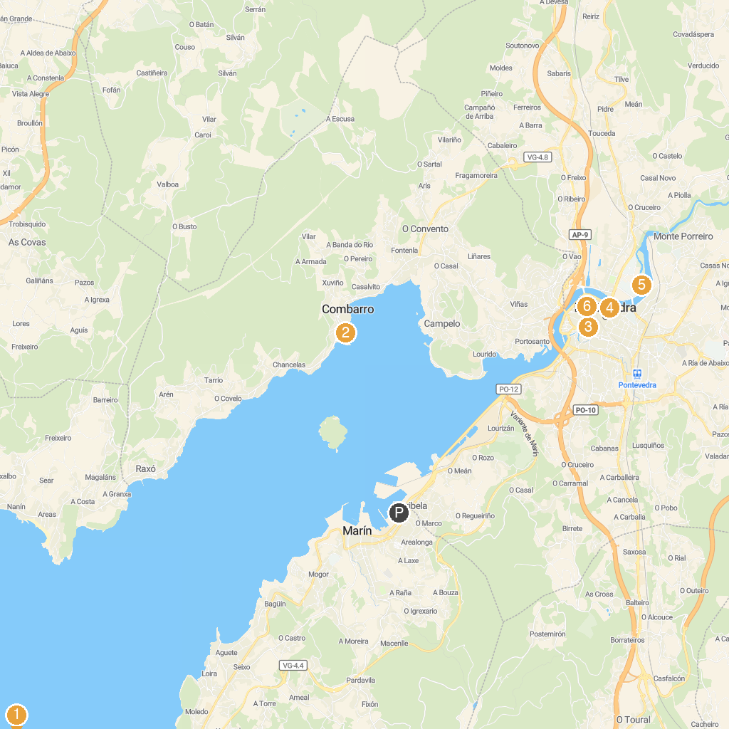
MAP KEY
1. Museo Massó | 5. Illa das Esculturas
2. Porto Marítimo | 6. Iglesia de Santa María la Mayor
3. Xardíns de Vincenti | 7. Ruta da Pedra e da Auga
4. Museo de Pontevedra - Edificio Castelao | 8. Soutomaior Castle
P. Cruise port / terminal
Map © MapTiler © OpenStreetMap contributors · cruiseports.org

