Marietta, Ohio, USA
Founded in 1788 as the first permanent American settlement in the Northwest Territory, Marietta pairs ancient Native American earthworks with golden-age steamboat lore—all within easy walking distance of the levee dock.
⚓ Docked (levee pier) · 🕒 Typical call: full day · 💵 US Dollar · 🗣️ English · 🏛️ History & culture
✍️ MY DAY IN PORT (FILL IN)
Ship / Date
In port | arrive ______ · all aboard ______
Booked excursion
Notes / meeting point
GETTING ASHORE
- Docking: Direct levee dock — no tender
- Walk to center: Under 2 min to Front St
- Best For: American pioneer & steamboat history
- Don't Miss: Hopewell burial mound at Mound Cemetery
GETTING AROUND
- 🚕 Taxi: Varies — Local operators include Adams Taxi & Transportation Service and Ohio Valley Cab Service. Contact directly for fares; use
- 📱 Rideshare: ✅ Uber, Lyft
TOP THINGS TO DO
- Campus Martius Museum — Built on the original 1788 pioneer stockade site, this museum preserves the Rufus Putnam House — the oldest surviving home in…
- Ohio River Museum & W.P. Snyder Jr. — The last intact steam-powered sternwheel towboat in the US sits moored outside this museum dedicated to the golden age of Ohio…
- Mound Cemetery & Conus Mound — An ancient conical burial mound—part of the Marietta Earthworks built by the Adena or Hopewell peoples—rises from within a…
- The Castle Historic House Museum — An 1855 Gothic Revival mansion with octagonal towers, Victorian gardens, and guided tours through the history of Marietta's most…
- Harmar Village & Pedestrian Bridge — Cross the historic Harmar Railroad Bridge — now a pedestrian swing bridge — to this neighborhood of brick streets, antique shops…
BEST WALKS
- Riverfront to Mound Cemetery Loop: 1.5 miles | ~45 min | Easy — From the levee, walk up Greene Street into downtown, browse Front Street's boutiques and Putnam…
- Lafayette Hotel to Campus Martius: 0.5 miles | ~20 min | Easy — Stop in the Lafayette Hotel lobby for steamboat memorabilia, then walk two blocks to Campus Martius…
WEATHER · DAYLIGHT · MONEY
Month | High °F | Low °F | Rainy days
May | 74 | 51 | 12
Jul | 85 | 63 | 10
Sep | 77 | 54 | 9
Daylight: May 5:15AM–7:30PM · Jul 5:05AM–7:50PM · Sep 6:00AM–6:35PM
cruiseports.org/marietta-oh · Confirm terminal & all-aboard time with your ship

Marietta, Ohio, USA — Port Map
Red = walkable sights · Amber = excursions farther out · P = cruise terminal
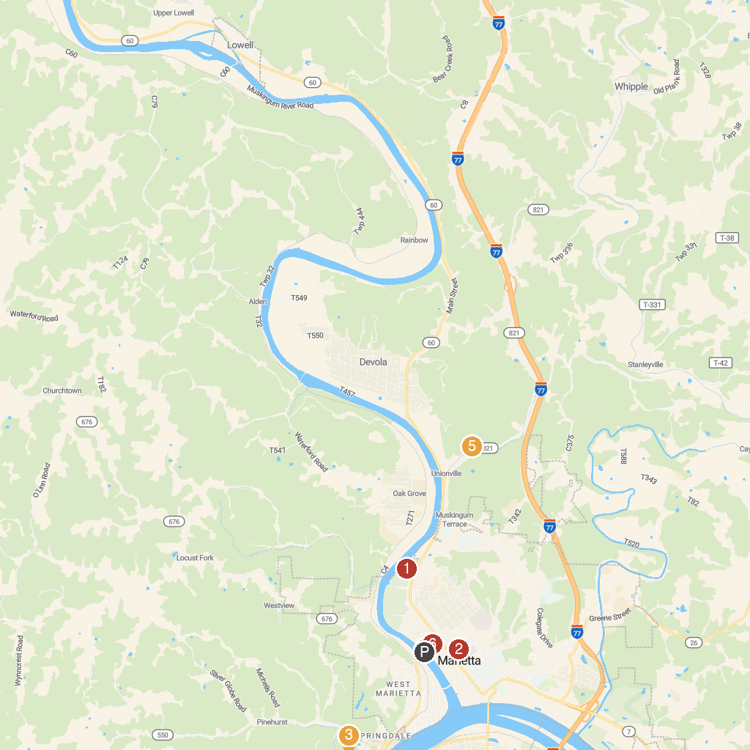
MAP KEY
1. Marietta Aquatic Center | 4. Ohio River Museum
2. The Castle Historic House Museum | 5. Broughton Nature and Wildlife Education Area
3. Henderson Hall | 6. Campus Martius Museum
P. Cruise port / terminal
Map © MapTiler © OpenStreetMap contributors · cruiseports.org

