Margaux-Cantenac, Médoc, France
The Médoc's crown jewel, where every plot of gravel soil hides a Grand Cru and the names on the gates read like a wine lover's bucket list. Margaux-Cantenac is small, serene, and utterly unforgettable.
⚓ Pier / Pontoon (Port de Cantenac) · 🕒 Typical call: 6–8 hrs · 💶 Euro (€) · 🗣️ French · 🍷 Wine region
✍️ MY DAY IN PORT (FILL IN)
Ship / Date
In port | arrive ______ · all aboard ______
Booked excursion
Notes / meeting point
GETTING ASHORE
- Docking: Pontoon at Port de Cantenac — no terminal building; rural setting
- Walk to village: ~2.5 km (30 min) to Margaux village center; flat terrain
- Best For: Wine lovers, châteaux visits, cycling through famous vineyards
- Don't Miss: Sarments de Margaux chocolates at Mademoiselle de Margaux
GETTING AROUND
- 🚕 Taxi: €60–€75 — Fixed-price private transfers to Bordeaux city center (~29 km, ~34 min). Metered fares may vary by traffic; pre-booking
- 📱 Rideshare: ✅ Uber
TOP THINGS TO DO
- Château Margaux Grand Tour — Visit the Premier Grand Cru Classé itself.
- Château d'Issan Cellar & Tasting — The closest major estate to the dock (~1.7 km walk), featuring a stunning 17th-century moated castle.
- Vineyard Cycling — Margaux-Cantenac is almost perfectly flat — ideal for cycling.
- Blending Workshop at Château Marquis de Terme — One of the most visitor-friendly estates in the appellation.
- Village Walk & La Maison du Vin — Stroll into Margaux village, visit the 19th-century Église Saint-Michel with its stained-glass windows, browse La Maison du Vin…
BEST WALKS
- Dock to Château d'Issan: 3.4 km round trip · 45 min · Easy — Walk from the Port de Cantenac pontoon along Route du Port d'Issan (~1.7 km each way) past rows of…
- Cantenac to Margaux Village: 5 km round trip · 60–70 min · Easy — Follow the D2 wine road north from Cantenac through Château Palmer and Château Cantenac Brown into…
WEATHER · DAYLIGHT · MONEY
Month | High °F | Low °F | Rainy days
May | 68 | 51 | 12
Jul | 81 | 62 | 8
Sep | 75 | 57 | 8
Daylight: May 6:26AM–9:14PM · Jul 6:23AM–9:35PM · Sep 7:33AM–8:04PM
cruiseports.org/margaux-cantenac · Confirm terminal & all-aboard time with your ship

Margaux-Cantenac, Médoc, France — Port Map
Red = walkable sights · Amber = excursions farther out · P = cruise terminal
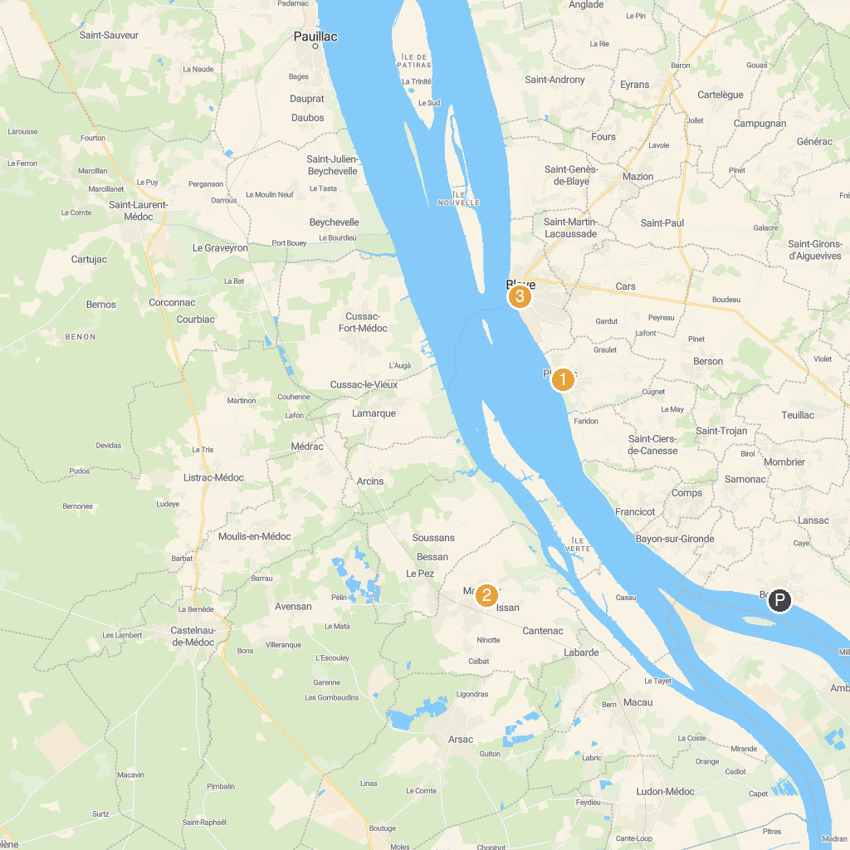
MAP KEY
1. Villa Gallo Romaine de Plassac | 3. Tourist Office of Blaye
2. Château Marquis de Terme Tourisme
P. Cruise port / terminal
Map © MapTiler © OpenStreetMap contributors · cruiseports.org

