Margarita Island, Nueva Esparta, Venezuela
Venezuela's largest island earns its 'Pearl of the Caribbean' nickname: golden beaches, a vast mangrove lagoon, 17th-century forts, and the Venezuelan street-food classic — empanadas de cazón fresh from the fryer.
⚓ Pier (Puerto El Guamache) · 🕒 Typical call: 7-9 hrs · 💵 USD widely accepted · 🗣️ Spanish · 🏖️ Beach destination
✍️ MY DAY IN PORT (FILL IN)
Ship / Date
In port | arrive ______ · all aboard ______
Booked excursion
Notes / meeting point
GETTING ASHORE
- Docking: Pier at Puerto El Guamache (SW coast); tendering rare
- Walk to Center: No walkable city center — taxis required; Porlamar ~35 min
- Best For: Beaches, mangrove boat tours, colonial forts
- Don't Miss: La Restinga National Park mangrove boat ride
GETTING AROUND
- 🚕 Taxi: $20–$30 USD — El Guamache cruise port is about 45 minutes from Porlamar city center. Informal taxis are plentiful at the pier; USD is
TOP THINGS TO DO
- La Restinga National Park Boat Tour — Board a lancha (small motor boat) to navigate tight mangrove tunnels alive with sea stars, seahorses, and herons, emerging onto a…
- Castillo de San Carlos de Borromeo, Pampatar — A well-preserved 17th-century star fort built to repel pirate raids, overlooking Pampatar Bay.
- Island Jeep Safari — 4x4s cross both halves of the island — from the lush eastern mountains to the stark cactus desert of the Macanao Peninsula…
- Playa El Yaque Windsurfing Beach — Constant trade winds make El Yaque a world-class windsurfing and kitesurfing spot.
- La Asunción & Castillo de Santa Rosa — The island's historic capital features the 16th-century Castillo de Santa Rosa — where patriot Luisa Cáceres de Arismendi was…
BEST WALKS
- Port Beach Stroll: Easy · 30-45 min · No transport needed — The beach at Playa El Guamache sits directly beside the cruise terminal.
- Pampatar Waterfront: Easy · 1 hr on foot · Taxi to Pampatar required — From the drop-off in Pampatar, walk the seafront Paseo to the Castillo de San Carlos de Borromeo…
WEATHER · DAYLIGHT · MONEY
Month | High °F | Low °F | Rainy days
May | 83 | 77 | 9
Jul | 83 | 77 | 21
Sep | 86 | 79 | 15
Daylight: May 5:53AM–6:30PM · Jul 6:00AM–6:42PM · Sep 6:05AM–6:15PM
cruiseports.org/margarita-island-venezuela · Confirm terminal & all-aboard time with your ship

Margarita Island, Nueva Esparta, Venezuela — Port Map
Red = walkable sights · Amber = excursions farther out · P = cruise terminal
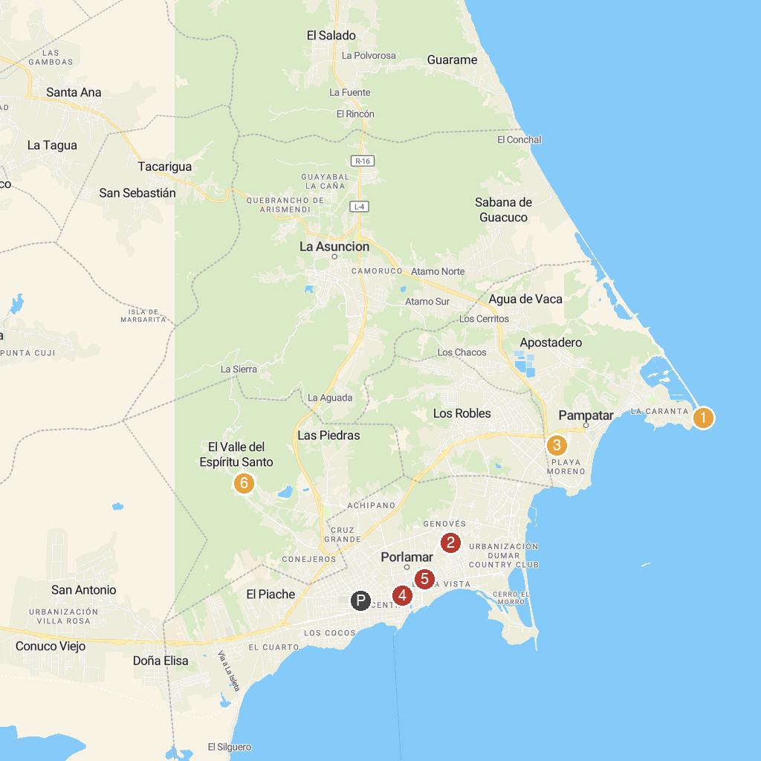
MAP KEY
1. Punta Ballena | 4. Museum of Contemporary Art Francisco Narváez
2. Casa de la Cultura Ramón Vásquez Brito | 5. Casino Caribe Plaza
3. Parque de Atracciones Diverland | 6. The minor Basilica of Our Lady of the Valley
P. Cruise port / terminal
Map © MapTiler © OpenStreetMap contributors · cruiseports.org

