Marco Island, Florida, USA
The largest island in Florida's Ten Thousand Islands, Marco is a sun-soaked Gulf Coast escape prized for powdery shell-sand beaches, dolphin-filled mangrove waterways, and a surprisingly rich Calusa Indian heritage.
⚓ Small ship / tender (no large cruise pier) · 🕒 Typical call: 6-8 hrs · 💵 USD · 🗣️ English · 🐚 Famous for shelling
✍️ MY DAY IN PORT (FILL IN)
Ship / Date
In port | arrive ______ · all aboard ______
Booked excursion
Notes / meeting point
GETTING ASHORE
- Docking: Tender to Rose Marina or Caxambas Park; small-ship dockage at Rose Marina
- Walk to center: Limited — Snook Inn & Esplanade ~10-15 min from Rose Marina; beaches need a ride
- Best For: Beaches, shelling, dolphin/manatee boat tours, Cape Romano dome houses
- Don't Miss: Key Marco Cat (replica) at Marco Island Historical Museum (free)
GETTING AROUND
- 🚕 Taxi: $75+/hr (3-hr min) — Local car services such as Direct Transportation Marco offer on-demand rides. Hourly rates apply with a minimum booking;
- 📱 Rideshare: ✅ Uber, Lyft
TOP THINGS TO DO
- Ten Thousand Islands Dolphin & Mangrove Tour — Glide through the labyrinthine mangrove channels of the Ten Thousand Islands National Wildlife Refuge, spotting bottlenose…
- Cape Romano Dome Houses Boat Tour — Take a charter boat south to see the surreal Cape Romano Dome Homes — six futuristic concrete domes completed in 1982 (begun in…
- Tigertail Beach & Shelling — Marco Island's signature beach experience: walk the wild tidal spit known as Sand Dollar Spit to find lightning whelks, fighting…
- Marco Island Historical Museum — Free and compact, this museum is a genuine gem.
- CraigCat Guided Boat Tour — Pilot your own two-person, low-to-the-water CraigCat boat through the Marco River and mangrove backcountry on a guided group tour…
BEST WALKS
- Rose Marina to Snook Inn & Esplanade: ~1 mile | Easy | Flat riverside path — From Rose Marina, follow Smokehouse Bay Drive north along the Marco River waterfront to the…
- Otter Mound Preserve Loop: 0.3 miles | Easy | Shaded trail — A short, peaceful walk through a small preserve built on an ancient Calusa shell mound in the…
WEATHER · DAYLIGHT · MONEY
Month | High °F | Low °F | Rainy days
May | 86 | 72 | 13
Jul | 88 | 77 | 24
Sep | 87 | 75 | 22
Daylight: May 6:40AM–8:05PM · Jul 6:44AM–8:20PM · Sep 7:13AM–7:30PM
cruiseports.org/marco-island-florida · Confirm terminal & all-aboard time with your ship

Marco Island, Florida, USA — Port Map
Red = walkable sights · Amber = excursions farther out · P = cruise terminal
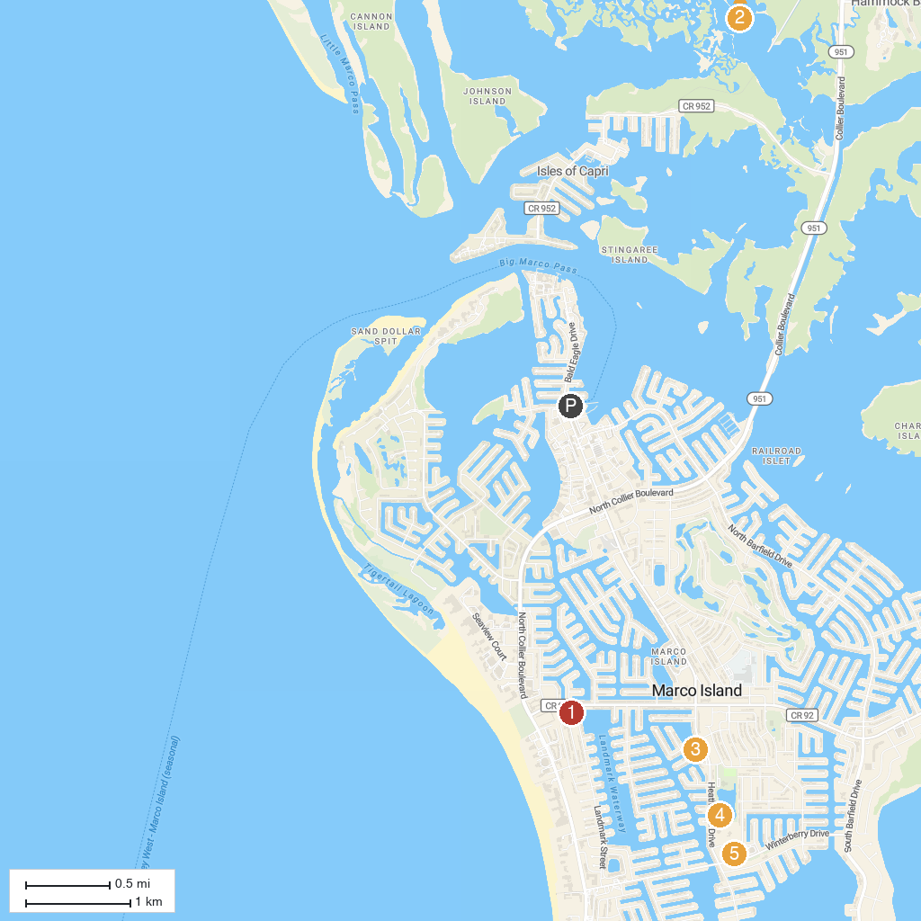
MAP KEY
1. Rookery Bay Environmental Learning Center | 5. Marco Island Historical Museum
2. San Marco Catholic Church | 6. Canine Cove Dog Park
3. Briggs Boardwalk | 7. Winterberry Park
4. Collier-Seminole State Park
P. Cruise port / terminal
Map © MapTiler © OpenStreetMap contributors · cruiseports.org

