Mar del Plata, Buenos Aires Province, Argentina
Argentina's Atlantic playground. Known as 'La Feliz', Mar del Plata pairs 47 km of Atlantic coastline with an art-deco casino, a raucous sea lion colony, and some of the country's finest alfajores.
⚓ Pier (commercial port) · 🕒 Typical call: 8-10 hrs · 💵 Argentine Peso / USD widely accepted · 🗣️ Spanish
✍️ MY DAY IN PORT (FILL IN)
Ship / Date
In port | arrive ______ · all aboard ______
Booked excursion
Notes / meeting point
GETTING ASHORE
- Docking: Pier — ships berth at the commercial/fishing port, ~5 km south of the city centre
- To the centre: ~5 km to the Rambla/Casino — a long ~1 hr walk; taxis and remises are the easy option
- Best For: Beaches, sea lion watching, casino, Argentinian seafood & sweets
- Don't Miss: Stone sea lions on La Rambla and the live sea lions at Puerto de Pescadores
GETTING AROUND
- 🚕 Taxi: $4–7 USD — Metered taxis are plentiful at the port. The city center (Plaza Colón) is about 6.5 km away; expect ARS 5,000–7,000 (rou
- 📱 Rideshare: ✅ Uber, Cabify, DiDi
TOP THINGS TO DO
- La Rambla & Casino Central — Stroll the iconic beachfront promenade past the art-deco Casino Central (free entry to the gallery), photograph the giant stone…
- Sea Lions at Puerto de Pescadores — Argentina's busiest fishing harbour hosts hundreds of South American sea lions basking on the docks year-round.
- Playa Bristol & Playa Grande — Playa Bristol in the city centre is the classic Mar del Plata beach — wide sand, volleyball, and a buzzing summer vibe.
- Villa Victoria & Museo MAR — Victoria Ocampo's beautifully preserved 1912 English-built chalet-mansion is now a literary museum and cultural centre with…
- Laguna de los Padres & Sierra de los Padres — A scenic 20-minute drive inland brings you to a peaceful lagoon ringed by pampas grasslands and woods.
BEST WALKS
- Rambla Seafront Walk: ~5 km · 75–90 min · Easy · Flat — Start at Puerto de Pescadores beside the pier to see the sea lion colony, then walk north along the…
- Stella Maris & Water Tower Viewpoint: 2 km loop · 1 hr · Easy — Head uphill into the Stella Maris neighbourhood to the Tudor-style Torre Tanque water tower (free…
WEATHER · DAYLIGHT · MONEY
Month | High °F | Low °F | Rainy days
May | 60 | 50 | 7
Jul | 54 | 43 | 8
Sep | 59 | 46 | 7
Daylight: May 7:44AM–5:48PM · Jul 8:03AM–5:49PM · Sep 6:50AM–6:40PM
cruiseports.org/mar-del-plata · Confirm terminal & all-aboard time with your ship

Mar del Plata, Buenos Aires Province, Argentina — Port Map
Red = walkable sights · Amber = excursions farther out · P = cruise terminal
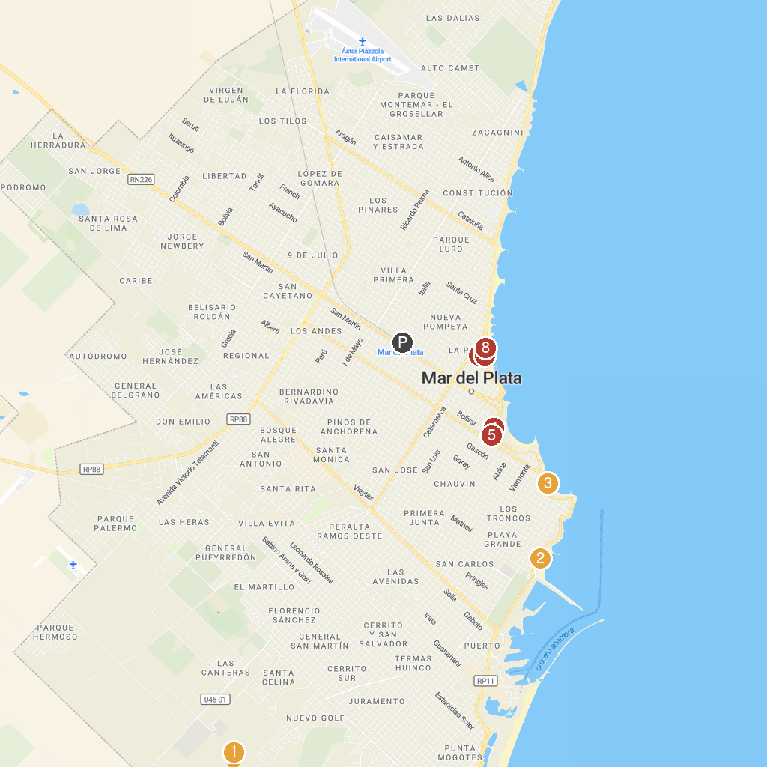
MAP KEY
1. Aquopolis Parque Acuático | 5. Plaza Colón
2. Grand Beach | 6. Museo Municipal De Ciencias Naturales Lorenzo Scaglia
3. Varese Beach | 7. Balneario San Sebastián
4. Millennium Square | 8. Balneario Alicante
P. Cruise port / terminal
Map © MapTiler © OpenStreetMap contributors · cruiseports.org

