Maputo, Maputo Province, Mozambique
Once known as Lourenço Marques, Maputo blends Portuguese colonial grandeur with African energy — jacaranda-lined boulevards, an Eiffel-designed train station, and the best prawns on the continent.
⚓ Docked (pier) · 🕒 Typical call: 8-10 hrs · 💵 MZN / USD accepted · 🗣️ Portuguese · 🍤 Famous for LM Prawns
✍️ MY DAY IN PORT (FILL IN)
Ship / Date
In port | arrive ______ · all aboard ______
Booked excursion
Notes / meeting point
GETTING ASHORE
- Docking: Dedicated cruise terminal inside Port of Maputo; shuttle to city center
- Walk to center: Shuttle required — active industrial port, not walkable
- Best For: Colonial architecture, fresh seafood, craft markets
- Don't Miss: CFM Railway Station & the Fish Market with cook-to-order seafood
GETTING AROUND
- 🚕 Taxi: $16–24 USD — Taxis are available at the pier. Always agree on the fare before you get in — meters are rarely used. A typical city-cen
- 📱 Rideshare: ✅ Bolt, Yango
TOP THINGS TO DO
- Colonial Maputo Walking Tour — Hit the architectural highlights: the mint-green CFM Railway Station (Beaux-Arts, often called one of the world's most beautiful…
- Fish Market Cook-to-Order Experience — Mercado de Peixe is a full culinary adventure: pick live crabs, prawns, or fish from the wet market stalls, then hand them to the…
- Inhaca Island Day Trip — A pristine marine reserve across Maputo Bay — white sand beaches, coral reefs, and snorkeling.
- Fortress of Maputo & Natural History Museum — Maputo's oldest Portuguese fort holds the wooden coffin of tribal leader Ngungunhane.
- FEIMA Craft Market — Maputo's premier artisan market in a leafy park — local paintings, wooden carvings, batik textiles, and wickerwork alongside…
BEST WALKS
- Baixa Colonial Loop: ~2 km · 45-60 min · Flat · Easy — Start at the CFM Railway Station and walk the historic downtown core: east to Independence Square…
- Historic Ironwork & Landmarks Walk: ~1 km · 20 min · Flat · Easy — A short dedicated walk between two of Maputo's most photographed landmarks — the iconic Beaux-Arts…
WEATHER · DAYLIGHT · MONEY
Month | High °F | Low °F | Rainy days
May | 79 | 64 | 4
Jul | 76 | 59 | 3
Sep | 81 | 64 | 5
Daylight: May 6:20AM–5:11PM · Jul 6:36AM–5:15PM · Sep 5:47AM–5:42PM
cruiseports.org/maputo · Confirm terminal & all-aboard time with your ship

Maputo, Maputo Province, Mozambique — Port Map
Red = walkable sights · Amber = excursions farther out · P = cruise terminal
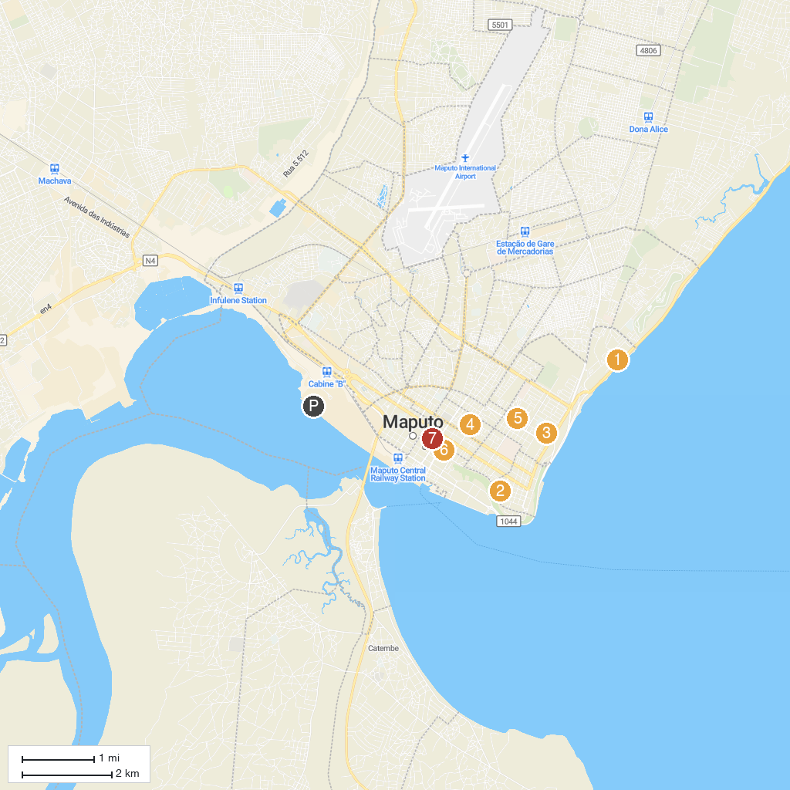
MAP KEY
1. Casino Polana | 5. The Smiling Lion
2. Museu de Historia Natural | 6. Catedral de Maputo
3. Saint Anthony Catholic Church | 7. Museu Nacional de Arte
4. Jardim Dona Berta
P. Cruise port / terminal
Map © MapTiler © OpenStreetMap contributors · cruiseports.org

