Mantua, Lombardy, Italy
Encircled by three shimmering lakes and crowned by 500-room ducal palaces, Mantua is the Gonzaga family's Renaissance masterpiece — and one of northern Italy's most rewarding river cruise stops.
⚓ Docked (river pier) · 🕒 Typical call: 6–8 hrs · 💶 Euro (€) · 🗣️ Italian
✍️ MY DAY IN PORT (FILL IN)
Ship / Date
In port | arrive ______ · all aboard ______
Booked excursion
Notes / meeting point
GETTING ASHORE
- Docking: River ships berth at Porto Catena on Lago Inferiore — ~1.2 km flat walk (15–20 min) to Piazza Sordello
- UNESCO Status: Historic centre of Mantua & Sabbioneta listed 2008
- Best For: Renaissance art, Gonzaga palaces, unique Lombard cuisine
- Don't Miss: Camera degli Sposi frescoes (book online!) & Palazzo Te's Chamber of the Giants
GETTING AROUND
- 🚕 Taxi: €7–€12 — City taxis are available with a base fare of ~€5.60 plus ~€1.30/km. Short hops within the historic center run €7–€12. Pr
- 📱 Rideshare: ✅ Uber
TOP THINGS TO DO
- Palazzo Ducale & Camera degli Sposi — The Gonzaga's 500-room royal complex is Italy's second-largest residential palace after the Vatican.
- Palazzo Te — Chamber of the Giants — The Gonzaga pleasure palace designed by Giulio Romano contains the Sala dei Giganti — an immersive room where the entire ceiling…
- Lotus Lake Boat Tour (Jul–Aug) — In summer, Lago Superiore blooms with thousands of lotus flowers — the largest colony in Europe, introduced in 1921.
- Piazza Sordello & Piazza delle Erbe Walking Tour — Mantua's interlocking medieval squares are lined with the Astronomical Clock Tower (1472), Basilica di Sant'Andrea, and the…
- Tortelli di Zucca Cooking & Tasting — Mantua's signature pumpkin ravioli — stuffed with sweet squash, amaretti, and mostarda, tossed in sage butter — is unlike…
BEST WALKS
- Lakeside to the Ducal Palace: 1.2 km · 15 min · Flat · Easy — Stroll north from the river dock along the lake promenade, enter through Porta Pradella, and follow…
- Centro Storico Loop: 2.5 km · 40 min · Flat · Easy — From Piazza Sordello, loop through Piazza delle Erbe past the Clock Tower and Basilica di…
WEATHER · DAYLIGHT · MONEY
Month | High °F | Low °F | Rainy days
May | 73 | 56 | 14
Jul | 87 | 69 | 9
Sep | 77 | 61 | 8
Daylight: May 5:47AM–8:39PM · Jul 5:44AM–9:00PM · Sep 6:55AM–7:27PM
cruiseports.org/mantua · Confirm terminal & all-aboard time with your ship

Mantua, Lombardy, Italy — Port Map
Red = walkable sights · Amber = excursions farther out · P = cruise terminal
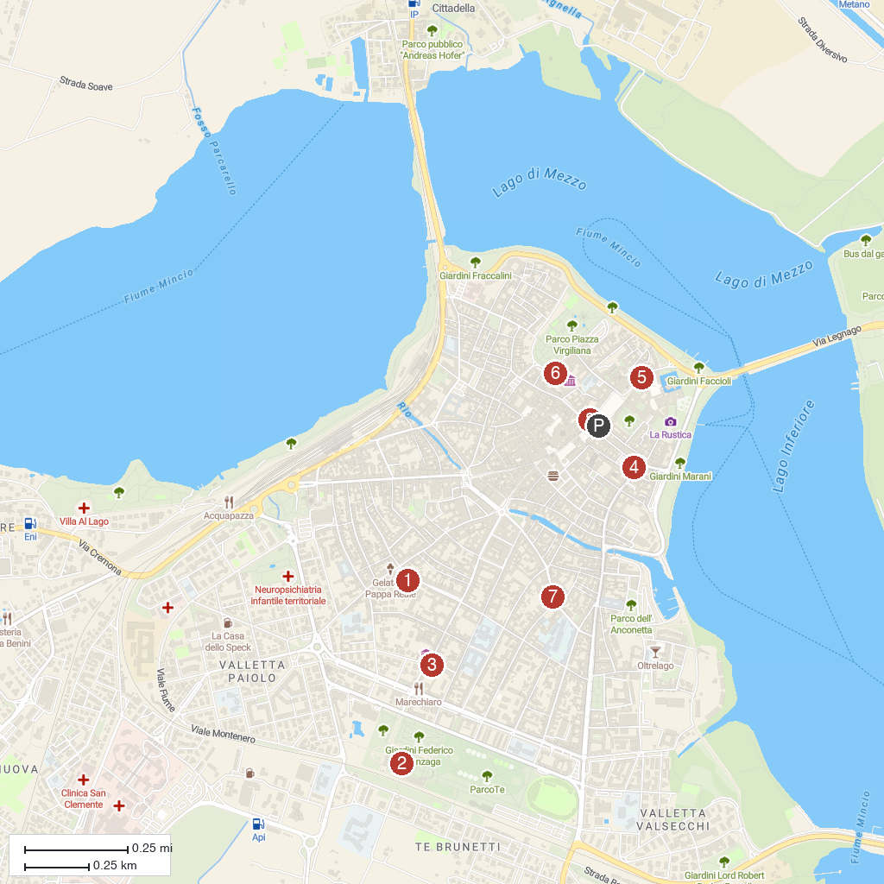
MAP KEY
1. Church of St. Barnabas | 5. National Archaeological Museum
2. Te Palace | 6. Museo Diocesano "Francesco Gonzaga"
3. San Sebastiano's Church | 7. Casa della beata Osanna Andreasi
4. Teatro Scientifico del Bibiena | 8. Voltone St. Peter
P. Cruise port / terminal
Map © MapTiler © OpenStreetMap contributors · cruiseports.org

