Mannum, South Australia, Australia
The birthplace of Murray River paddlesteaming, Mannum is a laid-back inland river town where heritage vessels still churn the chocolate-brown Murray and red gum forests line limestone cliffs.
⚓ Docked (river wharf) · 🕒 Typical call: 6-8 hrs · 💵 Australian Dollar (AUD) · 🗣️ English · 🚢 River cruise homeport
✍️ MY DAY IN PORT (FILL IN)
Ship / Date
In port | arrive ______ · all aboard ______
Booked excursion
Notes / meeting point
GETTING ASHORE
- Docking: Direct riverbank wharf; no tender. Walk straight off gangway.
- Walk to centre: 1–2 min to Randell St; town is flat and compact.
- Best For: Paddle steamer history, river nature walks, relaxed Aussie country town vibe.
- Don't Miss: PS Marion inside the Mannum Dock Museum; free cable ferry ride across the Murray.
GETTING AROUND
- 🚕 Taxi: Fares set by operator — request a quote — A handful of local taxi and private transfer operators serve Mannum. Short in-town trips and the 83 km transfer to Adela
- 📱 Rideshare: ✅ Uber
TOP THINGS TO DO
- Mannum Dock Museum of River History — The crown jewel of Mannum.
- PS Marion & PW Mayflower Short Cruise — If your port schedule aligns, step aboard one of these fully restored steam-powered paddle steamers for a 1–2 hour cruise on the…
- Mannum Waterfalls Walk — About 9 km from town, Reedy Creek Reserve features bushwalks past natural granite waterfalls and boulders.
- Hermann Gass Bird Sanctuary — A peaceful Murray River wetland at the north end of town with a boardwalk through reeds and red gums.
- Kayak the Murray River — The stretch of Murray at Mannum is ideal for self-guided paddling.
BEST WALKS
- Randell Street Heritage Walk: 1.5 km loop • ~30–40 min • Flat • Free — Follow the self-guided heritage trail past 19th-century limestone buildings, the original site of…
- Mannum Scenic Lookout: 2 km return • ~45 min • Moderate (steep hill) • Free — A steep climb from town to the lookout at Crawford Crescent rewards with panoramic views of the…
WEATHER · DAYLIGHT · MONEY
Month | High °F | Low °F | Rainy days
May | 65 | 49 | 7
Jul | 59 | 44 | 9
Sep | 66 | 46 | 7
Daylight: May 7:00AM–5:17PM · Jul 7:18AM–5:19PM · Sep 6:12AM–6:03PM
cruiseports.org/mannum-sa · Confirm terminal & all-aboard time with your ship

Mannum, South Australia, Australia — Port Map
Red = walkable sights · Amber = excursions farther out · P = cruise terminal
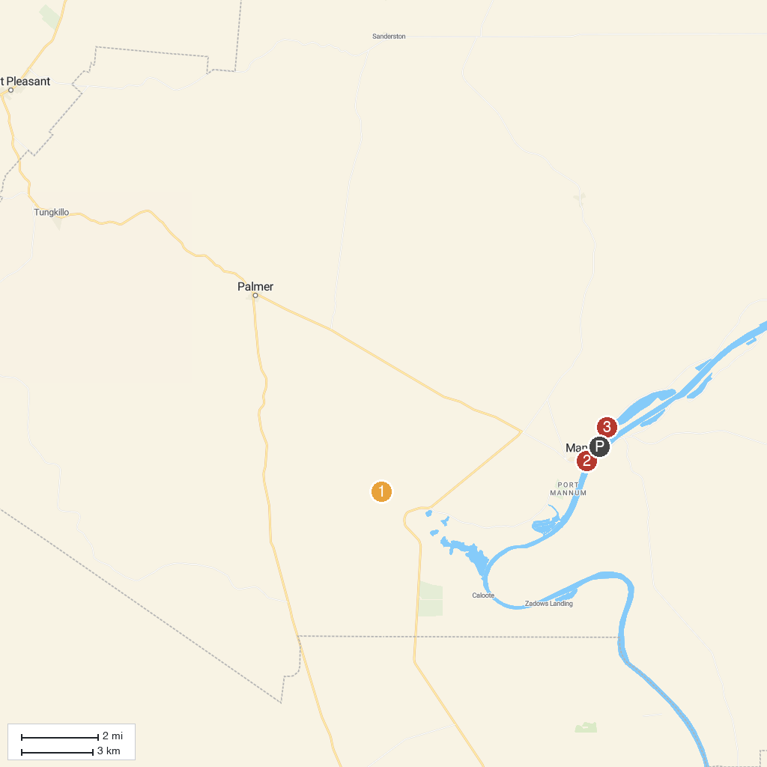
MAP KEY
1. Mannum Waterfalls Upper Car Park | 3. Lookout
2. Mary Ann Reserve
P. Cruise port / terminal
Map © MapTiler © OpenStreetMap contributors · cruiseports.org

