Little Current, Manitoulin Island, Ontario, Canada
The world's largest freshwater island greets cruise passengers with a walkable waterfront, a century-old swing bridge that still pivots open every hour, and trails that climb to cliff-edge views over the North Channel. It's unhurried, wild, and unmistakably Canadian.
⚓ Pier (downtown waterfront docks) · 🕒 Typical call: 7-9 hrs · 💵 Canadian Dollar (CAD) · 🗣️ English / Anishinaabemowin · 🌿 Great Lakes cruise
✍️ MY DAY IN PORT (FILL IN)
Ship / Date
In port | arrive ______ · all aboard ______
Booked excursion
Notes / meeting point
GETTING ASHORE
- Docking: Pier — ships tie up directly at the Little Current downtown docks, steps from Water Street
- Walk to center: 0-5 min — the waterfront boardwalk is right off the gangway
- Best For: Nature hikes, Indigenous culture, historic swing bridge, Great Lakes scenery
- Don't Miss: Watching the Little Current Swing Bridge pivot open on the hour for boat traffic
GETTING AROUND
- 🚕 Taxi: ~CAD $10–$20 in town; ~CAD $40–$80+ for island destinations — Several local taxi services operate on the island, including Mother's Taxi, D&R Taxi, Jeff's Taxi, and Island Wide Taxi.
TOP THINGS TO DO
- Little Current Swing Bridge — Built in 1913, this one-lane bridge is the only road link to the mainland.
- Cup and Saucer Trail Hike — Manitoulin's most famous trail climbs the Niagara Escarpment to 70-metre cliffs with sweeping views over the North Channel, West…
- Bridal Veil Falls, Kagawong — A 35-foot waterfall about 35 minutes west of the port.
- Ojibwe Cultural Foundation, M'Chigeeng — A museum and gallery dedicated to Anishinaabe heritage, language, and art, located about 25 minutes from the port.
- Low Island Park & Beach — A 10-minute walk west of the docks along the waterfront boardwalk, this municipal park has a sandy beach on the North Channel…
BEST WALKS
- Waterfront Boardwalk to Swing Bridge: 2 km round trip · 30-40 min · Flat & paved — Head east from the ship along the downtown docks and boardwalk to the iconic 1913 Swing Bridge.
- Waterfront to Low Island Park: 1.5 km one way · 20 min · Flat — Walk west along the waterfront boardwalk to Low Island Park for a beach break, wooded trails, and…
WEATHER · DAYLIGHT · MONEY
Month | High °F | Low °F | Rainy days
May | 56 | 43 | 10
Jul | 73 | 63 | 9
Sep | 65 | 57 | 10
Daylight: May 5:55AM–8:53PM · Jul 5:52AM–9:14PM · Sep 7:06AM–7:38PM
cruiseports.org/manitoulin-island · Confirm terminal & all-aboard time with your ship

Little Current, Manitoulin Island, Ontario, Canada — Port Map
Red = walkable sights · Amber = excursions farther out · P = cruise terminal
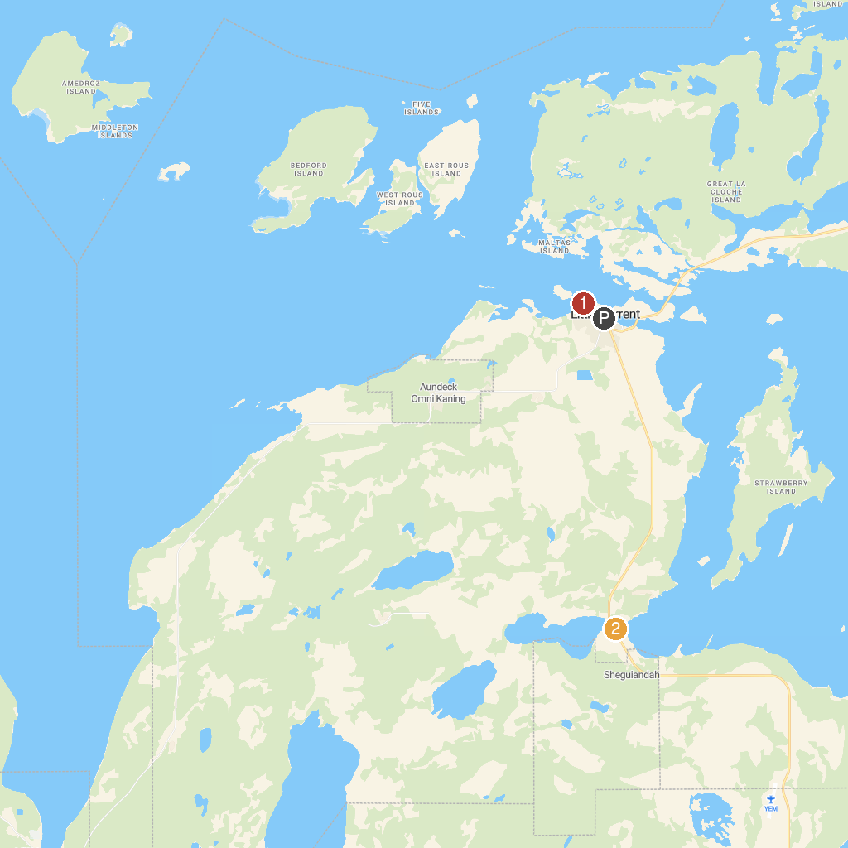
MAP KEY
1. Low Island Municipal Park | 2. Centennial Museum Sheguiandah
P. Cruise port / terminal
Map © MapTiler © OpenStreetMap contributors · cruiseports.org

