Manila, Metro Manila, Philippines
The Pearl of the Orient packs Spanish colonial history, the world's oldest Chinatown, and some of Asia's best street food into one high-energy port day. Intramuros and three free National Museums are all within a short ride of Pier 15.
⚓ Pier (Pier 15, South Harbor) · 🕒 Typical call: 8-10 hrs · 💵 Philippine Peso (PHP) · 🗣️ English widely spoken · 🚦 Allow extra time — Manila traffic is severe
✍️ MY DAY IN PORT (FILL IN)
Ship / Date
In port | arrive ______ · all aboard ______
Booked excursion
Notes / meeting point
GETTING ASHORE
- Docking: Pier 15, Manila South Harbor — all ships dock; no tendering
- Walk to center: Not walkable — port is industrial; use Grab app or taxi (5-10 min to Intramuros)
- Best For: History buffs, food lovers, culture seekers
- Don't Miss: Fort Santiago, National Museum of Fine Arts (free), Binondo food crawl
GETTING AROUND
- 🚕 Taxi: PHP 95–150 (~$2–3) — White government-regulated taxis are available outside the terminal. Metered fares are very affordable — most city-cente
- 📱 Rideshare: ✅ Grab
- 🚌 Hop-on hop-off: ✅
TOP THINGS TO DO
- Intramuros & Fort Santiago — The 16th-century Spanish walled city is the heart of Old Manila.
- National Museums Trio (Free) — Three world-class museums adjacent to Rizal Park — all free.
- Binondo Chinatown Food Crawl — Established in 1594, Binondo is the oldest Chinatown in the world.
- Bambike Eco-Tour of Intramuros — Tour the walled city on handcrafted bamboo bicycles — a uniquely Filipino, eco-friendly experience that covers the key sites at a…
- Corregidor Island WWII Tour — A ferry from Manila Bay takes you to Corregidor, the island fortress that fell to Japan in 1942 and was retaken in 1945.
BEST WALKS
- Intramuros Walled City Walk: 1.5–2 km · 2-3 hrs · Easy (some cobblestones) — From the main Intramuros gate, walk to Fort Santiago for the dungeon and Rizal execution site, then…
- Rizal Park & National Museums: 1 km · 1.5-2 hrs · Easy — Cross from Intramuros to Rizal Park, see the Rizal Monument with its ceremonial guard, then loop…
WEATHER · DAYLIGHT · MONEY
Month | High °F | Low °F | Rainy days
May | 92 | 80 | 17
Jul | 86 | 78 | 28
Sep | 85 | 77 | 27
Daylight: May 5:28AM–6:16PM · Jul 5:34AM–6:29PM · Sep 5:44AM–5:57PM
cruiseports.org/manila · Confirm terminal & all-aboard time with your ship

Manila, Metro Manila, Philippines — Port Map
Red = walkable sights · Amber = excursions farther out · P = cruise terminal
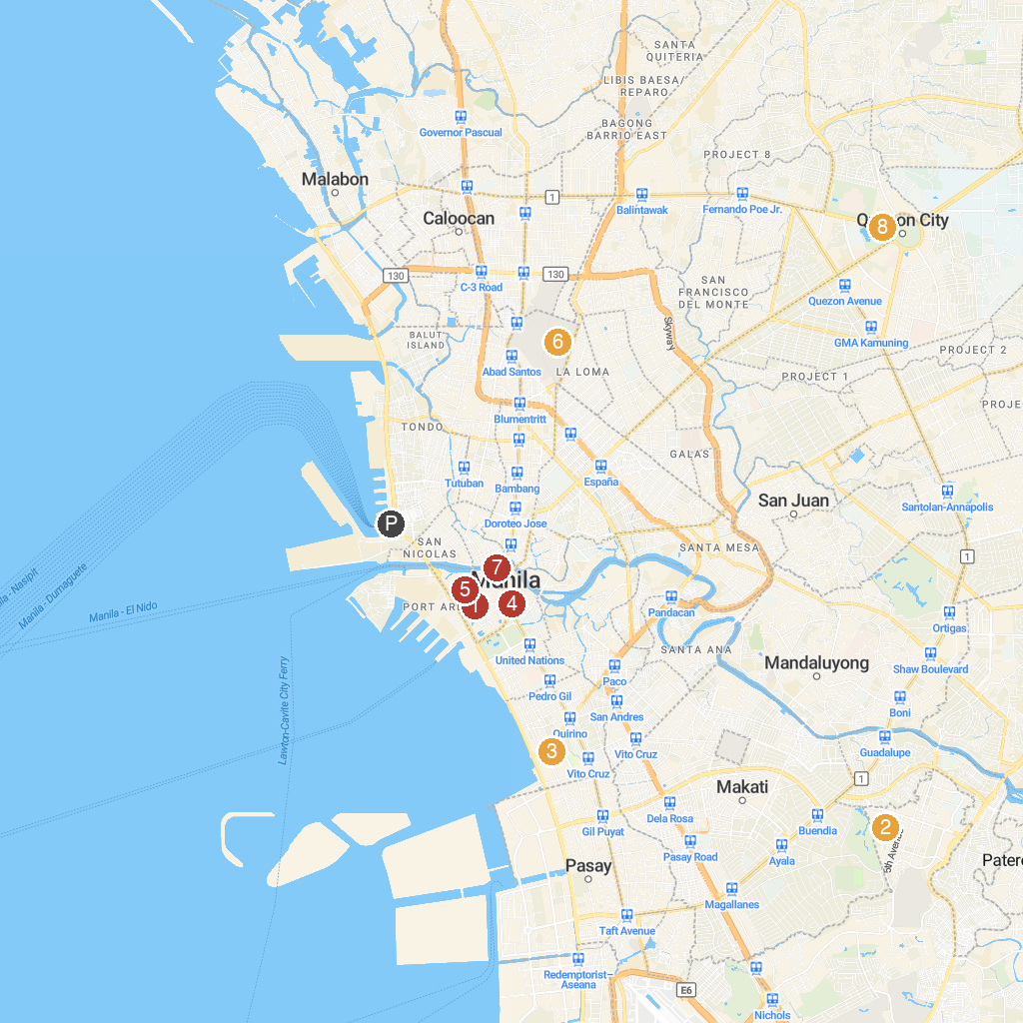
MAP KEY
1. Archdiocesan Shrine of Nuestra Señora de la Consolación y Correa - San Agustin Church | 5. Minor Basilica and Metropolitan Cathedral of the Immaculate Conception - The Manila Cathedral
2. The Mind Museum | 6. Manila North Cemetery
3. Manila Zoological & Botanical Garden | 7. Philippine Postal Corporation
4. Manila City Hall | 8. Ninoy Aquino Parks and Wildlife Center
P. Cruise port / terminal
Map © MapTiler © OpenStreetMap contributors · cruiseports.org

