Mangalore, Karnataka, India
Where the Western Ghats meet the Arabian Sea, Mangalore blends ancient temples, red-tiled rooftops, and some of the finest seafood cuisine in India — all from a working port that welcomes cruise ships with traditional Yakshagana dancers on the pier.
⚓ Pier (New Mangalore Port) · 🕒 Typical call: 8-10 hrs · 💵 Indian Rupee (INR) · 🗣️ Kannada / Tulu / English
✍️ MY DAY IN PORT (FILL IN)
Ship / Date
In port | arrive ______ · all aboard ______
Booked excursion
Notes / meeting point
GETTING ASHORE
- Docking: Pier — New Mangalore Port (Panambur), ~10 km from city centre
- Walk to Centre: Not walkable; shuttle or taxi required (port is industrial)
- Best For: Temple hopping, Mangalorean seafood, beach walks, day trips to Jain sites
- Don't Miss: St. Aloysius Chapel frescoes and Chicken Ghee Roast at a local restaurant
GETTING AROUND
- 🚕 Taxi: ₹500–₹830 (~$6–$10) — Pre-paid taxis available at the port for the 10–15 km ride to city center. Negotiate fare before you start or insist on
- 📱 Rideshare: ✅ Uber, Ola, Rapido
TOP THINGS TO DO
- St. Aloysius Chapel & City Temples — The Jesuit-built St.
- Moodabidri & Karkala Jain Pilgrimage — The most popular full-day excursion from Mangalore.
- Panambur Beach — The closest beach to the port, just outside the port gates, with golden sand, jet ski and camel rides, and great street food…
- Tannirbhavi Beach & Sultan Battery — A quieter pine-lined beach south of the river, reachable by car or a scenic ferry from the Sultan Battery — a compact stone…
- Mangalorean Food & Market Walk — Dive into one of India's most celebrated regional cuisines: Chicken Ghee Roast, Neer Dosa with coconut chutney, Kane Rava Fry…
BEST WALKS
- Old Town Temple & Chapel Walk: ~3 km | Easy | 1.5-2 hrs — From the city centre, walk to St.
- Panambur Beach Stroll: ~2 km beachfront | Easy | 1 hr — A leisurely walk along Panambur Beach from the main entry point south along the shoreline.
WEATHER · DAYLIGHT · MONEY
Month | High °F | Low °F | Rainy days
May | 88 | 79 | 20
Jul | 81 | 76 | 31
Sep | 82 | 75 | 26
Daylight: May 6:05AM–6:48PM · Jul 6:12AM–7:01PM · Sep 6:19AM–6:32PM
cruiseports.org/mangalore · Confirm terminal & all-aboard time with your ship

Mangalore, Karnataka, India — Port Map
Red = walkable sights · Amber = excursions farther out · P = cruise terminal
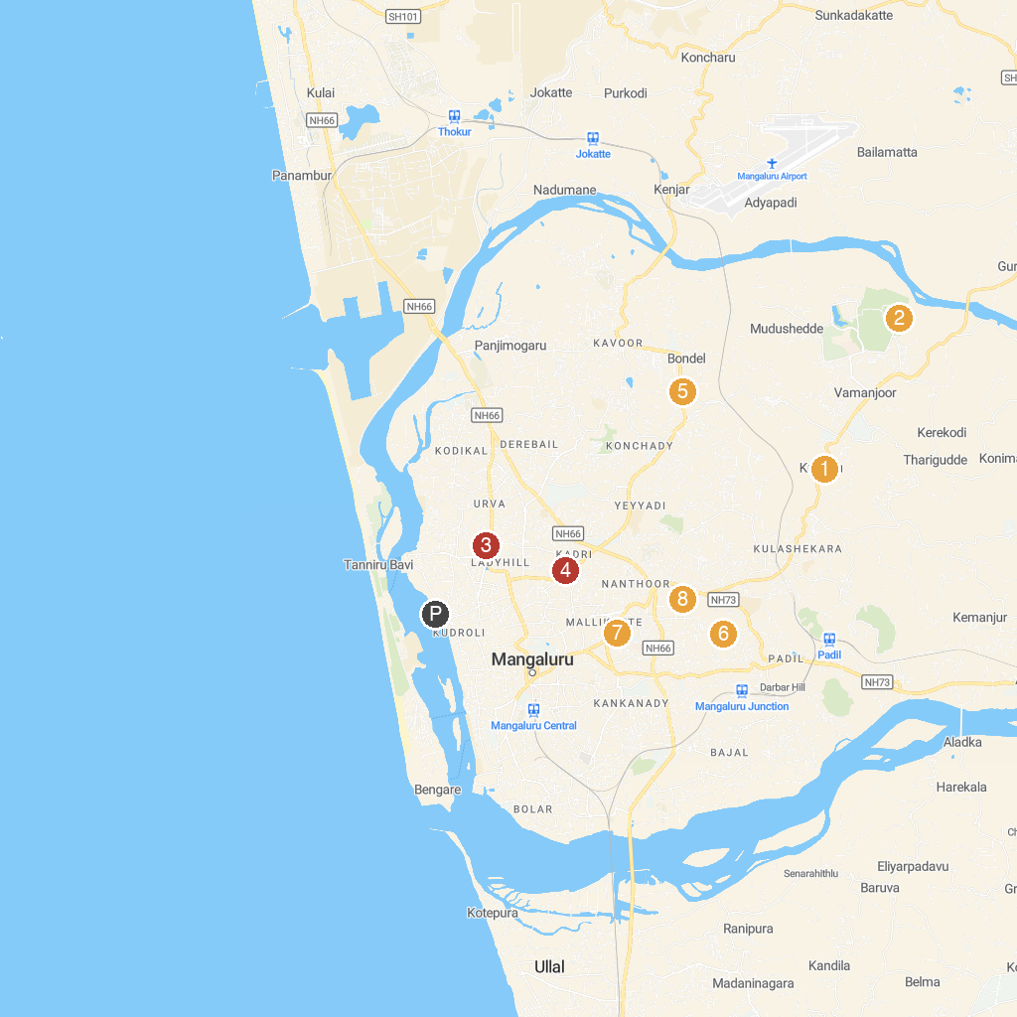
MAP KEY
1. Shri Ananthapadmanabha Swamy Temple (Kudupu) | 5. St. Lawrence Church and Shrine, Bondel
2. Pilikula Artisans Village | 6. Maroli Shri Suryanarayana Swamy Temple
3. Shree Shirdi Sai Baba Mandir | 7. St. Sebastian Church, Mangalore
4. Srimanthi Bai Memorial Government Museum | 8. Infant Jesus Shrine
P. Cruise port / terminal
Map © MapTiler © OpenStreetMap contributors · cruiseports.org

