Manfredonia, Puglia, Italy
Gateway to the wild Gargano Peninsula, Manfredonia delivers medieval castles, a ghostly wire-mesh basilica, and some of Puglia's freshest seafood — all just minutes from the pier.
⚓ Pier (docked) · 🕒 Typical call: 6-8 hrs · 💶 Euro (€) · 🗣️ Italian · 🏛️ UNESCO nearby
✍️ MY DAY IN PORT (FILL IN)
Ship / Date
In port | arrive ______ · all aboard ______
Booked excursion
Notes / meeting point
GETTING ASHORE
- Docking: Pier — Molo di Ponente; short walk to town
- Walk to center: ~5-10 min (500 m) from pier to historic centre
- Best For: History, authentic Puglian cuisine, Gargano day trips
- Don't Miss: Tresoldi's wire-mesh basilica at Siponto (3 km south)
GETTING AROUND
- 🚕 Taxi: €5–€10 — Licensed taxis are available near the port. Fares within Manfredonia are short and inexpensive; agree on a fare before b
TOP THINGS TO DO
- Siponto Wire-Mesh Basilica — Artist Edoardo Tresoldi reconstructed a vanished early-Christian basilica in wire mesh (rising about 14 m high) beside the…
- Castello Svevo-Angioino & Daunian Stele Museum — The waterfront castle built by King Manfred in 1256 houses the National Archaeological Museum of Manfredonia.
- Monte Sant'Angelo — UNESCO Sanctuary — Perched 800 m above sea level, this UNESCO World Heritage site centres on a cave-church dedicated to the Archangel Michael, a…
- Gargano National Park & Foresta Umbra — Italy's 'spur' is carpeted by the ancient Foresta Umbra beech forest.
- Lido di Siponto Beach — Three kilometres south of town, Siponto's long golden-sand beach is calm and family-friendly.
BEST WALKS
- Castle to Cathedral Stroll: 1.5 km · ~30 min · Easy — A short flat walk linking the two main monuments of Manfredonia, passing through the pedestrian…
- Waterfront Lungomare: 2 km · ~35 min · Easy — Head south from the pier along the wide seafront promenade — good for people-watching and views…
WEATHER · DAYLIGHT · MONEY
Month | High °F | Low °F | Rainy days
May | 75 | 58 | 9
Jul | 91 | 72 | 3
Sep | 82 | 65 | 7
Daylight: May 5:37AM–8:08PM · Jul 5:35AM–8:28PM · Sep 6:36AM–7:05PM
cruiseports.org/manfredonia · Confirm terminal & all-aboard time with your ship

Manfredonia, Puglia, Italy — Port Map
Red = walkable sights · Amber = excursions farther out · P = cruise terminal
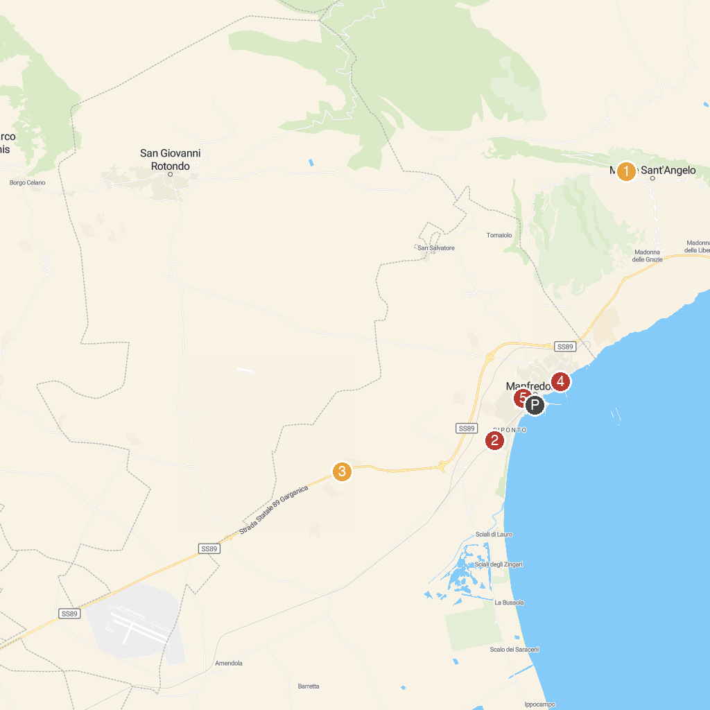
MAP KEY
1. Basilica Santuario di San Michele Arcangelo | 5. Water Park Acquapark Ippocampo
2. Basilica of St. Mary of Siponto | 6. Castle of Manfredonia
3. Abbazia San Leonardo in Lama Volara, Manfredonia | 7. Church of the Holy Family
4. Monte Saraceno
P. Cruise port / terminal
Map © MapTiler © OpenStreetMap contributors · cruiseports.org

