Mandal, Agder, Norway
Norway's southernmost town earns its nickname 'The Little White Town' — a sun-bleached old quarter, a sweeping sandy beach, and a salmon river running right through the heart of it.
⚓ Docked (pier, ~2.5 km from center) · 🕒 Typical call: 7-9 hrs · 💵 Norwegian Krone (NOK) — card everywhere · 🗣️ Norwegian / English widely spoken
✍️ MY DAY IN PORT (FILL IN)
Ship / Date
In port | arrive ______ · all aboard ______
Booked excursion
Notes / meeting point
GETTING ASHORE
- Docking: Gismerøya/Kleven pier, ~2.5 km from center; shuttle usually provided
- Walk to center: ~35 min flat walk or 10 min shuttle
- Best For: Charming old town strolling, Norway's best sandy beach, local history
- Don't Miss: Sjøsanden beach and the view from Uranienborg hilltop
GETTING AROUND
- 🚕 Taxi: 100–150 NOK (~–14 USD) — Taxis are available at the port. Agder Taxi (07000) and OpaTaxi serve Mandal with online/app booking and fixed rates. Th
TOP THINGS TO DO
- Sjøsanden Beach & Furulunden Nature Park — An 800-metre crescent of fine golden sand framed by pine forest — routinely called Norway's best beach.
- Mandal Old Town Walk — Stroll the narrow cobblestone lanes of Sjøgata and Grensen, lined with beautifully preserved 18th- and 19th-century white-painted…
- Mandal Museum & Vigeland House — Gustav Vigeland — Norway's most famous sculptor, creator of Oslo's Vigeland Park — was born in Mandal.
- Lindesnes Lighthouse Day Trip — Norway's oldest lighthouse stands at the country's southernmost point, about 45 minutes by car from Mandal.
- RIB Speed Boat Archipelago Tour — High-speed rigid inflatable boat tours thread through Mandal's island archipelago, often heading toward Ryvingen Lighthouse.
BEST WALKS
- Old Town to Sjøsanden Beach: 3 km round trip · 45 min · Easy flat walk — From the town center, walk west along the river and through the old town streets before following…
- Uranienborg Viewpoint: 15 min walk · Short steep climb · Panoramic views — From the town center, a short but steep path leads up to Uranienborg — once an optical telegraph…
WEATHER · DAYLIGHT · MONEY
Month | High °F | Low °F | Rainy days
May | 56 | 45 | 12
Jul | 66 | 55 | 14
Sep | 60 | 52 | 15
Daylight: May 5:06AM–9:48PM · Jul 4:50AM–10:21PM · Sep 6:59AM–7:51PM
cruiseports.org/mandal · Confirm terminal & all-aboard time with your ship

Mandal, Agder, Norway — Port Map
Red = walkable sights · Amber = excursions farther out · P = cruise terminal
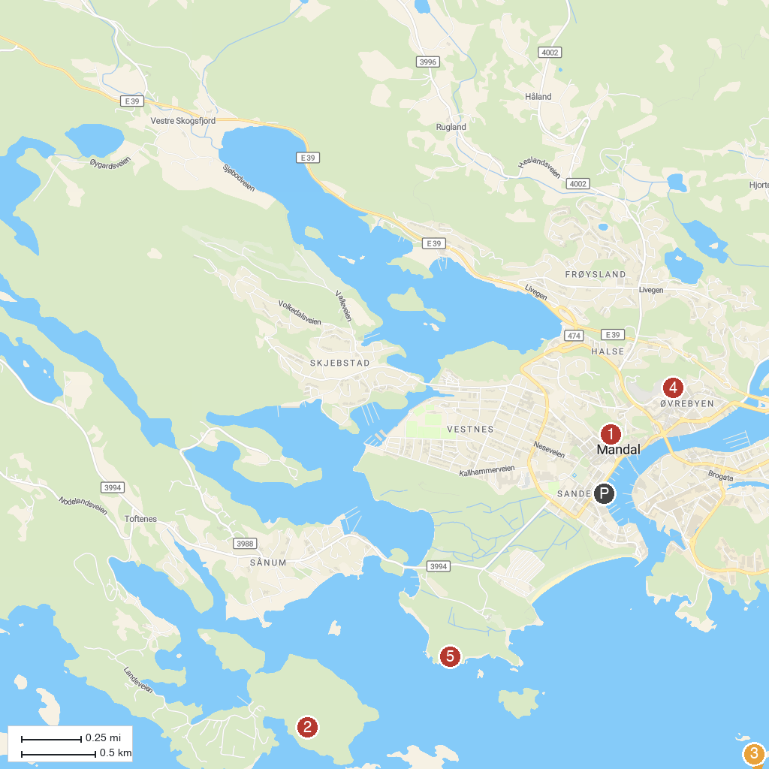
MAP KEY
1. Uranienborg | 4. Mandal Kirke
2. Landehovde coastal fort | 5. Spidsbo (Beach/Strand)
3. Ryvingen Lighthouse
P. Cruise port / terminal
Map © MapTiler © OpenStreetMap contributors · cruiseports.org

