Manaus, Brazil
A thousand miles up the Amazon — a rubber-boom metropolis in the heart of the rainforest, where a grand opera house rises from the jungle and two great rivers run side by side without mixing.
⚓ Docked (floating port) · 🕒 Typical call: 10–12 hrs · 💵 Brazilian Real (BRL) · 🗣️ Portuguese · limited English
✍️ MY DAY IN PORT (FILL IN)
Ship / Date
In port | arrive ______ · all aboard ______
Booked excursion
Notes / meeting point
GETTING ASHORE
- Docking: Floating port
- Walk to center: 5–10 min
- Best For: Amazon · Wildlife
- Don't Miss: Meeting of the Waters
GETTING AROUND
- 🚕 Taxi: R$10–R$18 (~US$2–4) — Metered taxis are available at the port. Base fare is approximately R$5.60 plus R$4.00/km; the short run to the center i
- 📱 Rideshare: ✅ Uber, 99
TOP THINGS TO DO
- Meeting of the Waters — Watch the inky Rio Negro and the sandy Rio Solimões run side by side for kilometers without mixing — a natural wonder reached by…
- Amazon Jungle & Wildlife Cruise — Navigate igarapés (jungle creeks) and flooded forest by small boat, spotting pink river dolphins, sloths, monkeys, and giant…
- Teatro Amazonas Opera House — The opulent rubber-boom opera house (1896), with its tiled dome and European chandeliers — a surreal monument to Manaus's gilded…
- Pink River Dolphin Encounter — A boat trip to a calm tributary to see (and sometimes swim with) the Amazon's famous pink dolphins, often combined with a visit…
BEST WALKS
- Historic center & opera house: ~2 km · 1.5 hrs · easy — From the floating port up to the Teatro Amazonas on its mosaic plaza, past the Igreja de São…
- Mercado Adolpho Lisboa: ~1 km · 1 hr · easy — A riverside market hall modeled on Les Halles in Paris, brimming with Amazonian fruit, fish, and…
- Praça da Matriz & cathedral: ~1 km · 45 min · easy — The central square and the Manaus cathedral, the civic heart of the rubber-boom city, a few blocks…
WEATHER · DAYLIGHT · MONEY
Month | High °F | Low °F | Rainy days
May | 85 | 76 | 27
Jul | 87 | 76 | 13
Sep | 91 | 78 | 11
Daylight: May 5:57AM–5:55PM · Jul 6:07AM–6:04PM · Sep 5:52AM–5:57PM
cruiseports.org/manaus · Confirm terminal & all-aboard time with your ship

Manaus, Brazil — Port Map
Red = walkable sights · Amber = excursions farther out · P = cruise terminal
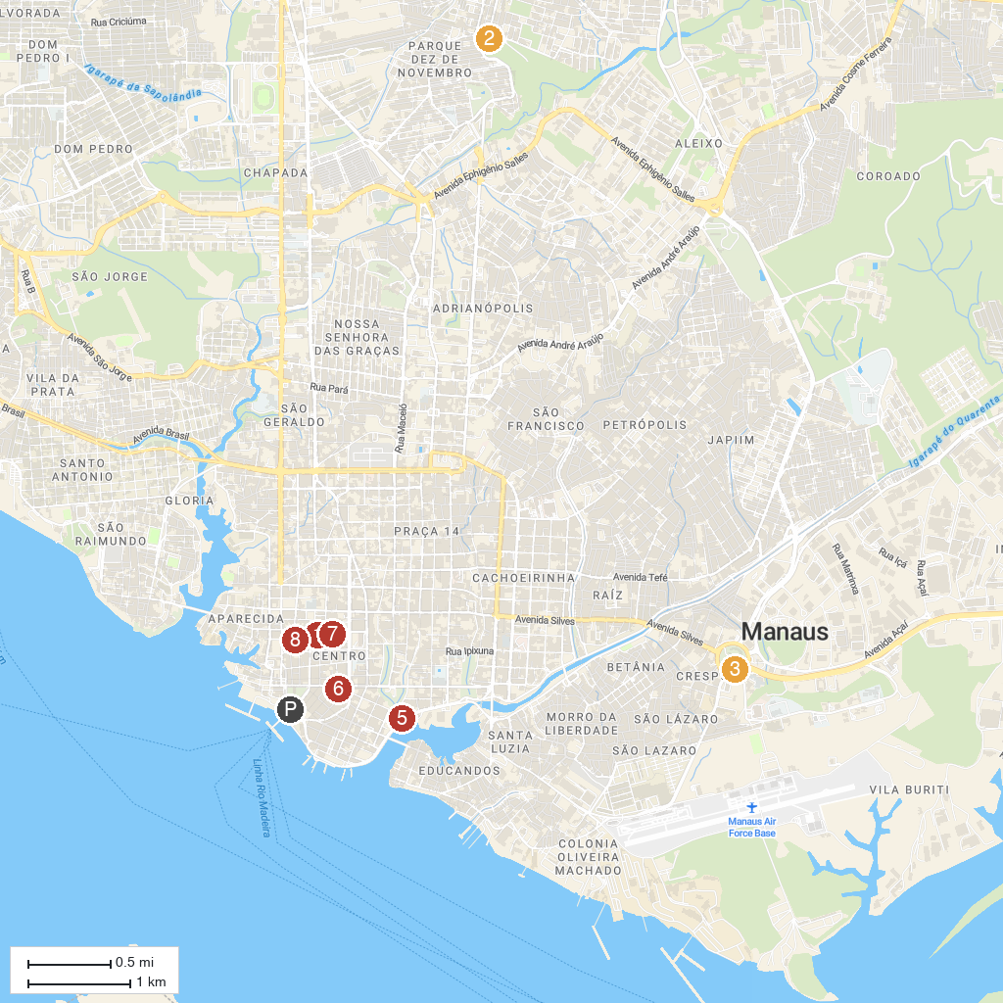
MAP KEY
1. Amazonas Theater | 5. Parque Senador Jefferson Péres
2. Parque Municipal do Mindu | 6. Praça da Polícia (Praça Heliodoro Balbi)
3. Museu Do Homem Do Norte | 7. Galeria do Largo
4. Port of Manaus | 8. Museu da Casa Eduardo Ribeiro
P. Cruise port / terminal
Map © MapTiler © OpenStreetMap contributors · cruiseports.org

